Table of Contents
LAB 5.1 – JAVASCRIPT FUNDAMENTALS 2
LAB 5.2 – Asynchronous JavaScript: async/await and Error Handling 37
LAB 5.3 – React Components 68
LAB 5.4 – React State and User Events 97
LAB 5.5 – Smart Contract Development and Deployment 124
LAB 5.6 – Wallet Connection and Web3.js Integration 139
LAB 5.7 – Reading and Updating Blockchain State 171
LAB 5.8 – Integrated Lab: Building a Complete SimpleStorage DApp 207

LAB 5.1 – JAVASCRIPT FUNDAMENTALS
Lab Topic: Variables, Functions, Objects, and Arrays
Lab Environment: Online JavaScript Editor – PlayCode
Lab Objective: Practice fundamental JavaScript concepts through simple financial examples to prepare for developing decentralized applications (DApps).

1. Learning Outcomes
After completing this lab, students will be able to:
- Declare and manipulate JavaScript variables using let and const.
- Create functions with parameters and return values.
- Represent financial accounts using JavaScript objects.
- Store and access multiple accounts and transactions using arrays.
- Process simple financial transactions using JavaScript.
- Develop a basic transaction manager that simulates account balance updates.

2. Lab Preparation

Step 1. Open the Online JavaScript Editor
Open link: https://playcode.io/javascript, choose Open the playground
Trong ảnh bạn gửi:
- Bên trái: Danh sách file.
- Ở giữa: File script.js đang mở — đây là nơi viết JavaScript.
- Góc dưới bên phải: Console — nơi hiển thị kết quả.
- Góc trên bên phải: Preview — giao diện web mẫu, chưa cần sử dụng.
- Trong giao diện PlayCode AI Chat là khu vực trợ lý AI hỗ trợ viết code và giải thích JavaScript.

Step 2. Create a JavaScript Program
Enter the following code in the JavaScript editor:
console.log("Hello, Blockchain!");
console.log("Welcome to Lab 5.1");
Run the program using the editor's Run function, if required.
Expected Output
Hello, Blockchain!
Welcome to Lab 5.1
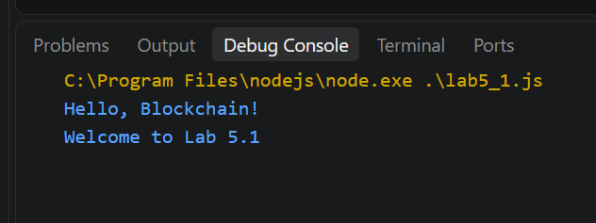
For each exercise, students should replace the previous example with the new code, unless instructed otherwise. This avoids variable redeclaration errors.

3. Exercise 1. JavaScript Variables
Objective: Understand how to declare and update variables using let and const.

Step 1. Declare Variables
Enter the following code:
const account = "Alice";
let balance = 10;
const depositAmount = 2;

console.log("Account:", account);
console.log("Initial Balance:", balance);
console.log("Deposit Amount:", depositAmount);
Expected Output:
Account: Alice
Initial Balance: 10
Deposit Amount: 2
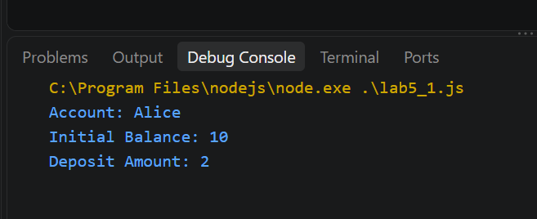

Step 2. Update the Balance
Add the following code:
balance = balance + depositAmount;

console.log("Updated Balance:", balance);
Expected Output: Updated Balance: 12
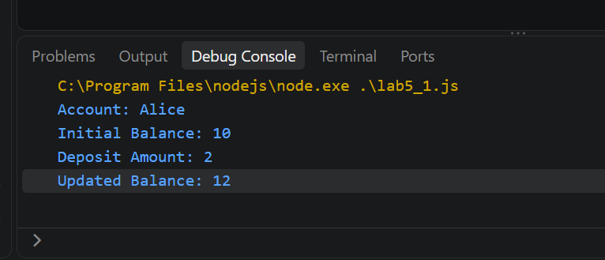

Step 3. Understand the Variables
Variable | Declaration | Purpose
account | const | Stores the account name
balance | let | Stores a balance that can change
depositAmount | const | Stores the deposit amount

Student Tasks
- Change the initial balance from 10 to 20.
- Change the deposit amount from 2 to 5.
- Run the program and verify that the updated balance is 25.
- Explain why balance is declared using let.
Expected Result: Students can declare, read, and update JavaScript variables.
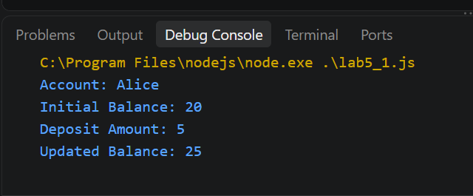
-> Dùng let vì balance có thể thay đổi sau khi deposit/withdraw.

4. Exercise 2. JavaScript Functions
Objective: Create reusable functions to perform simple financial calculations.

Step 1. Create a Function
function calculateBalance(balance, amount) {
return balance + amount;
}

const newBalance = calculateBalance(10, 2);

console.log("New Balance:", newBalance);
Expected Output
New Balance: 12
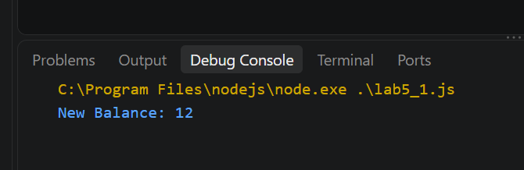

Step 2. Call the Function with Different Arguments
console.log(calculateBalance(20, 5));
console.log(calculateBalance(50, 10));
Expected Output
25
60
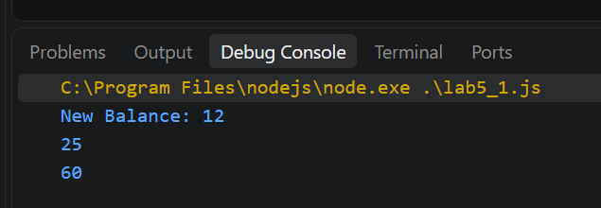

Step 3. Create a Withdrawal Function
function withdraw(balance, amount) {
if (amount > balance) {
return "Insufficient balance";
}

return balance - amount;
}

console.log(withdraw(10, 3));
console.log(withdraw(10, 15));
Expected Output
7
Insufficient balance
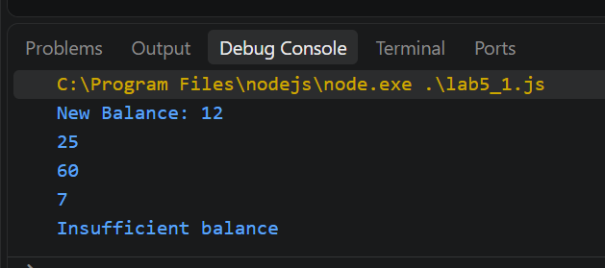

Student Tasks
- Create a function named deposit(balance, amount).
- The function should return the balance after a deposit. -> function “deposit”
- Test the function using deposit(15, 5).
- Create another test using withdraw(20, 8).
Expected Results: 20 and 12.
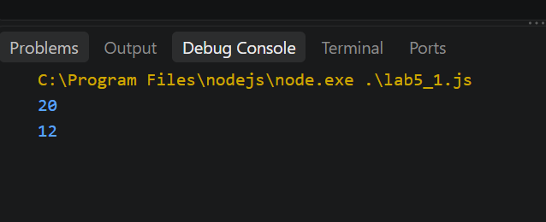

5. Exercise 3. JavaScript Objects
Objective: Represent a financial account using an object.

Step 1. Create an Account Object
const user = {
name: "Alice",
address: "0xABC",
balance: 10
};

console.log(user);
Expected Output
{
name: "Alice",
address: "0xABC",
balance: 10
}
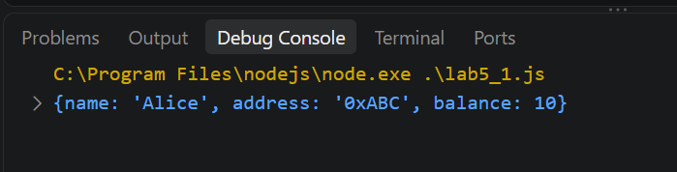

Step 2. Access Object Properties
console.log("Name:", user.name);
console.log("Address:", user.address);
console.log("Balance:", user.balance);
Expected Output
Name: Alice
Address: 0xABC
Balance: 10
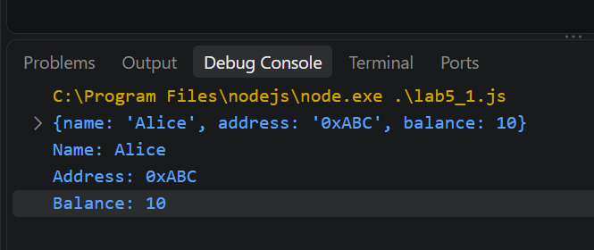

Step 3. Update an Object Property
user.balance = user.balance + 5;

console.log("Updated Balance:", user.balance);
Expected Output
Updated Balance: 15
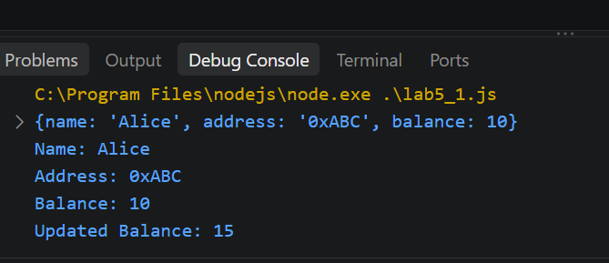

Student Tasks
- Add a property named currency with the value "ETH".
- Change the account name to "Bob".
- Update the balance to 20.
- Display the updated account information.
Expected Result: Students can create, access, and modify object properties.
Note: 0xABC is an illustrative address, not a complete Ethereum wallet address.
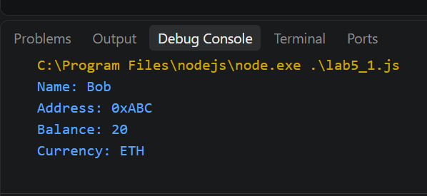

6. Exercise 4. JavaScript Arrays
Objective: Store and manage multiple accounts using arrays.

Step 1. Create an Array
const accounts = [
"Alice",
"Bob",
"Carol"
];

console.log(accounts);

Step 2. Access Array Elements
console.log("First Account:", accounts[0]);
console.log("Second Account:", accounts[1]);
console.log("Third Account:", accounts[2]);
Expected Output
First Account: Alice
Second Account: Bob
Third Account: Carol
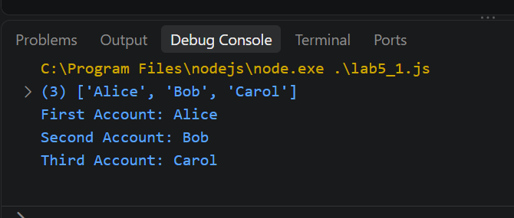

Step 3. Add an Account
accounts.push("David");

console.log(accounts);
Expected Output
["Alice", "Bob", "Carol", "David"]
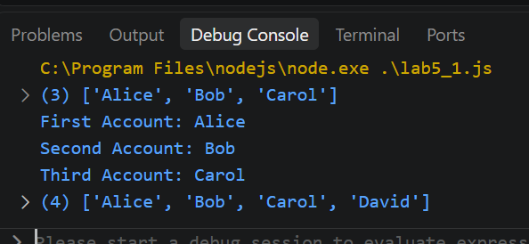

Step 4. Iterate Through the Array
for (const account of accounts) {
console.log("Account:", account);
}
Expected Output
Account: Alice
Account: Bob
Account: Carol
Account: David
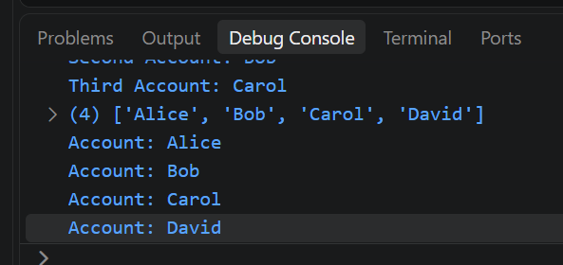

Student Tasks
- Add a new account named "Emma".
- Display the total number of accounts using accounts.length.
- Print all account names using a loop.
Expected Result: The array contains five accounts.
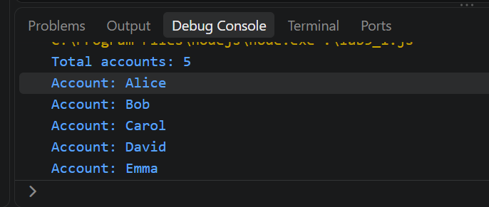

7. Exercise 5. Objects and Arrays in Financial Transactions
Objective: Represent multiple financial transactions using an array of objects.

Step 1. Create Transaction Data
const transactions = [
{
from: "Alice",
to: "Bob",
amount: 2
},
{
from: "Carol",
to: "Bob",
amount: 3
}
];

console.log(transactions);

Step 2. Access Transaction Information
console.log("Sender:", transactions[0].from);
console.log("Receiver:", transactions[0].to);
console.log("Amount:", transactions[0].amount);
Expected Output
Sender: Alice
Receiver: Bob
Amount: 2
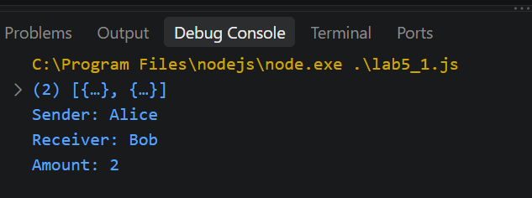

Step 3. Add a New Transaction
transactions.push({
from: "Bob",
to: "Alice",
amount: 1
});

console.log(transactions);

Step 4. Calculate the Total Transferred Amount
let total = 0;

for (const tx of transactions) {
total = total + tx.amount;
}

console.log("Total Transferred:", total);
Expected Output
Total Transferred: 6
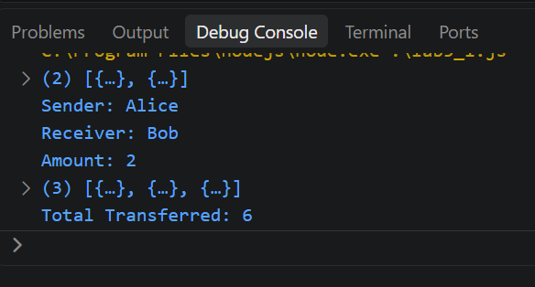

Student Tasks
- Add a fourth transaction: Alice sends 4 tokens to Carol.
- Calculate the total transferred amount.
- Display the sender, receiver, and amount of every transaction.
Expected Result: Total transferred amount = 10.
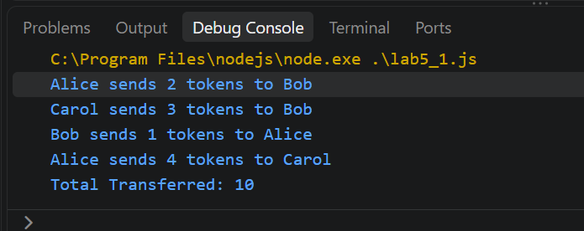

8. Exercise 6. Processing Financial Transactions
Objective: Combine variables, functions, objects, arrays, and loops to simulate account transfers.

Step 1. Create Account Balances
const balances = {
Alice: 20,
Bob: 10,
Carol: 15
};

console.log("Initial Balances:", balances);

Step 2. Create Transactions
const transactions = [
{ from: "Alice", to: "Bob", amount: 5 },
{ from: "Carol", to: "Alice", amount: 3 }
];

Step 3. Create a Transfer Function
function transfer(from, to, amount) {
if (amount <= 0) {
console.log("Invalid amount");
return;
}

if (balances[from] === undefined ||
balances[to] === undefined) {
console.log("Account not found");
return;
}

if (balances[from] < amount) {
console.log("Insufficient balance");
return;
}

balances[from] -= amount;
balances[to] += amount;

console.log(
`${from} transferred ${amount} to ${to}`
);
}

Step 4. Process the Transactions
for (const tx of transactions) {
transfer(tx.from, tx.to, tx.amount);
}

console.log("Final Balances:", balances);
Expected Output
Alice transferred 5 to Bob
Carol transferred 3 to Alice

Final Balances:
{
Alice: 18,
Bob: 15,
Carol: 12
}
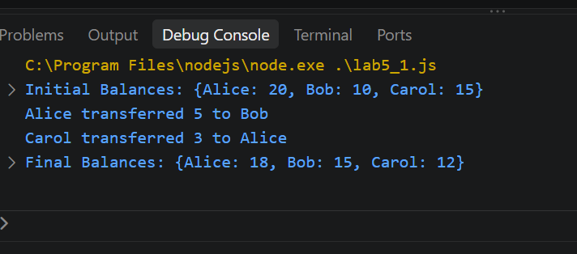

Step 5. Verify the Results
Account | Initial Balance | Final Balance
Alice | 20 | 18
Bob | 10 | 15
Carol | 15 | 12
Total | 45 | 45
The total balance remains unchanged because the transactions only transfer funds between accounts.

Student Tasks
- Add a transaction: Bob transfers 4 tokens to Carol.
- Run the program and calculate the final balances.
- Add a transaction: Alice transfers 100 tokens to Bob.
- Observe how the program handles insufficient balance.
- Explain why the total balance should remain unchanged after valid transfers.
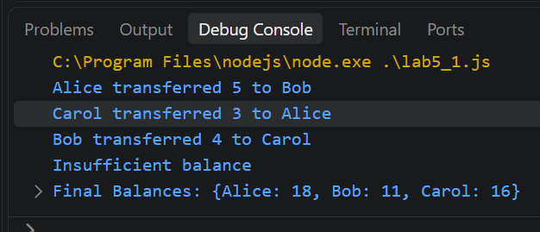
=> Tổng không đổi vì đây chỉ là chuyển tiền giữa các account, không tạo thêm và không xóa token. Tổng balance vẫn giữ nguyên sau các valid transfers

9. BUILDING A SIMPLE TRANSACTION MANAGER
Development Environment: PlayCode – Online JavaScript Editor
Technologies: HTML, CSS, JavaScript
Lab Objective: Build a simple financial transaction application that manages account balances, transfers tokens between users, validates transactions, displays transaction history, and calculates total balances.

1. Learning Outcomes
After completing this lab, students will be able to:
- Use JavaScript variables, objects, arrays, and functions.
- Create a web interface using HTML and CSS.
- Handle user events using JavaScript.
- Implement token transfer logic between accounts.
- Validate transactions and prevent insufficient-balance transfers.
- Update account balances and display transaction history.
- Explain the difference between a local JavaScript simulation and a blockchain transaction.

2. Application Overview
The application manages three accounts:
Account | Initial Balance
Alice | 20 tokens
Bob | 10 tokens
Carol | 15 tokens
Total | 45 tokens
For example, when Alice transfers 5 tokens to Bob, Alice's balance decreases to 15, Bob's balance increases to 15, and Carol's balance remains 15.
The application includes a sender selection, receiver selection, amount input, Transfer button, Reset button, transaction history, and total balance display.

Part 1. Set Up the Development Environment

Step 1. Open PlayCode
- Open a web browser.
- Visit https://playcode.io/javascript.
- Click Open the playground.
- Locate the file explorer on the left side of the screen.
The project should contain the following files:
- index.html — Application structure
- src/styles.css — Application styling
- src/script.js — Transaction processing logic

Part 2. Create the HTML Interface

Step 2. Open index.html
Select index.html, press Ctrl + A to select the existing code, delete it, and paste the following complete HTML source code.
<!DOCTYPE html>
<html lang="en">
<head>
<meta charset="UTF-8">
<meta name="viewport"
content="width=device-width, initial-scale=1.0">

<title>Simple Transaction Manager</title>

<link rel="stylesheet" href="./src/styles.css">
<script src="./src/script.js" defer></script>
</head>

<body>
<div class="container">

<header>
<h1>Simple Transaction Manager</h1>
<span class="badge">Interactive Simulation</span>
</header>

<!-- Account Balances -->
<div class="accounts">

<div class="account alice">
<p>Alice</p>
<h2 id="aliceBalance">20</h2>
<p>Tokens</p>
</div>

<div class="account bob">
<p>Bob</p>
<h2 id="bobBalance">10</h2>
<p>Tokens</p>
</div>

<div class="account carol">
<p>Carol</p>
<h2 id="carolBalance">15</h2>
<p>Tokens</p>
</div>

</div>

<!-- Transfer Form -->
<div class="form-row">

<div class="form-group">
<label for="sender">Sender</label>

<select id="sender">
<option value="Alice">Alice</option>
<option value="Bob">Bob</option>
<option value="Carol">Carol</option>
</select>
</div>

<div class="form-group">
<label for="receiver">Receiver</label>

<select id="receiver">
<option value="Bob">Bob</option>
<option value="Alice">Alice</option>
<option value="Carol">Carol</option>
</select>
</div>

</div>

<!-- Transfer Amount -->
<div class="form-group">
<label for="amount">Amount (tokens)</label>

<input
type="number"
id="amount"
min="1"
step="1"
value="5"
>
</div>

<!-- Action Buttons -->
<div class="buttons">
<button id="transferBtn">Transfer</button>
<button id="resetBtn">Reset</button>
</div>

<!-- Transaction Status -->
<p id="status">
Ready to process transactions.
</p>

<hr>

<!-- Transaction History -->
<div class="history-header">
<h3>Transaction History</h3>
<span id="transactionCount">0 transactions</span>
</div>

<div id="history">
No transactions yet.
</div>

<!-- Total Balance -->
<div class="total">
<h3>Total Balance</h3>
<strong>
<span id="totalBalance">45</span> tokens
</strong>
</div>

<p class="note">
This is a local JavaScript simulation,
not a blockchain transaction.
</p>

</div>
</body>
</html>

Step 3. Understand the HTML Elements
HTML Element | Purpose
<h1> | Displays the application title
<div> | Groups interface elements
<select> | Allows users to select sender and receiver
<input> | Accepts the transfer amount
<button> | Executes Transfer and Reset actions
id="aliceBalance" | Identifies Alice's balance display
id="status" | Displays success or error messages
id="history" | Displays completed transactions
Checkpoint 1: The Preview should display the account information, transfer form, and buttons. Styling will be added in the next step

Part 3. Design the Interface with CSS

Step 4. Open src/styles.css
Select styles.css, delete the existing code, and paste the following complete CSS source code.
/* General Page Styling */

* {
box-sizing: border-box;
}

body {
font-family: Arial, sans-serif;
background: #f5f6fa;
margin: 0;
padding: 25px;
color: #222;
}

/* Main Container */

.container {
max-width: 900px;
margin: auto;
background: white;
padding: 25px;
border: 1px solid #ddd;
border-radius: 18px;
}

/* Header */

header {
display: flex;
justify-content: space-between;
align-items: center;
gap: 12px;
}

h1 {
font-size: 26px;
}

.badge {
background: #eeeeee;
padding: 8px 12px;
border-radius: 20px;
font-size: 13px;
}

/* Account Cards */

.accounts {
display: grid;
grid-template-columns: repeat(3, 1fr);
gap: 15px;
margin: 25px 0;
}

.account {
text-align: center;
padding: 20px;
border-radius: 12px;
}

.account p {
margin: 5px;
}

.account h2 {
font-size: 30px;
margin: 10px;
}

.alice {
background: #e3f1ff;
}

.bob {
background: #e4f8e9;
}

.carol {
background: #ffe8ec;
}

/* Transfer Form */

.form-row {
display: grid;
grid-template-columns: 1fr 1fr;
gap: 15px;
}

label {
display: block;
margin: 15px 0 8px;
font-weight: bold;
}

select,
input {
width: 100%;
padding: 14px;
border: 1px solid #ccc;
border-radius: 10px;
font-size: 16px;
}

/* Buttons */

.buttons {
display: flex;
gap: 10px;
margin-top: 20px;
}

button {
padding: 14px 20px;
border-radius: 12px;
cursor: pointer;
font-size: 16px;
}

#transferBtn {
flex: 1;
background: #111;
color: white;
border: none;
}

#resetBtn {
background: white;
border: 1px solid #ccc;
}

/* Transaction Status */

#status {
color: #666;
min-height: 24px;
}

/* Transaction History */

hr {
border: 0;
border-top: 1px solid #eee;
margin: 25px 0;
}

.history-header,
.total {
display: flex;
justify-content: space-between;
align-items: center;
gap: 12px;
}

#history {
margin: 15px 0;
color: #555;
}

.transaction {
background: #f1f4f8;
padding: 14px;
border-radius: 10px;
margin-bottom: 8px;
}

/* Total Balance */

.total {
margin-top: 30px;
}

/* Note */

.note {
color: #777;
font-size: 13px;
}

/* Responsive Layout */

@media (max-width: 600px) {

.accounts {
grid-template-columns: 1fr;
}

.form-row {
grid-template-columns: 1fr;
}

header {
flex-wrap: wrap;
}
}

Checkpoint 2: The Preview should now show three colored account cards, a transfer form, and styled buttons.

Part 4. Implement the JavaScript Logic

Step 5. Open src/script.js
Select src/script.js, delete all existing code, and paste the entire source code below.
This version includes a safer initialization process to prevent the previously encountered Cannot read properties of null (reading 'addEventListener') error when the HTML elements are available.

Complete Source Code – src/script.js:
/*
LAB 5.1 – Simple Transaction Manager
JavaScript Fundamentals
*/

// STEP 1. Create initial account balances

const initialBalances = {
Alice: 20,
Bob: 10,
Carol: 15
};

// Store current account balances
let balances = { ...initialBalances };

// Store successful transactions
let transactions = [];

// STEP 2. Update the interface

function updateDisplay() {

document.getElementById("aliceBalance").textContent =
balances.Alice;

document.getElementById("bobBalance").textContent =
balances.Bob;

document.getElementById("carolBalance").textContent =
balances.Carol;

// Calculate total balance
const total =
balances.Alice + balances.Bob + balances.Carol;

document.getElementById("totalBalance").textContent =
total;

// Update transaction count
document.getElementById("transactionCount").textContent =
transactions.length + " transactions";
}

// STEP 3. Process token transfers

function transfer() {

// Get input values
const sender =
document.getElementById("sender").value;

const receiver =
document.getElementById("receiver").value;

const amountText =
document.getElementById("amount").value;

const amount = Number(amountText);

const status =
document.getElementById("status");

// Validate sender and receiver
if (sender === receiver) {

status.textContent =
"Error: Sender and receiver must be different.";

status.style.color = "red";
return;
}

// Validate transfer amount
if (
amountText.trim() === "" ||
!Number.isSafeInteger(amount) ||
amount <= 0
) {

status.textContent =
"Error: Enter a valid positive integer amount.";

status.style.color = "red";
return;
}

// Validate account names
if (
!Object.prototype.hasOwnProperty.call(balances, sender) ||
!Object.prototype.hasOwnProperty.call(balances, receiver)
) {

status.textContent =
"Error: Account not found.";

status.style.color = "red";
return;
}

// Check sufficient balance
if (balances[sender] < amount) {

status.textContent =
"Error: Insufficient balance.";

status.style.color = "red";
return;
}

// Deduct tokens from sender
balances[sender] -= amount;

// Add tokens to receiver
balances[receiver] += amount;

// Save successful transaction
transactions.push({
from: sender,
to: receiver,
amount: amount
});

// Display success message
status.textContent =
`Transfer successful! ${amount} tokens sent from ${sender} to ${receiver}.`;

status.style.color = "green";

// Update the interface
updateDisplay();

// Update transaction history
showHistory();

console.log(
"Transaction successful:",
sender,
"->",
receiver,
amount
);
}

// STEP 4. Display transaction history

function showHistory() {

const history =
document.getElementById("history");

// Clear the previous display
history.innerHTML = "";

// Display each successful transaction
transactions.forEach(function(tx) {

const item =
document.createElement("div");

item.className = "transaction";

item.textContent =
`${tx.from} → ${tx.to}: ${tx.amount} tokens`;

history.appendChild(item);
});
}

// STEP 5. Reset the simulation

function reset() {

// Restore original balances
balances = { ...initialBalances };

// Clear transaction records
transactions = [];

// Reset status message
const status =
document.getElementById("status");

status.textContent = "Simulation reset.";
status.style.color = "#666";

// Clear transaction history display
document.getElementById("history").textContent =
"No transactions yet.";

// Update account balances
updateDisplay();

console.log("Simulation reset.");
}

// STEP 6. Initialize the application

function initializeApp() {

const transferButton =
document.getElementById("transferBtn");

const resetButton =
document.getElementById("resetBtn");

// Check whether buttons exist
if (!transferButton || !resetButton) {

console.error(
"Error: Transfer or Reset button not found. Check index.html."
);

return;
}

// Handle Transfer button click
transferButton.addEventListener("click", transfer);

// Handle Reset button click
resetButton.addEventListener("click", reset);

// Display initial balances
updateDisplay();

console.log("Simple Transaction Manager is ready!");
}

// STEP 7. Wait until the HTML is ready

if (document.readyState === "loading") {

document.addEventListener(
"DOMContentLoaded",
initializeApp
);

} else {

initializeApp();

}

Step 6. Understand the JavaScript Functions
Function | Purpose
updateDisplay() | Updates account balances and transaction count
transfer() | Validates and processes token transfers
showHistory() | Displays successful transactions
reset() | Restores initial balances and clears history
initializeApp() | Connects the buttons to their event handlers

Step 7. Understand the Transaction Processing Flow

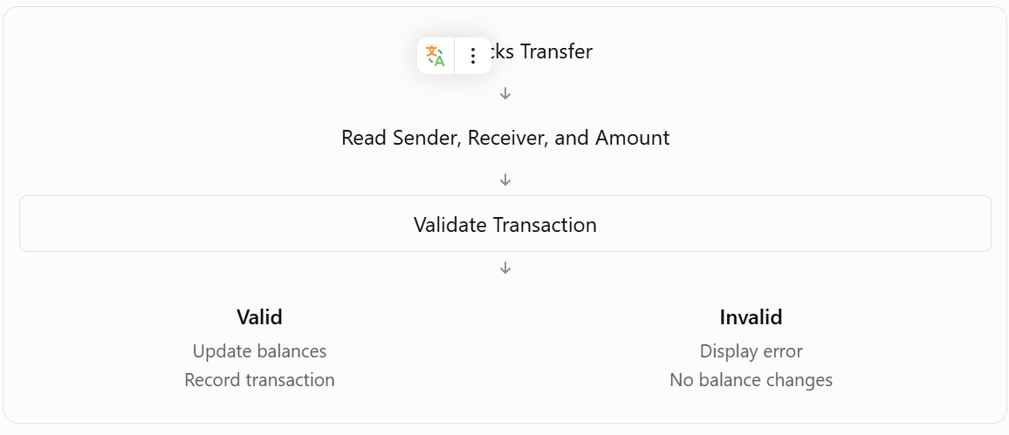

Part 5. Run the Application

Step 8. Check the File Structure
Confirm that the three files contain the correct code and are linked properly.
Project
│
├── index.html
│
└── src
├── styles.css
└── script.js
In index.html, the following lines must be present:
<link rel="stylesheet" href="./src/styles.css">
<script src="./src/script.js" defer></script>

Also verify that the buttons have the correct IDs:
<button id="transferBtn">Transfer</button>
<button id="resetBtn">Reset</button>

Step 9. Run the Program
PlayCode normally runs the application automatically.
If the Preview does not update, click the Refresh icon above the Preview panel.
The Console should display: Simple Transaction Manager is ready!

Checkpoint 3: The application should display Alice = 20, Bob = 10, Carol = 15, and Total Balance = 45 tokens.
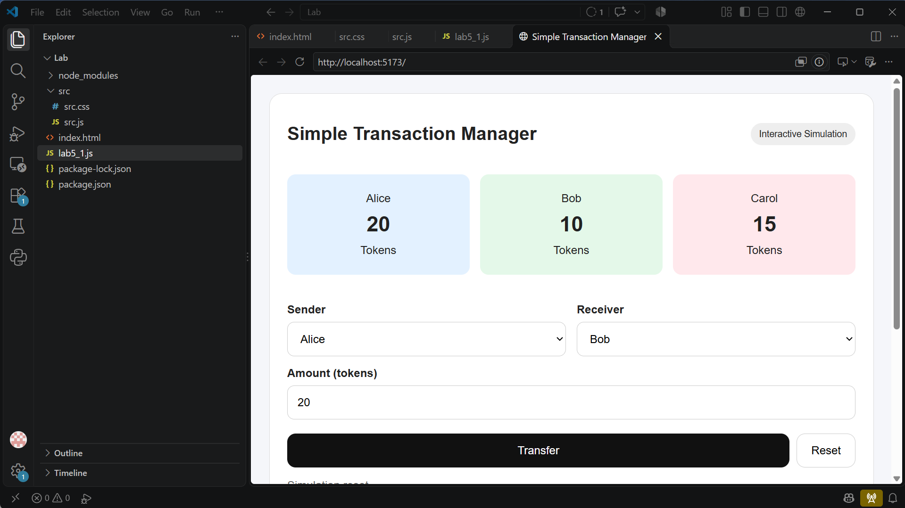

Part 6. Test the Application

Step 10. Test a Successful Transfer
Select Sender = Alice, Receiver = Bob, and Amount = 5. Click Transfer.
Expected Result:
Account | Before | After
Alice | 20 | 15
Bob | 10 | 15
Carol | 15 | 15
Total | 45 | 45
Expected message: Transfer successful! 5 tokens sent from Alice to Bob.
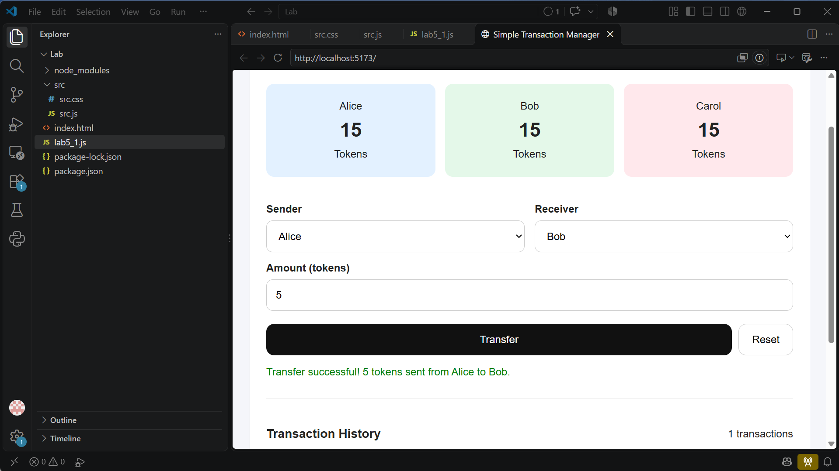

Step 11. Test Multiple Transfers
Without resetting, select Sender = Carol, Receiver = Alice, and Amount = 3. Click Transfer.
Expected Result:
Account | Balance
Alice | 18
Bob | 15
Carol | 12
Total | 45
The Transaction History should display:
Alice → Bob: 5 tokens
Carol → Alice: 3 tokens
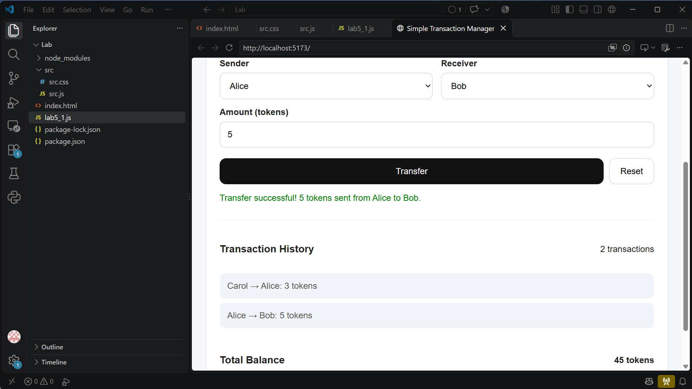

Step 12. Test Transaction Validation
Test Case | Action | Expected Result
TC01 | Alice transfers 100 tokens to Bob | Error: Insufficient balance
TC02 | Alice transfers 0 tokens to Bob | Error: Invalid amount
TC03 | Alice transfers -5 tokens to Bob | Error: Invalid amount
TC04 | Alice transfers tokens to Alice | Error: Sender and receiver must be different
TC05 | Click Reset | Original balances restored

TC01: 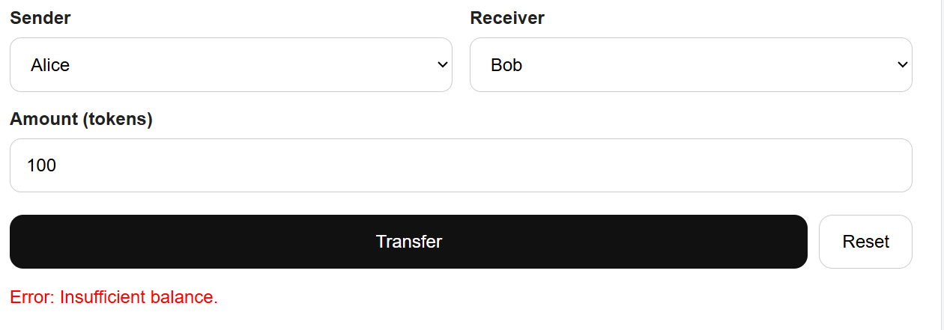
TC02
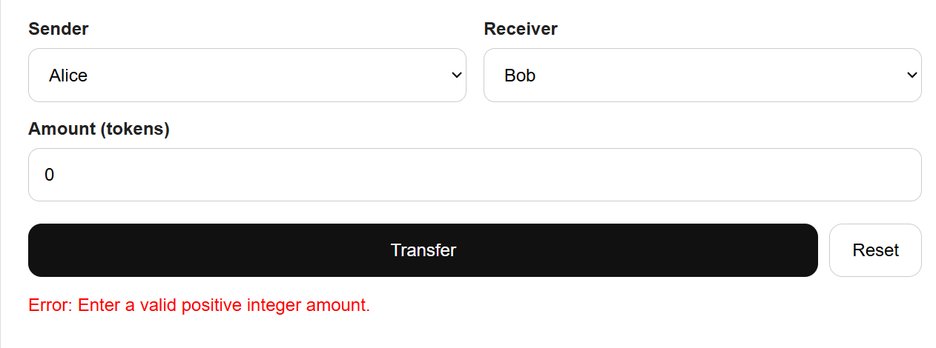
TC03
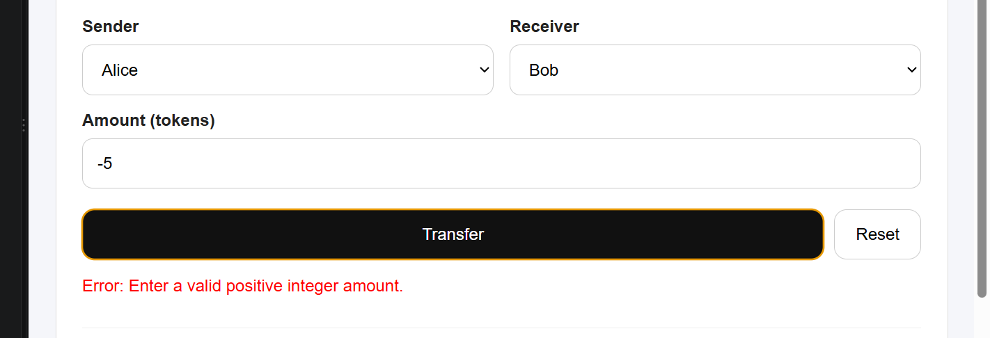
TC04
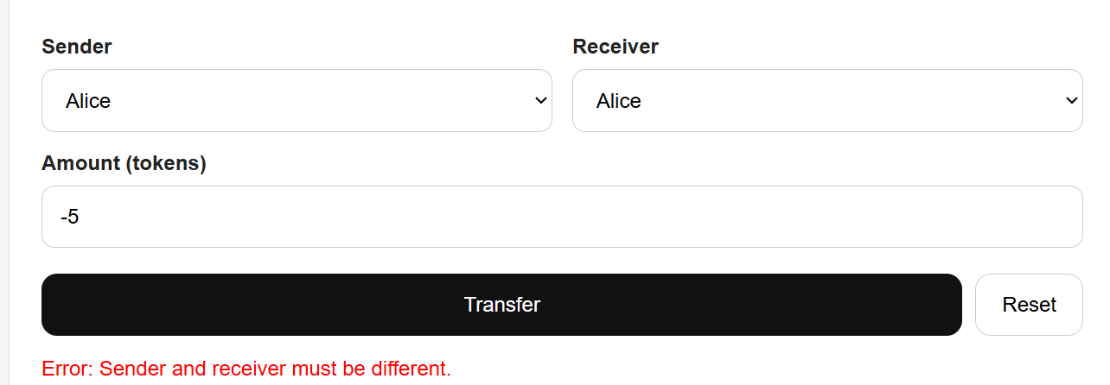
TC05
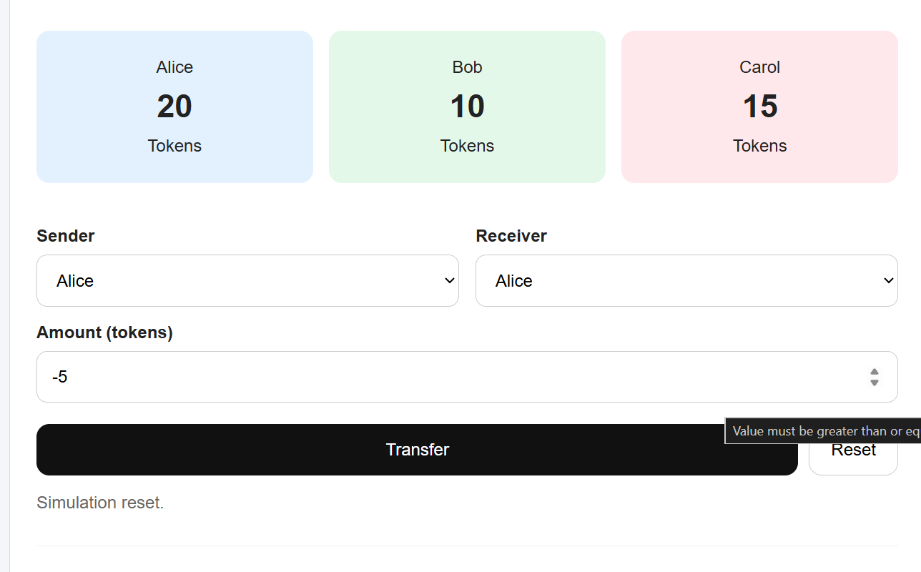

Step 13. Verify Reset
Click Reset.
The application should return to:
Alice: 20 tokens
Bob: 10 tokens
Carol: 15 tokens

Transaction History: 0 transactions
Total Balance: 45 tokens

Part 7. Student Practice
After completing the basic application, students should implement the following extensions:
- Add a fourth account named David with an initial balance of 30 tokens.
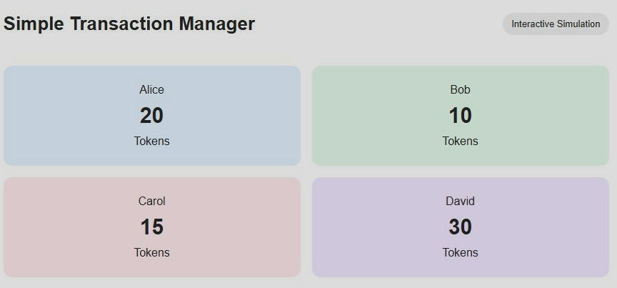

- Include David in the Sender and Receiver dropdown lists.
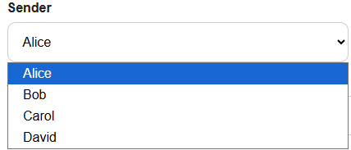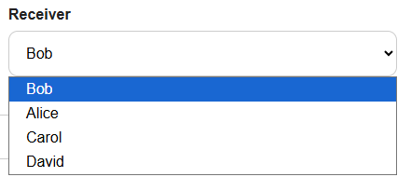
- Display David's balance on the interface.

- Update the total balance calculation to include David.
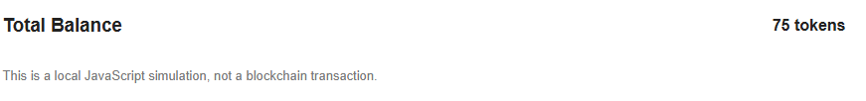
- Test transfers involving David. -> GOOD
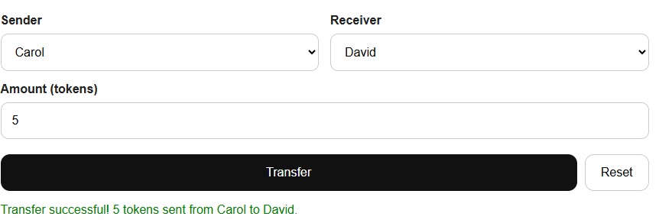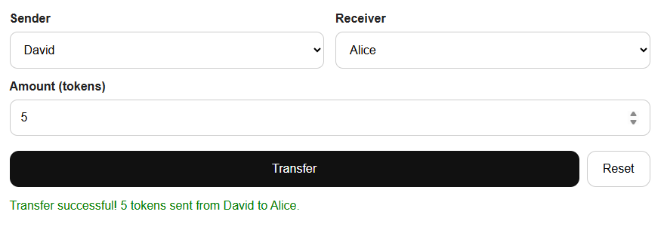
- Verify that the total balance remains unchanged after successful transfers.
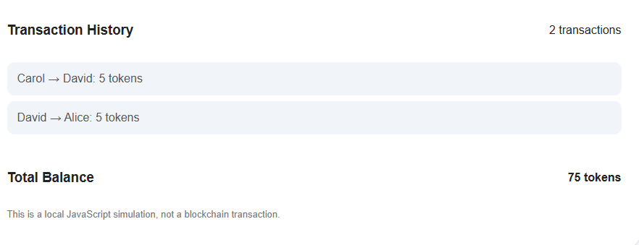
=> Tổng số dư luôn bằng 75 tokens sau các giao dịch thành công vì token chỉ chuyển giữa các tài khoản. Số token trừ ở sender bằng đúng số token cộng cho receiver. Không có token mới được tạo ra hoặc bị mất đi.

10. Lab Questions
Students should answer the following questions in their lab report:
- What is the difference between let and const?
  - let dùng để khai báo biến có thể thay đổi giá trị sau đó.
  - let dùng để khai báo biến có thể thay đổi giá trị sau đó.
- What is the difference between a function parameter and an argument?
  - Parameter là biến được khai báo trong phần định nghĩa hàm.
  - Argument là giá trị thật được truyền vào khi gọi hàm.
- How can a JavaScript object represent a blockchain account?
  - Balances thể hiện trạng thái số dư của các account
- Why are arrays useful for storing transaction records?
  - Arrays hữu ích vì có thể lưu nhiều giao dịch theo thứ tự. Nhờ array, chương trình có thể: Lưu nhiều giao dịch; Hiển thị transaction history trên giao diện; Đếm số lượng giao dịch bằng transactions.length.
- How does the transfer function update account balances?
  - Hàm transfer() lấy sender, receiver và amount từ giao diện. Sau khi validate hợp lệ, nó cập nhật số dư bằng 2 dòng:
balances[sender] -= amount;
balances[receiver] += amount;
- Why should a transaction be rejected when the sender has insufficient funds?
  - Một giao dịch phải bị từ chối khi người gửi không đủ tiền vì nếu vẫn cho chuyển, số dư của người gửi sẽ bị âm và hệ thống tài chính sẽ sai.
- What is the difference between this JavaScript simulation and a real blockchain transaction?
JavaScript simulation | Real blockchain transaction
Chạy local trên trình duyệt | Chạy trên blockchain network
Dữ liệu nằm trong biến JavaScript | Dữ liệu được ghi vào blockchain state
Không cần ví thật/private key | Cần wallet và chữ ký số
Không có gas fee | Có thể cần gas/transaction fee
Reset được dữ liệu dễ dàng | Giao dịch đã xác nhận thường không thể sửa/xóa
Không có consensus | Cần mạng blockchain validate và consensus

11. Expected Learning Outcomes
By the end of Lab 5.1, students should understand how JavaScript stores data, processes functions, manages account information, and simulates financial transactions.
Connection to the next labs: Lab 5.1 processes financial data locally in JavaScript. In later labs, React will provide the user interface, Web3.js will connect the application to Ethereum, and Solidity smart contracts will execute the on-chain financial logic.

LAB 5.2 – Asynchronous JavaScript: async/await and Error Handling

1. Lab Overview
In Lab 5.1, students practiced JavaScript variables, functions, objects, arrays, conditions, and financial transaction processing.
In Lab 5.2, students will learn how JavaScript handles operations that take time to complete. These concepts are particularly important for blockchain applications because communicating with Ethereum, waiting for wallet approval, and receiving transaction results are asynchronous operations.
Students will begin with simple console-based exercises and then build an interactive banking simulator.

2. Learning Objectives
After completing this lab, students should be able to:
- Explain synchronous and asynchronous JavaScript execution.
- Use setTimeout() to simulate delayed operations.
- Create and handle JavaScript Promises.
- Apply async and await to asynchronous functions.
- Handle errors using try, catch, and finally.
- Distinguish successful and failed asynchronous transactions.
- Develop a banking simulator that updates account balances after successful operations.

3. Lab Activities
Part | Activity | Expected Outcome
1 | Environment setup | Open PlayCode and prepare the editor
2 | Synchronous vs. asynchronous execution | Understand execution order
3 | JavaScript Promises | Simulate delayed transaction results
4 | Using async/await | Wait for asynchronous operations
5 | Error handling with try/catch/finally | Handle transaction failures
6 | Integrated Mini Project | Build an Asynchronous Banking Transaction Simulator
7 | Testing | Verify success, failure, and balance updates
8 | Student practice | Extend the simulator

Part 1. Prepare the Development Environment

Step 1. Open PlayCode
- Open your web browser.
- Visit https://playcode.io/javascript.
- Click Open the playground.
- Locate src/script.js in the file explorer.
- Open the Console panel to observe program output.
For Exercises 1–4, students only need to edit src/script.js.
PlayCode normally runs JavaScript automatically when the source code changes. Use the Refresh icon above Preview if necessary.

Step 2. Prepare a New Project
Use a separate PlayCode project for Lab 5.2, or save a copy of the Lab 5.1 project before replacing its source code.

Part 2. Exercise 1. Synchronous and Asynchronous JavaScript

Step 3. Understand Synchronous Execution
JavaScript normally executes synchronous statements in order.
Replace the code in src/script.js with:
console.log("Step 1: Start transaction");

console.log("Step 2: Process transaction");

console.log("Step 3: Transaction completed");

Expected Output:
Step 1: Start transaction
Step 2: Process transaction
Step 3: Transaction completed
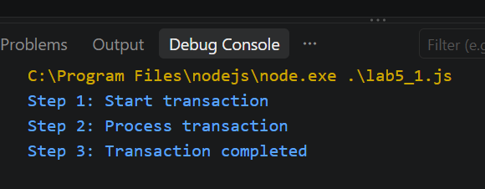
Explanation: Each statement executes before the next statement begins.

Step 4. Simulate an Asynchronous Operation
Replace the code with:
console.log("Step 1: Start transaction");

setTimeout(function() {
console.log("Step 2: Transaction completed");
}, 2000);

console.log("Step 3: Continue other operations");

Expected Output:
Step 1: Start transaction
Step 3: Continue other operations

(Approximately 2 seconds later)
Step 2: Transaction completed
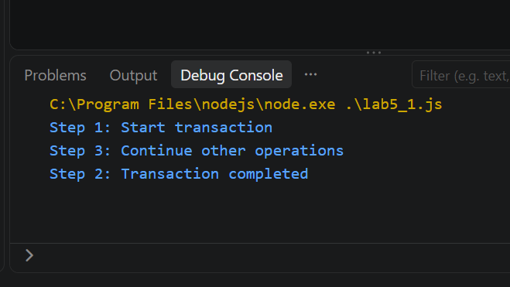
Explanation
- setTimeout() schedules a function to execute after a delay.
- 2000 represents approximately 2,000 milliseconds, or 2 seconds.
- JavaScript continues executing other statements instead of waiting for the timer callback.
Key Concept: Asynchronous programming allows an application to continue working while waiting for an operation to complete.
Student Task 1
Change the delay from 2000 to 5000 milliseconds. Run the program and explain why Step 3 appears before Step 2.
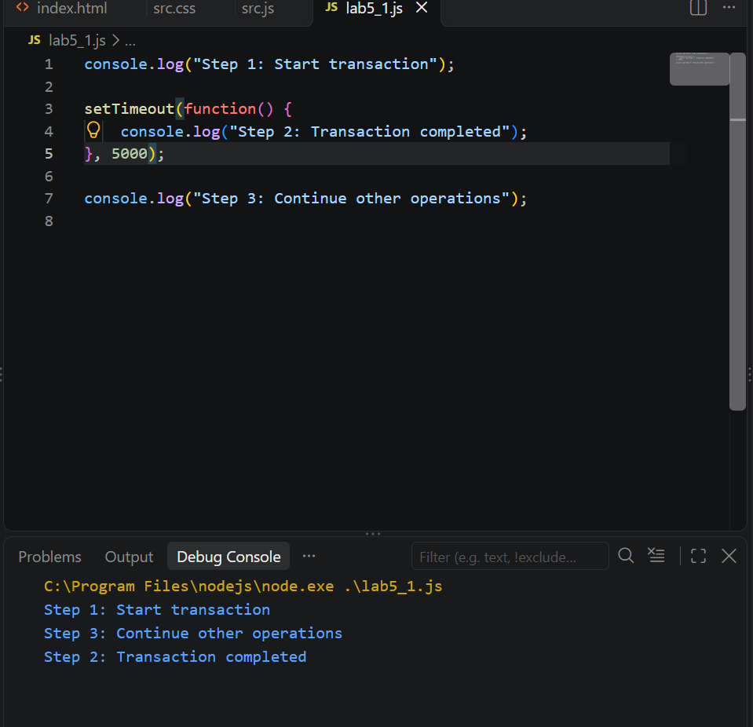
  - setTimeout() không chặn chương trình. Nó hẹn sau 5 giây mới chạy callback, còn JavaScript tiếp tục chạy dòng tiếp theo luôn.

Part 3. Exercise 2. JavaScript Promises

Step 5. Understand a Promise
A Promise represents the eventual result of an asynchronous operation.
A Promise can have three states:
State | Meaning
Pending | The operation is still in progress
Fulfilled | The operation completed successfully
Rejected | The operation failed

Step 6. Create a Promise
Replace src/script.js with:
function processDeposit(amount) {

return new Promise(function(resolve) {

setTimeout(function() {

resolve(
`Deposit of ${amount} tokens successful!`
);

}, 2000);

});
}

console.log("Starting deposit...");

processDeposit(5).then(function(result) {
console.log(result);
});

console.log("Waiting for transaction result...");

Expected Output:
Starting deposit...
Waiting for transaction result...

(Approximately 2 seconds later)
Deposit of 5 tokens successful!
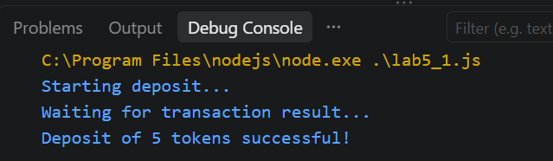
Explanation
- new Promise(...) creates a Promise.
- resolve(...) marks the operation as successful.
- .then(...) processes the successful result.
- setTimeout() simulates transaction processing time.

Step 7. Create a Rejected Promise
Replace the code with:
function processWithdrawal(balance, amount) {

return new Promise(function(resolve, reject) {

setTimeout(function() {

if (amount > balance) {
reject("Insufficient balance");
} else {
resolve(balance - amount);
}

}, 2000);

});
}

processWithdrawal(20, 30)
.then(function(newBalance) {
console.log("New Balance:", newBalance);
})
.catch(function(error) {
console.log("Transaction Failed:", error);
});

Expected Output:
Transaction Failed: Insufficient balance
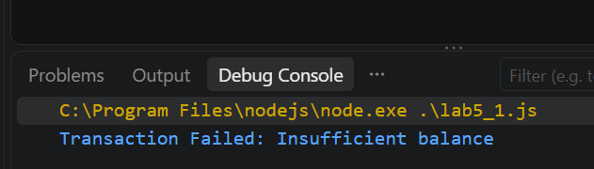
Explanation: Because the requested withdrawal exceeds the available balance, the Promise is rejected and .catch() handles the error.

Student Task 2
Change the withdrawal amount from 30 to 8.
Expected Output
New Balance: 12
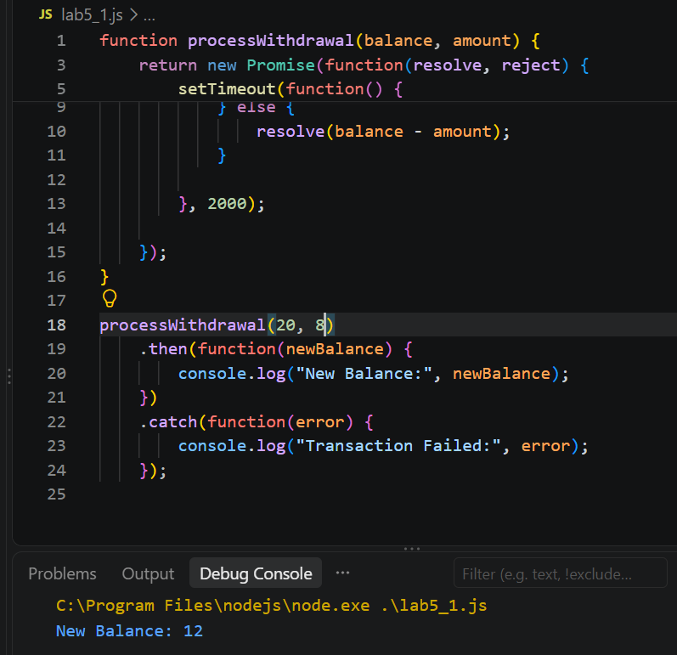

Part 4. Exercise 3. Using async/await

Step 8. Understand async and await
The async keyword declares an asynchronous function.
The await keyword waits for a Promise to settle before continuing execution within that function.

Step 9. Implement async/await
Replace src/script.js with:
function processDeposit(amount) {

return new Promise(function(resolve) {

setTimeout(function() {

resolve(
`Deposit of ${amount} tokens successful!`
);

}, 2000);

});
}

async function deposit() {

console.log("Processing deposit...");

const result = await processDeposit(5);

console.log(result);

console.log("Deposit operation finished.");
}

deposit();

Expected Output:
Processing deposit...

(Approximately 2 seconds later)
Deposit of 5 tokens successful!
Deposit operation finished.
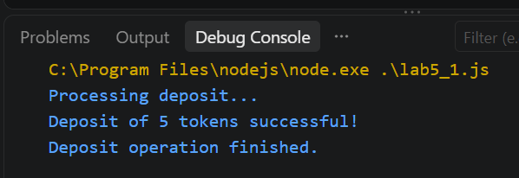
Explanation
const result = await processDeposit(5);
The deposit() function pauses at await until processDeposit(5) fulfills. Other JavaScript tasks can continue during this waiting period.

Student Task 3
Modify the program to process a deposit of 15 tokens.
Expected Output:
Processing deposit...
Deposit of 15 tokens successful!
Deposit operation finished.
The deposit result should appear after approximately 2 seconds.
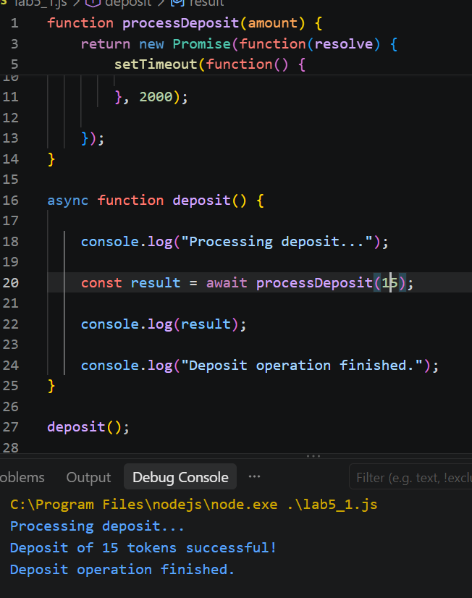

Part 5. Exercise 4. Error Handling with try/catch/finally

Step 10. Understand Error Handling
Asynchronous transactions may fail because of invalid input, insufficient funds, network problems, or user rejection.
JavaScript provides three important statements:
Statement | Purpose
try | Runs code that may fail
catch | Handles errors
finally | Runs cleanup code whether the operation succeeds or fails

Step 11. Implement try/catch/finally
Replace src/script.js with:
function processWithdrawal(balance, amount) {

return new Promise(function(resolve, reject) {

setTimeout(function() {

if (amount <= 0) {

reject(new Error("Invalid withdrawal amount"));

} else if (amount > balance) {

reject(new Error("Insufficient balance"));

} else {

resolve(balance - amount);

}

}, 2000);

});
}

async function withdraw() {

console.log("Processing withdrawal...");

try {

const newBalance =
await processWithdrawal(20, 8);

console.log("Withdrawal successful!");
console.log("New Balance:", newBalance);

} catch (error) {

console.log("Transaction Failed:", error.message);

} finally {

console.log("Transaction processing finished.");

}
}

withdraw();

Expected Output:
Processing withdrawal...

(Approximately 2 seconds later)
Withdrawal successful!
New Balance: 12
Transaction processing finished.
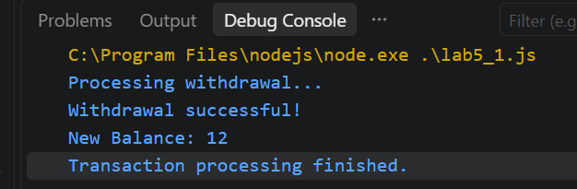

Step 12. Test Error Handling
Change: await processWithdrawal(20, 8);
to: await processWithdrawal(20, 30);
Expected Output:
Processing withdrawal...

(Approximately 2 seconds later)
Transaction Failed: Insufficient balance
Transaction processing finished.
Important: The finally block executes in both cases.
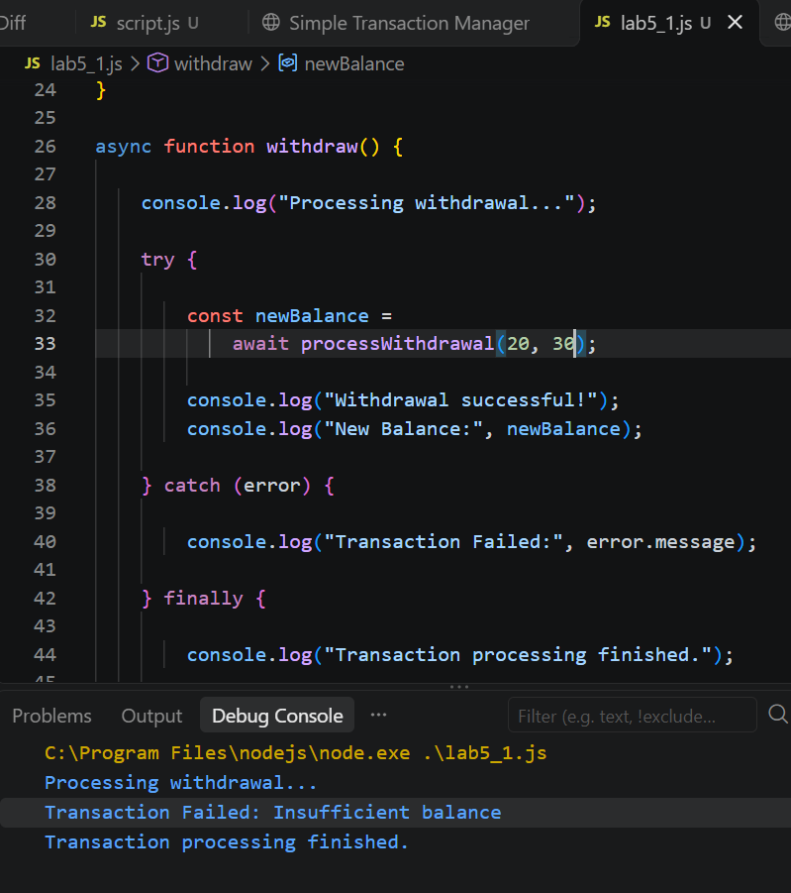

Student Task 4
Test the following withdrawal amounts:
Initial Balance | Withdrawal | Expected Result
20 | 5 | New balance = 15
20 | 20 | New balance = 0
20 | 25 | Insufficient balance
20 | -5 | Invalid withdrawal amount

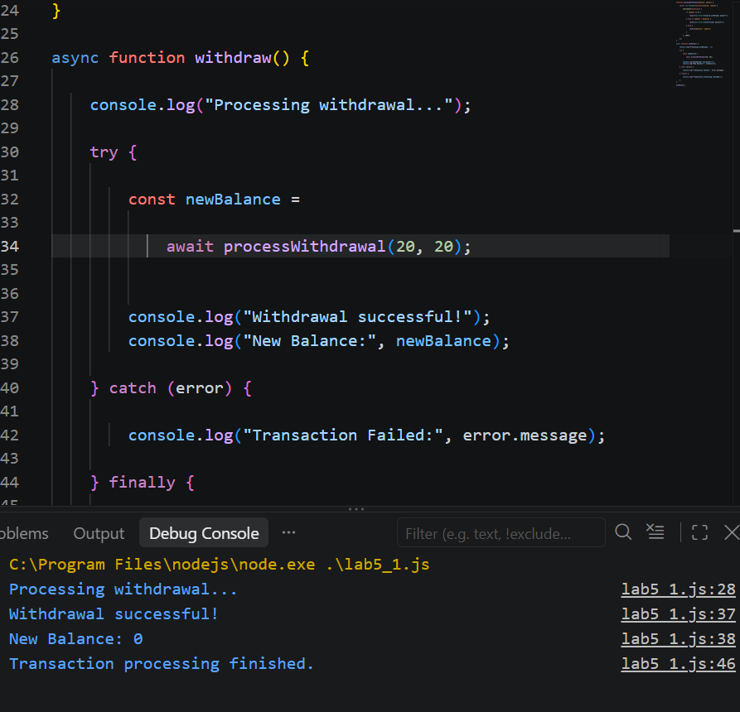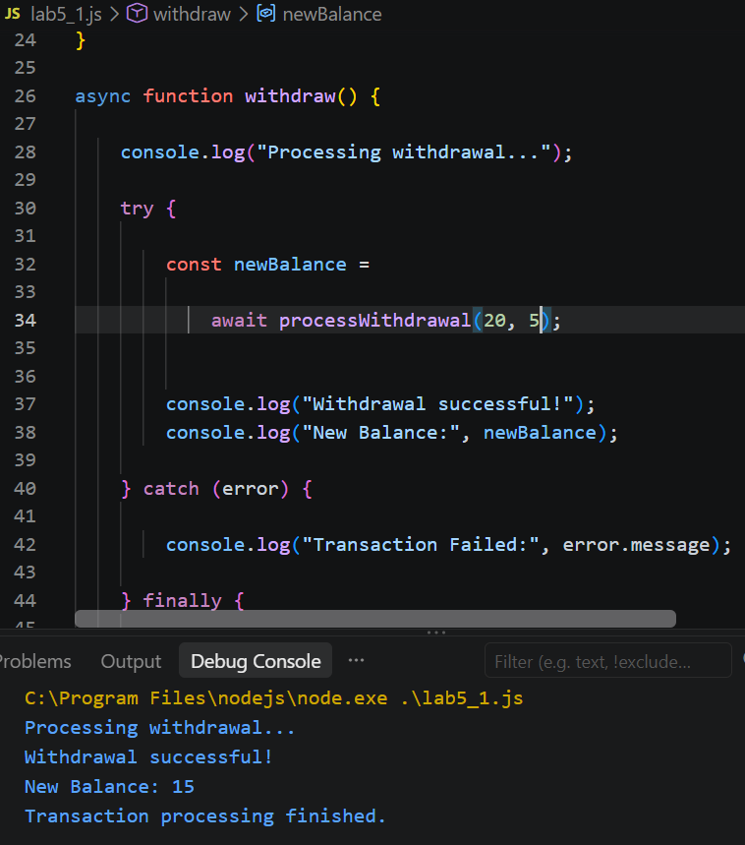
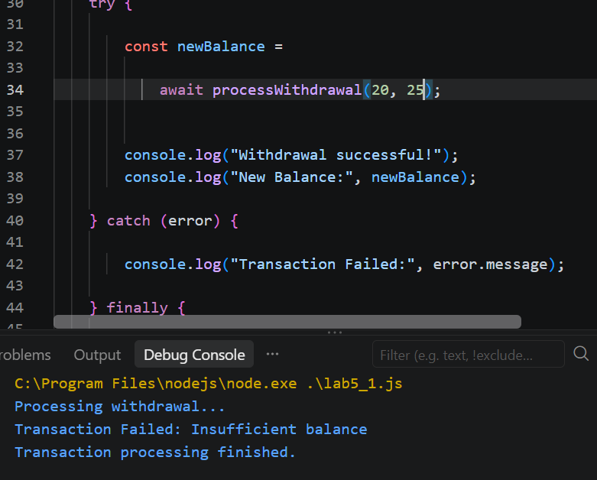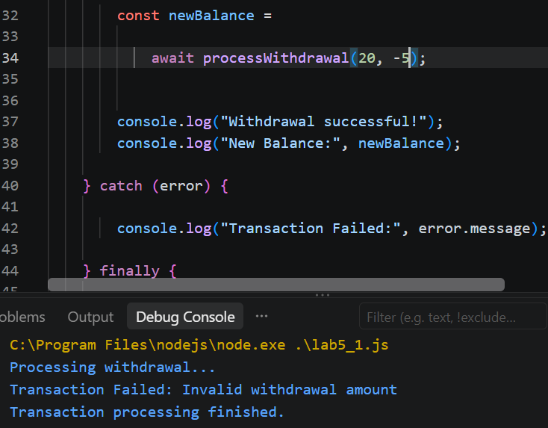

Part 6. Integrated Mini Project. Asynchronous Banking Transaction Simulator

4. Project Objective
Develop an interactive banking application that simulates delayed deposits and withdrawals.
The application must use:
- JavaScript Promises.
- async/await.
- try/catch/finally.
- Input validation.
- Asynchronous transaction processing.
- Dynamic balance updates.
- Transaction history.

5. Expected Application Interface
The application should display a current balance, an amount input field, Deposit and Withdraw buttons, transaction status, transaction history, and a Reset button.
Try the interactive example below to understand the expected behavior.

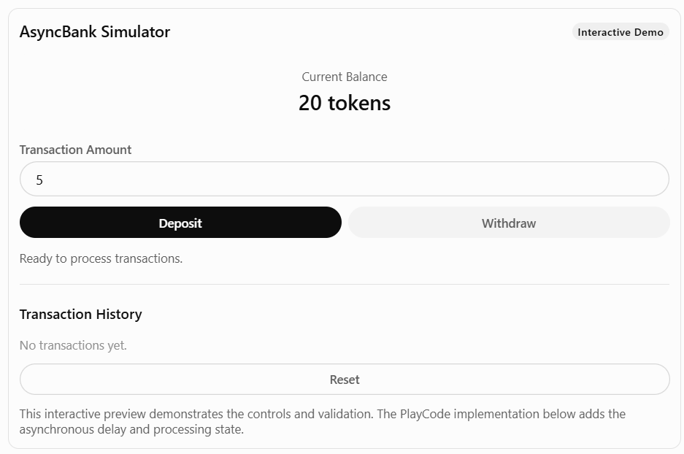

Step 13. Create the HTML Interface
Open index.html, delete the existing code, and paste:
<!DOCTYPE html>
<html lang="en">
<head>
<meta charset="UTF-8">

<meta name="viewport"
content="width=device-width, initial-scale=1.0">

<title>AsyncBank Simulator</title>

<link rel="stylesheet" href="./src/styles.css">
<script src="./src/script.js" defer></script>
</head>

<body>

<div class="container">

<header>
<h1>AsyncBank Simulator</h1>
<span class="badge">Async/Await Lab</span>
</header>

<p class="subtitle">
Simulating asynchronous banking transactions
</p>

<div class="balance-card">
<p>Current Balance</p>

<h2>
<span id="balance">20</span> tokens
</h2>
</div>

<div class="form-group">
<label for="amount">
Transaction Amount (tokens)
</label>

<input
type="number"
id="amount"
min="1"
step="1"
value="5"
>
</div>

<div class="buttons">
<button id="depositBtn">Deposit</button>
<button id="withdrawBtn">Withdraw</button>
</div>

<p id="status">
Ready to process transactions.
</p>

<hr>

<div class="history-header">
<h3>Transaction History</h3>

<span id="transactionCount">
0 transactions
</span>
</div>

<div id="history">
No transactions yet.
</div>

<button id="resetBtn">
Reset Simulation
</button>

<p class="note">
Transactions are simulated locally.
No blockchain network is used.
</p>

</div>

</body>
</html>

Step 14. Create the CSS Design
Open src/styles.css, delete the existing code, and paste:
* {
box-sizing: border-box;
}

body {
font-family: Arial, sans-serif;
background: #f5f6fa;
color: #222;
margin: 0;
padding: 25px;
}

.container {
max-width: 750px;
margin: auto;
background: white;
padding: 28px;
border: 1px solid #ddd;
border-radius: 18px;
}

header {
display: flex;
align-items: center;
justify-content: space-between;
gap: 12px;
}

h1 {
font-size: 25px;
margin: 0;
}

.badge {
background: #ede9fe;
padding: 8px 12px;
border-radius: 20px;
font-size: 13px;
}

.subtitle {
color: #666;
}

.balance-card {
background: #ede9fe;
padding: 30px;
margin: 25px 0;
border-radius: 15px;
text-align: center;
}

.balance-card h2 {
font-size: 36px;
margin: 10px 0;
}

label {
display: block;
margin-bottom: 10px;
font-weight: bold;
}

input {
width: 100%;
padding: 14px;
border: 1px solid #ccc;
border-radius: 10px;
font-size: 16px;
}

.buttons {
display: grid;
grid-template-columns: 1fr 1fr;
gap: 12px;
margin-top: 20px;
}

button {
padding: 14px;
border-radius: 10px;
border: none;
font-size: 16px;
cursor: pointer;
}

#depositBtn {
background: #2563eb;
color: white;
}

#withdrawBtn {
background: #111827;
color: white;
}

#resetBtn {
width: 100%;
margin-top: 20px;
background: white;
border: 1px solid #ccc;
}

button:disabled {
opacity: 0.5;
cursor: not-allowed;
}

#status {
min-height: 24px;
margin: 20px 0;
color: #666;
}

hr {
border: 0;
border-top: 1px solid #eee;
margin: 25px 0;
}

.history-header {
display: flex;
align-items: center;
justify-content: space-between;
gap: 12px;
}

#transactionCount {
font-size: 14px;
color: #777;
}

.transaction {
background: #f1f4f8;
padding: 12px;
margin: 8px 0;
border-radius: 10px;
}

.note {
font-size: 13px;
color: #777;
margin-top: 20px;
}

@media (max-width: 600px) {
header {
flex-direction: column;
align-items: flex-start;
}

.buttons {
grid-template-columns: 1fr;
}
}

Step 15. Implement the Complete JavaScript Logic
Open src/script.js, delete the existing code, and paste the following complete source:
/*
LAB 5.2 – Asynchronous Banking Transaction Simulator
Topics: Promises, async/await, try/catch/finally
*/

// STEP 1. Application state

const initialBalance = 20;
const processingDelay = 2000;

let balance = initialBalance;
let transactions = [];
let isProcessing = false;

// STEP 2. Update the interface

function updateDisplay() {

document.getElementById("balance").textContent =
balance;

document.getElementById("transactionCount").textContent =
transactions.length + " transactions";
}

// STEP 3. Display status messages

function showStatus(message, color = "#666") {

const status =
document.getElementById("status");

status.textContent = message;
status.style.color = color;
}

// STEP 4. Enable or disable controls

function setProcessing(processing) {

isProcessing = processing;

document.getElementById("depositBtn").disabled =
processing;

document.getElementById("withdrawBtn").disabled =
processing;

document.getElementById("resetBtn").disabled =
processing;

document.getElementById("amount").disabled =
processing;
}

// STEP 5. Validate user input

function getValidAmount() {

const amountText =
document.getElementById("amount").value;

const amount = Number(amountText);

if (
amountText.trim() === "" ||
!Number.isSafeInteger(amount) ||
amount <= 0
) {

throw new Error(
"Enter a valid positive integer amount."
);
}

return amount;
}

// STEP 6. Simulate an asynchronous transaction

function simulateTransaction(type, amount) {

return new Promise(function(resolve, reject) {

setTimeout(function() {

if (type === "Withdraw" && amount > balance) {

reject(
new Error("Insufficient balance.")
);

return;
}

if (
type === "Deposit" &&
!Number.isSafeInteger(balance + amount)
) {

reject(
new Error("Balance exceeds the supported range.")
);

return;
}

resolve({
type: type,
amount: amount,
success: true
});

}, processingDelay);

});
}

// STEP 7. Process deposits asynchronously

async function deposit() {

if (isProcessing) {
return;
}

try {

const amount = getValidAmount();

setProcessing(true);

showStatus(
"Processing deposit... Please wait.",
"#2563eb"
);

const result =
await simulateTransaction("Deposit", amount);

balance += result.amount;

transactions.push({
type: "Deposit",
amount: result.amount,
balance: balance
});

showStatus(
`Deposit successful! Added ${result.amount} tokens.`,
"green"
);

updateDisplay();
showHistory();

console.log("Deposit completed:", result);

} catch (error) {

showStatus(
"Transaction Failed: " + error.message,
"red"
);

console.error(error.message);

} finally {

setProcessing(false);

console.log("Deposit processing finished.");

}
}

// STEP 8. Process withdrawals asynchronously

async function withdraw() {

if (isProcessing) {
return;
}

try {

const amount = getValidAmount();

setProcessing(true);

showStatus(
"Processing withdrawal... Please wait.",
"#2563eb"
);

const result =
await simulateTransaction("Withdraw", amount);

balance -= result.amount;

transactions.push({
type: "Withdrawal",
amount: result.amount,
balance: balance
});

showStatus(
`Withdrawal successful! Removed ${result.amount} tokens.`,
"green"
);

updateDisplay();
showHistory();

console.log("Withdrawal completed:", result);

} catch (error) {

showStatus(
"Transaction Failed: " + error.message,
"red"
);

console.error(error.message);

} finally {

setProcessing(false);

console.log("Withdrawal processing finished.");

}
}

// STEP 9. Display transaction history

function showHistory() {

const history =
document.getElementById("history");

history.innerHTML = "";

transactions.forEach(function(tx, index) {

const item =
document.createElement("div");

item.className = "transaction";

const sign =
tx.type === "Deposit" ? "+" : "-";

item.textContent =
`${index + 1}. ${tx.type}: ${sign}${tx.amount} tokens | Balance: ${tx.balance}`;

history.appendChild(item);
});
}

// STEP 10. Reset the simulation

function reset() {

if (isProcessing) {
return;
}

balance = initialBalance;
transactions = [];

document.getElementById("amount").value = 5;

document.getElementById("history").textContent =
"No transactions yet.";

showStatus("Simulation reset.");

updateDisplay();

console.log("Simulation reset.");
}

// STEP 11. Initialize the application

function initializeApp() {

const depositButton =
document.getElementById("depositBtn");

const withdrawButton =
document.getElementById("withdrawBtn");

const resetButton =
document.getElementById("resetBtn");

if (
!depositButton ||
!withdrawButton ||
!resetButton
) {

console.error(
"Required buttons not found. Check index.html."
);

return;
}

depositButton.addEventListener("click", deposit);

withdrawButton.addEventListener("click", withdraw);

resetButton.addEventListener("click", reset);

updateDisplay();

console.log("AsyncBank Simulator is ready!");
}

// STEP 12. Wait until HTML is ready

if (document.readyState === "loading") {

document.addEventListener(
"DOMContentLoaded",
initializeApp
);

} else {

initializeApp();

}

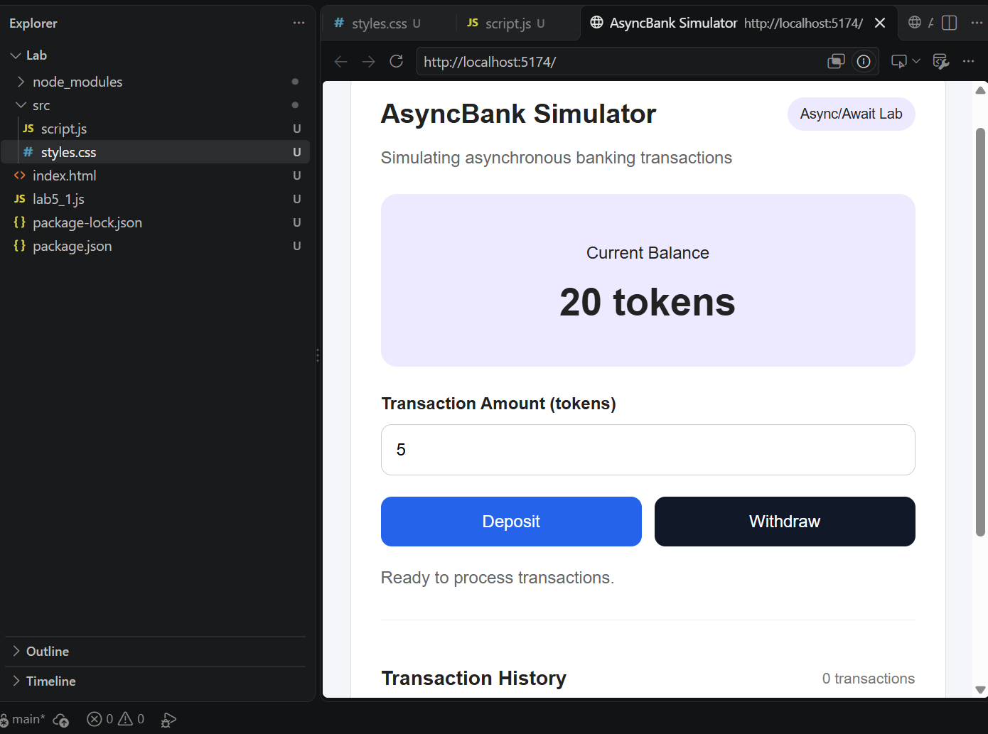

Step 16. Understand the Asynchronous Transaction Flow
User enters an amount
↓
User clicks Deposit or Withdraw
↓
Input validation
↓
Status: Processing...
↓
simulateTransaction()
↓
Promise pending for ~2 seconds
↓
Promise settles
/ \
Fulfilled Rejected
↓ ↓
Update catch(error)
Balance ↓
↓ Show Error
Save History
↓
Show Success
\ /
finally
↓
Enable Buttons
Important: The balance is updated only after the simulated Promise fulfills successfully. While the Promise is pending, the buttons and amount input are disabled to prevent overlapping transactions.

Part 7. Test the Integrated Application

Step 17. Run the Application
- Open the Preview panel.
- Refresh the application if necessary.
- Confirm that the initial balance is 20 tokens.
- Open the Console.
Expected Console Output
AsyncBank Simulator is ready!
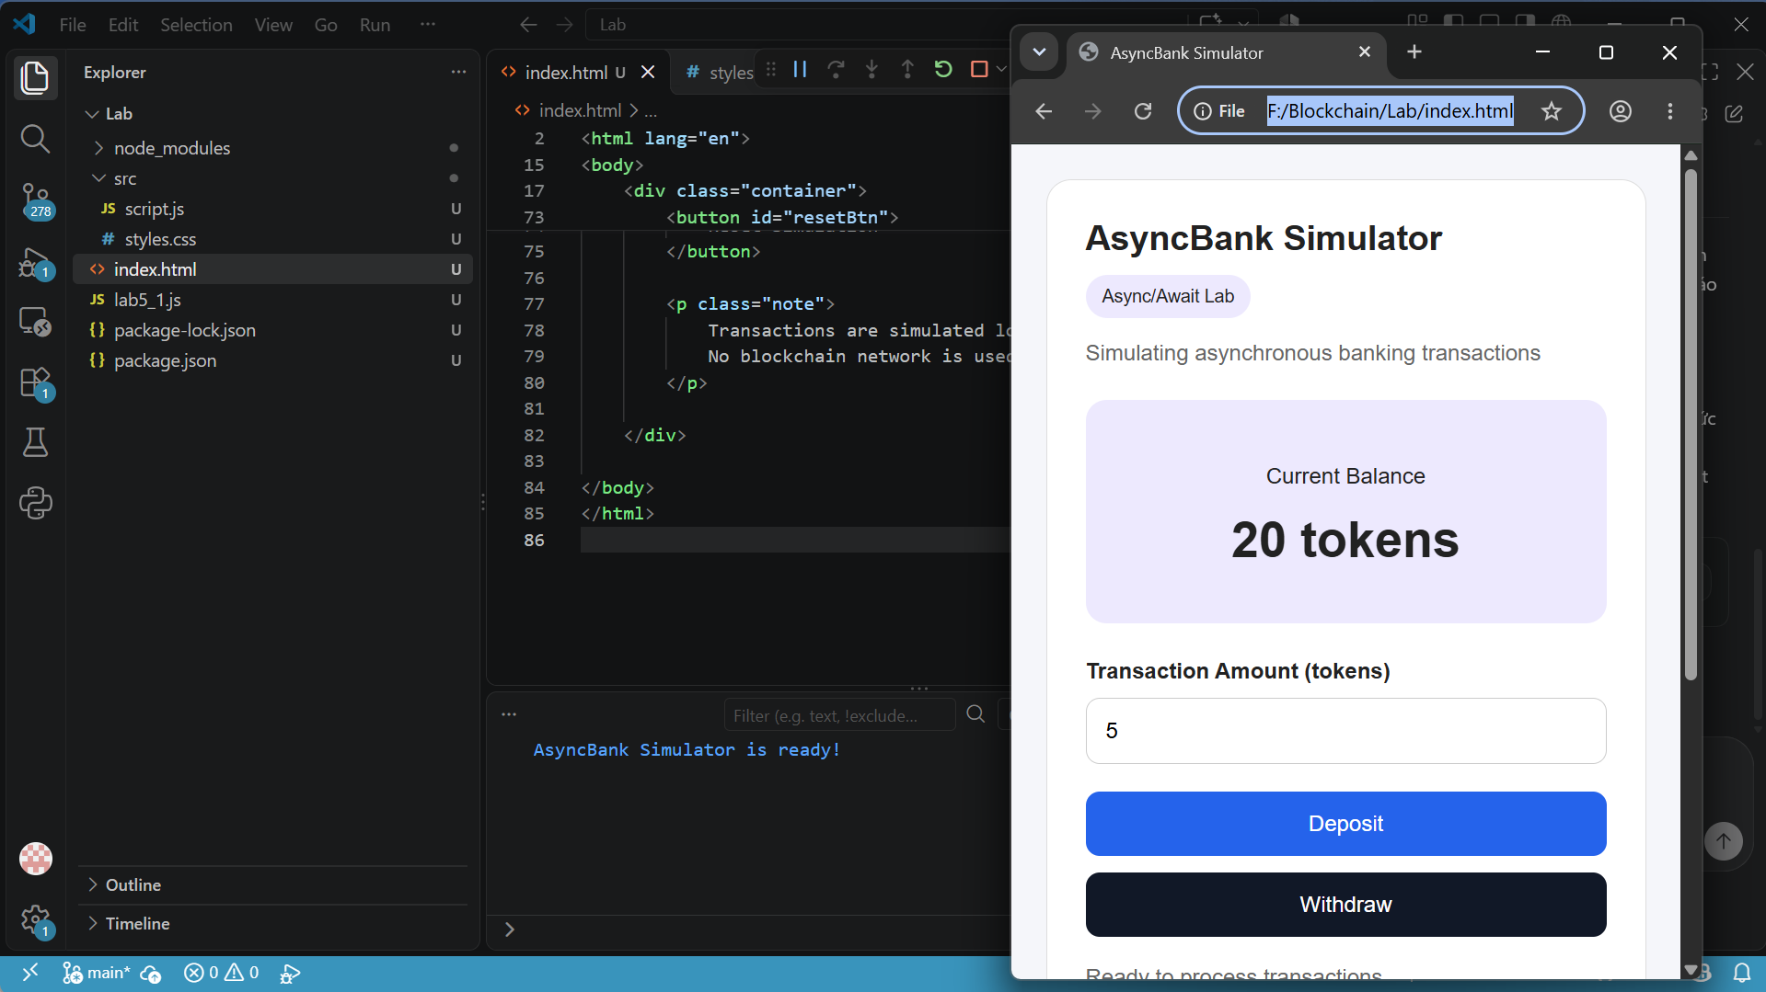

Step 18. Test Successful Transactions
Perform the following tests sequentially, without resetting between TC01 and TC03.
Test Case | Action | Expected Balance | Expected Status
TC01 | Deposit 5 tokens | 25 | Deposit successful
TC02 | Withdraw 8 tokens | 17 | Withdrawal successful
TC03 | Deposit 10 tokens | 27 | Deposit successful
Each transaction should display a processing message for approximately 2 seconds before the balance changes.
Expected Transaction History
1. Deposit: +5 tokens | Balance: 25
2. Withdrawal: -8 tokens | Balance: 17
3. Deposit: +10 tokens | Balance: 27
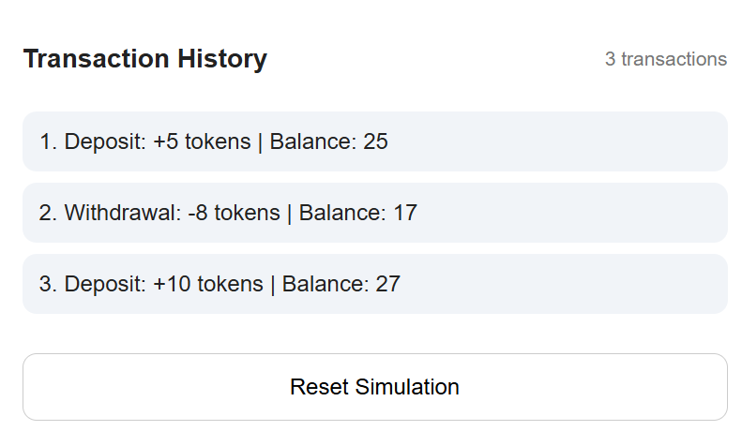

Step 19. Test Failed Transactions
Continue from the balance of 27 tokens.
Test Case | Action | Expected Result
TC04 | Withdraw 100 tokens | Insufficient balance
TC05 | Deposit 0 tokens | Invalid amount
TC06 | Withdraw -5 tokens | Invalid amount
TC07 | Deposit 2.5 tokens | Invalid amount
TC08 | Click Reset | Balance returns to 20
Failed transactions must not change the balance or appear in the transaction history.
TC04
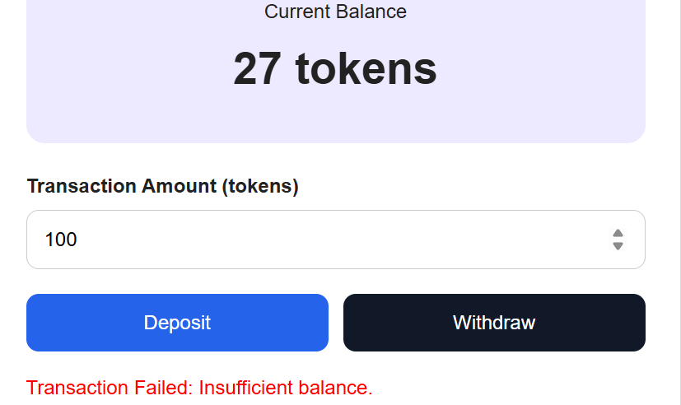
TC05
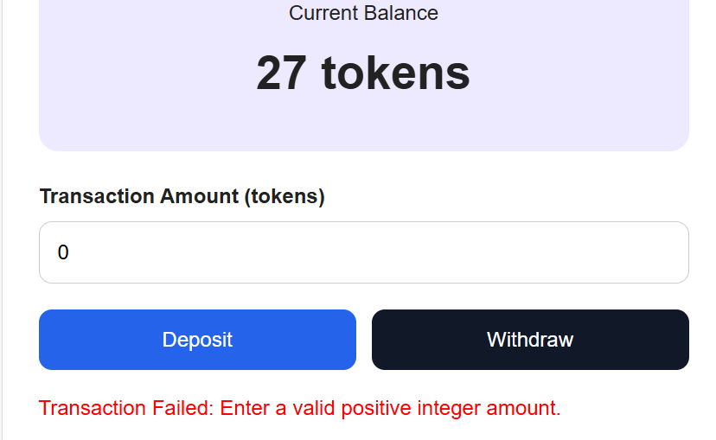
TC06
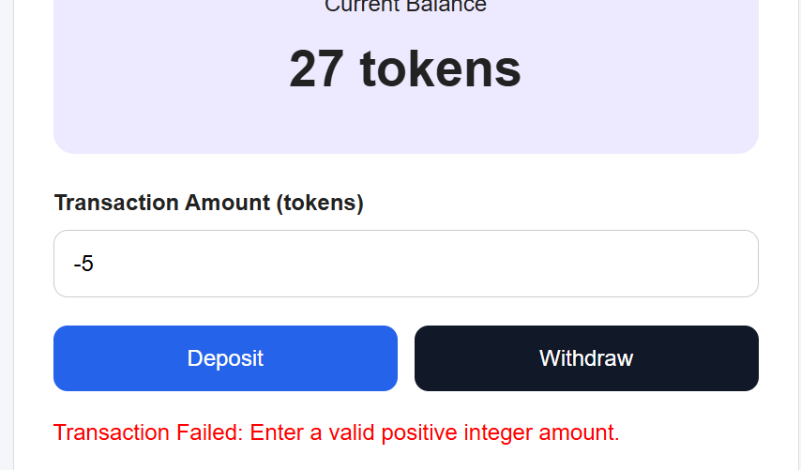
TC07
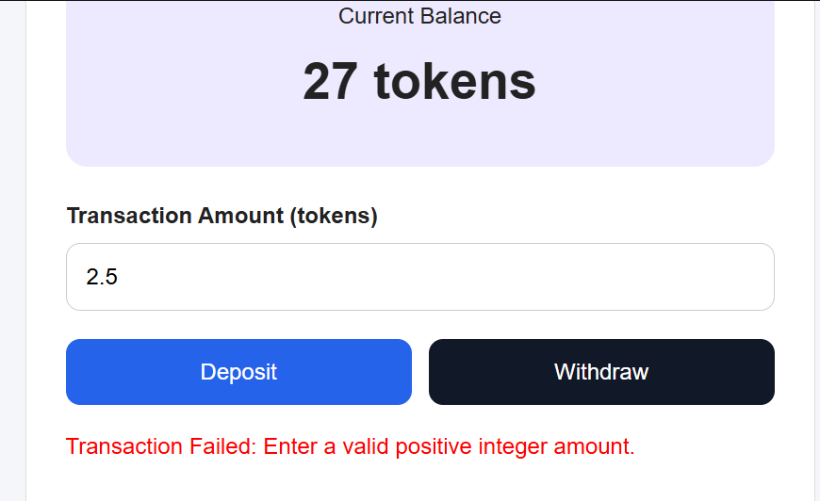
TC08
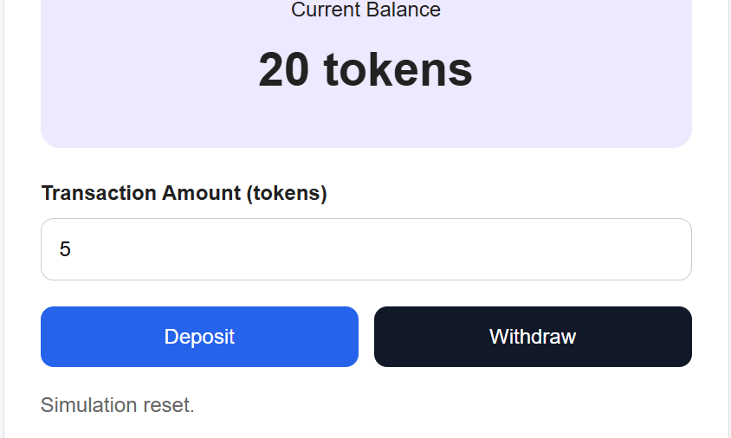

Step 20. Verify the Processing State
- Enter 5 in the Amount field.
- Click Deposit.
- Immediately observe the interface.
- Confirm that the status displays Processing deposit... Please wait.
- Confirm that the action buttons are temporarily disabled.
- After approximately 2 seconds, verify that the balance increases.

Part 8. Student Practice
After completing the integrated simulator, students should implement the following extensions.

Exercise 1. Change the Processing Delay
Change: const processingDelay = 2000;
to: const processingDelay = 5000;
Observe the processing message and explain the effect of the delay.
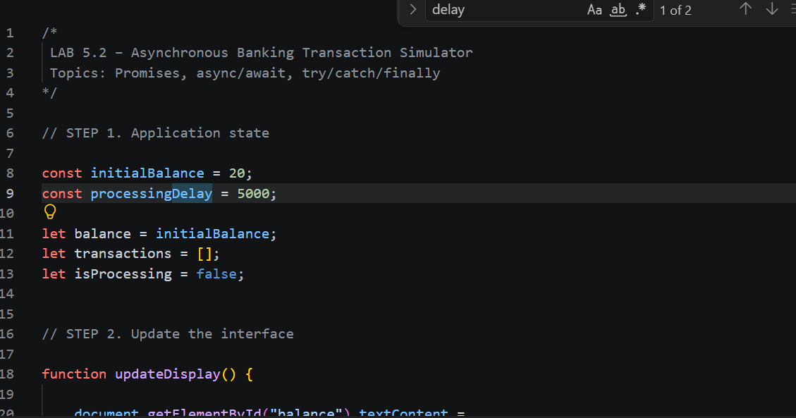

Exercise 2. Add a Maximum Withdrawal Limit
Modify the withdrawal logic to reject withdrawals greater than 50 tokens, even when the account has sufficient funds.

Exercise 3. Simulate Network Errors
Modify simulateTransaction() to support a simulated network failure:
if (Math.random() < 0.2) {
reject(new Error("Simulated network error."));
return;
}
Place this check inside the setTimeout() callback, before the success validation.
Expected Behavior: Some transactions fail with a network error. The balance and transaction history must remain unchanged for failed transactions.
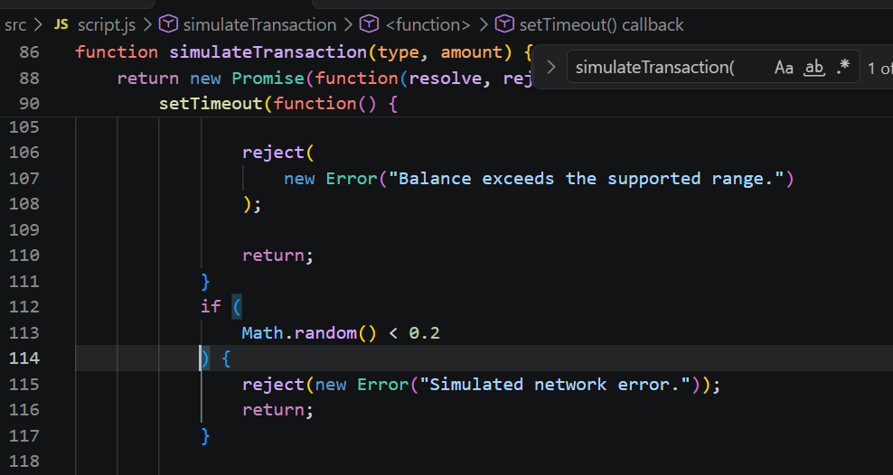

Exercise 4. Add a Transaction Processing Counter
Display the total number of attempted transactions, including successful and failed transactions.
  - Sửa trên file script.js -> thêm totalAttemp =0 -> chỉnh updateDisplay -> Deposit -> transtraction history
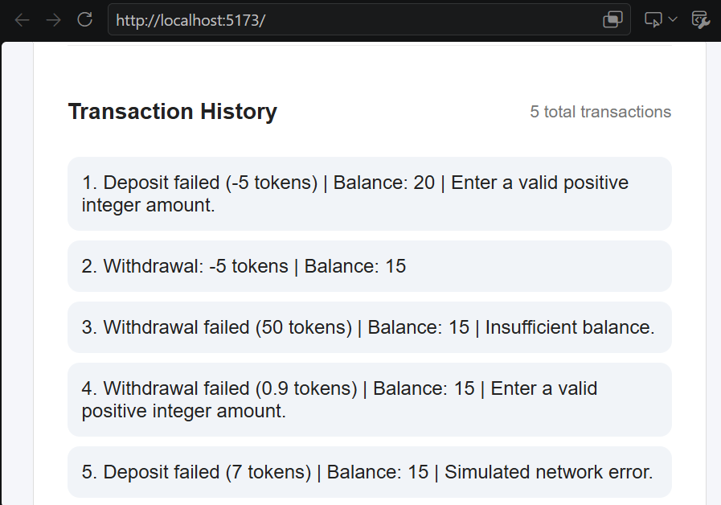

Exercise 5. Add a Retry Feature
Allow the user to retry a failed transaction. The application must not duplicate a transaction that has already succeeded.

Part 9. Lab Report Questions
- What is asynchronous programming in JavaScript?
  - Lập trình bất đồng bộ cho phép JavaScript thực hiện các thao tác tốn nhiều thời gian mà không làm gián đoạn phần còn lại của chương trình. Các tác vụ khác có thể tiếp tục trong khi chờ đợi thao tác hoàn tất.
- What is the difference between synchronous and asynchronous execution?
  - Đồng bộ: Các tác vụ được thực hiện lần lượt theo thứ tự. Mỗi tác vụ phải hoàn tất trước khi tác vụ tiếp theo bắt đầu.
  - Bất đồng bộ: JavaScript có thể tiếp tục thực hiện các tác vụ khác trong khi chờ một thao tác (chẳng hạn như bộ đếm thời gian hoặc giao dịch) hoàn tất.
- What is a Promise?
  - Promise là một đối tượng JavaScript đại diện cho kết quả thành công hoặc thất bại trong tương lai của một thao tác bất đồng bộ.
- What are the three states of a Promise?
  - Đang chờ xử lý: Thao tác vẫn đang được thực hiện.
  - Đã hoàn tất: Thao tác đã hoàn tất thành công.
  - Bị từ chối: Thao tác đã thất bại.
- What is the purpose of resolve() and reject()?
  - resolve() cho biết thao tác bất đồng bộ đã hoàn tất thành công và cung cấp kết quả của nó.
  - reject() cho biết thao tác đã thất bại và cung cấp lỗi hoặc lý do dẫn đến thất bại đó.
- What does the async keyword do?
  - Từ khóa `async` dùng để khai báo một hàm bất đồng bộ. Nó cho phép sử dụng `await` bên trong hàm và khiến hàm đó trả về một `Promise`.
- What happens when JavaScript encounters await?
  - Khi JavaScript gặp từ khóa `await`, nó sẽ tạm dừng việc thực thi bên trong hàm bất đồng bộ hiện tại cho đến khi `Promise` được giải quyết (settle). Các tác vụ JavaScript khác vẫn có thể tiếp tục chạy trong khoảng thời gian này.
- How do try, catch, and finally work?
  - try: Thực thi đoạn mã có thể gây ra lỗi.
  - catch: Xử lý các lỗi phát sinh trong quá trình thực thi.
  - finally: Thực thi đoạn mã bất kể thao tác thành công hay thất bại.
- Why does the simulator disable buttons during transaction processing?
  - Trình mô phỏng vô hiệu hóa các nút bấm để ngăn người dùng gửi nhiều giao dịch trong khi một giao dịch khác đang được xử lý. Điều này giúp tránh tình trạng giao dịch trùng lặp, cập nhật số dư không chính xác và trạng thái ứng dụng không nhất quán.
- Why should balances only be updated after successful transaction processing?
  - Số dư chỉ nên được cập nhật sau khi giao dịch thành công để đảm bảo tính chính xác của hồ sơ tài chính. Nếu giao dịch thất bại do không đủ số dư hoặc dữ liệu đầu vào không hợp lệ, số dư ban đầu phải được giữ nguyên.
- How is the simulated transaction delay related to blockchain transactions?
  - Độ trễ được mô phỏng đại diện cho thời gian chờ đợi trong các giao dịch blockchain thực tế, chẳng hạn như quá trình giao tiếp mạng, xác thực giao dịch và xác nhận khối. Trình mô phỏng sử dụng hàm `setTimeout()` để tái tạo độ trễ này mà không cần kết nối với một blockchain thực tế.
- How would async/await be used when calling a Solidity smart contract through Web3.js?
  - async/await cho phép JavaScript chờ kết quả của một tương tác với hợp đồng thông minh. Ví dụ, `await` có thể được sử dụng khi gửi giao dịch hoặc đọc dữ liệu hợp đồng thông qua Web3.js.

LAB 5.3 – React Components

1. Lab Overview
In Lab 5.1, students practiced JavaScript fundamentals by developing a Simple Transaction Manager.
In Lab 5.2, students learned asynchronous JavaScript using Promises, async/await, and error handling.
In Lab 5.3, students will learn how to build user interfaces using React components. React allows developers to divide a complex application into smaller, reusable components.
Students will build a React Banking Dashboard that displays account balances, processes simulated token transfers, and maintains transaction history.
The application will run locally in the browser. It will not connect to an Ethereum blockchain or a smart contract.

2. Learning Objectives
By the end of this lab, students should be able to:
- Explain the purpose of React components.
- Write functional components using JSX.
- Pass data between components using props.
- Manage application data using the useState Hook.
- Handle user interactions in React.
- Render dynamic lists using the map() method.
- Build an interactive banking dashboard using reusable React components.

3. Lab Activities
Part | Activity | Expected Outcome
1 | React environment setup | Run a React application in PlayCode
2 | Creating React components | Build reusable UI components
3 | Working with props | Pass account data to components
4 | Managing state with useState | Update displayed balances
5 | Event handling | Respond to button clicks
6 | Rendering lists | Display transaction history
7 | Integrated Mini Project | Build a React Banking Dashboard
8 | Testing | Verify transfers and balance updates
9 | Student Practice | Extend the dashboard
10 | Lab Submission | Submit code and screenshots
Part 1. Prepare the React Development Environment

Step 1. Open PlayCode React
- Open https://playcode.io/react.
- Start a new React project.
- Locate the file explorer on the left.
- Open the React source files.
- Locate the Preview and Console panels.
Important: Lab 5.3 uses the React editor, not the JavaScript-only editor used in Labs 5.1 and 5.2.
For the exercises below, use the following project structure:

React Banking Dashboard
│
├── index.html
│
└── src
├── App.jsx
├── main.jsx
└── styles.css
If PlayCode creates additional files, they may remain in the project. Create or rename the files above as needed, and ensure that index.html loads src/main.jsx.

Step 2. Understand the React Application Structure
File | Purpose
index.html | Provides the HTML root element
src/main.jsx | Starts the React application
src/App.jsx | Contains React components and application logic
src/styles.css | Defines the application appearance
React uses a root element to display the application.
Open index.html and enter:
<!DOCTYPE html>
<html lang="en">
<head>
<meta charset="UTF-8">

<meta name="viewport"
content="width=device-width, initial-scale=1.0">

<title>React Banking Dashboard</title>
</head>

<body>
<div id="root"></div>

<script type="module" src="/src/main.jsx"></script>
</body>
</html>

Open src/main.jsx and enter:
import React from "react";
import { createRoot } from "react-dom/client";

import App from "./App.jsx";
import "./styles.css";

createRoot(document.getElementById("root")).render(
<React.StrictMode>
<App />
</React.StrictMode>
);

Checkpoint 1: The project should be ready to render the App component. The next step will create that component.
Part 2. Exercise 1. Creating React Components

Step 3. Understand a React Component
A React component is a reusable part of a user interface.
For example, a banking dashboard can contain:
- Header component.
- Account card component.
- Transfer form component.
- Transaction history component.
Each component is responsible for displaying a specific part of the application.

Step 4. Create Your First Component
Open src/App.jsx, delete the existing code, and paste:
function Welcome() {
return (
<div>
<h1>React Banking Dashboard</h1>
<p>Welcome to React Components!</p>
</div>
);
}

export default function App() {
return <Welcome />;
}

Expected Output
React Banking Dashboard

Welcome to React Components!
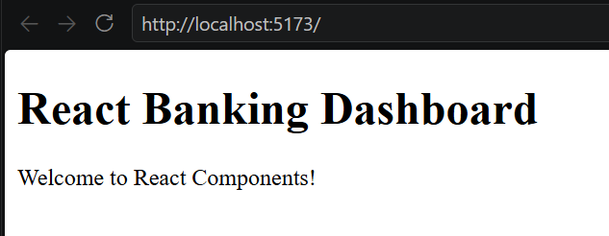

Explanation
Code | Purpose
function Welcome() | Defines a React component
return (...) | Specifies the interface to display
<Welcome /> | Uses the component
export default | Makes the App component available to other files
React component names should begin with an uppercase letter.

Student Task 1
Create a new component called CourseInfo that displays:
INS3278 – Blockchain for Financial Projects
Week 5 – React Components
Display it below the Welcome component.
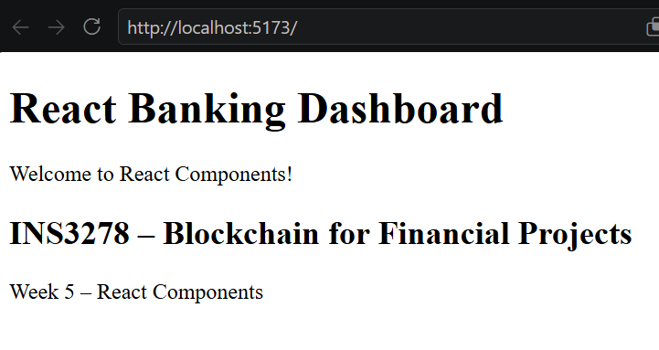
Part 3. Exercise 2. JSX and Props

Step 5. Understand JSX
JSX allows developers to write HTML-like markup inside JavaScript.
Example:
function AccountCard() {
return (
<div>
<h3>Alice</h3>
<h2>20 Tokens</h2>
</div>
);
}
The component displays Alice's account information.
However, a banking application usually contains multiple accounts. Creating separate components for every account would duplicate code.
React solves this problem using props.

Step 6. Create a Reusable Component with Props
Replace src/App.jsx with:
function AccountCard({ name, balance }) {

return (
<div className="account-card">
<h3>{name}</h3>
<h2>{balance} Tokens</h2>
</div>
);
}

export default function App() {

return (
<div>
<h1>React Banking Dashboard</h1>

<AccountCard name="Alice" balance={20} />
<AccountCard name="Bob" balance={10} />
<AccountCard name="Carol" balance={15} />
<AccountCard name="David" balance={30} />
</div>
);
}

Expected Output
React Banking Dashboard

Alice
20 Tokens

Bob
10 Tokens

Carol
15 Tokens

David
30 Tokens
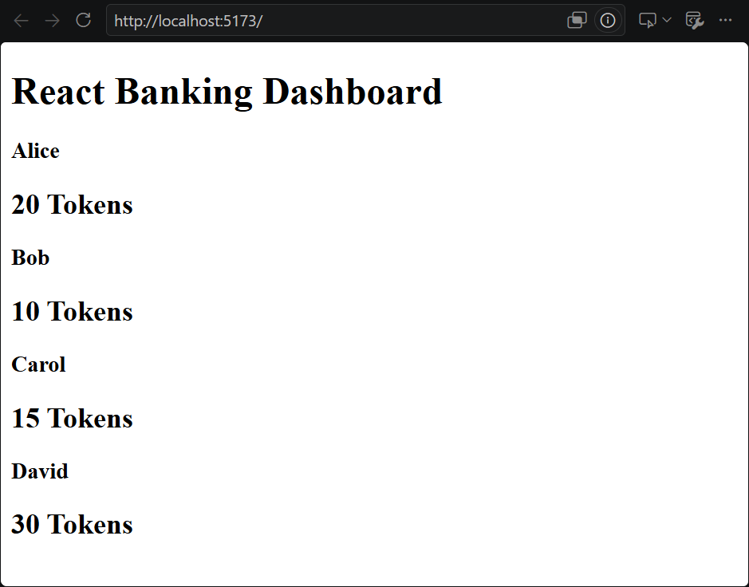

Explanation:
AccountCard is a reusable component.
The properties:
name="Alice"
balance={20}
are passed from the parent component to the child component.
Inside the component:
function AccountCard({ name, balance })
React receives these values through props.
Important: Props are read-only. A child component should not directly modify its props.

Student Task 2
Add a fifth account:
Emma
25 Tokens
Use the existing AccountCard component without creating a new component.
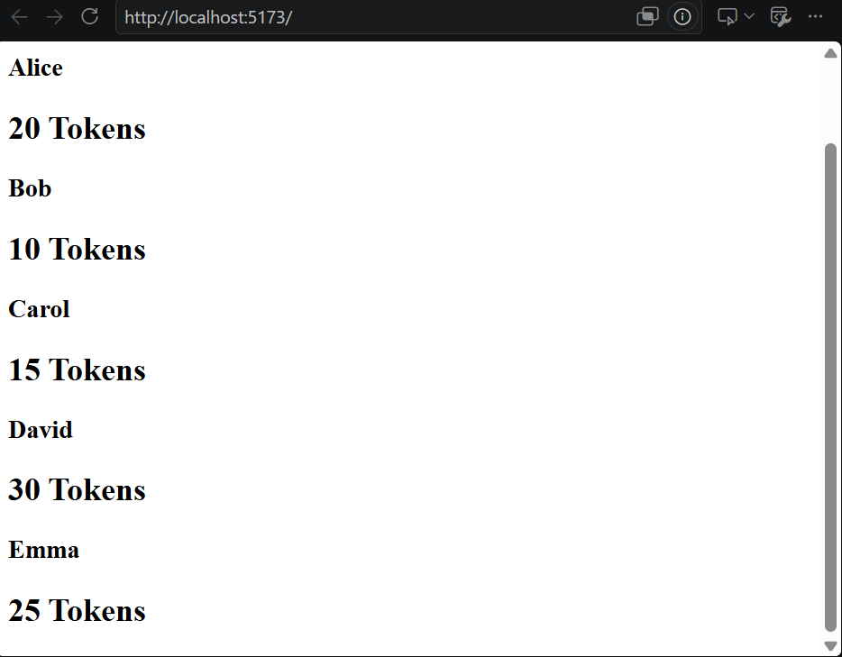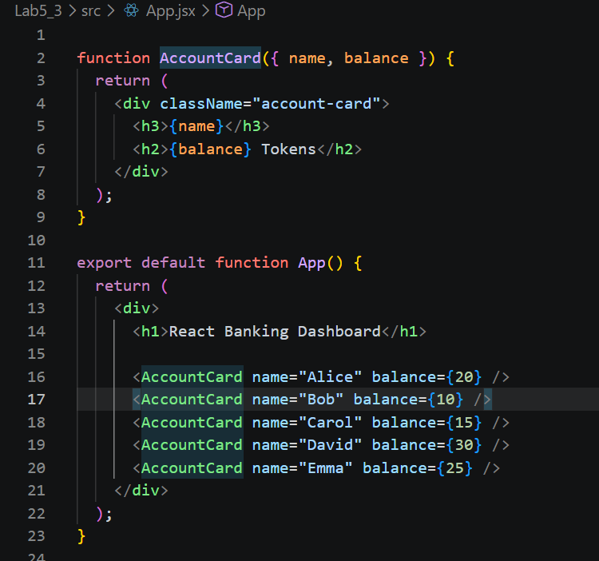

Part 4. Exercise 3. Managing State with useState

Step 7. Understand React State
Props allow data to be passed into components.
State allows a component to remember information that may change over time.
For example, when Alice receives 5 tokens, her displayed balance should change from 20 to 25.
React provides the useState Hook for this purpose.

Step 8. Create a Balance Counter
Replace src/App.jsx with:
import { useState } from "react";

export default function App() {

const [balance, setBalance] = useState(20);

function deposit() {
setBalance(previousBalance => previousBalance + 5);
}

function withdraw() {
setBalance(previousBalance =>
Math.max(0, previousBalance - 5)
);
}

return (
<div>
<h1>React Banking Dashboard</h1>

<h2>Balance: {balance} Tokens</h2>

<button onClick={deposit}>
Deposit 5
</button>

<button onClick={withdraw}>
Withdraw 5
</button>
</div>
);
}

Step 9. Test State Updates
The initial balance is 20 tokens.
Click Deposit 5.
Expected balance:
Balance: 25 Tokens
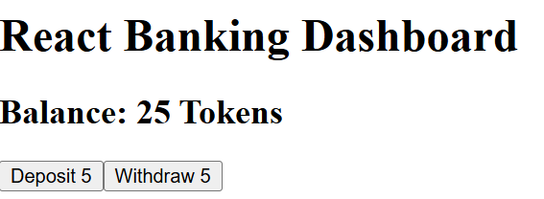
Click Withdraw 5.
Expected balance:
Balance: 20 Tokens
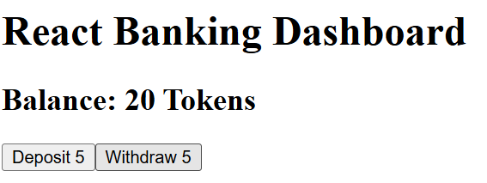

Explanation
const [balance, setBalance] = useState(20);
Element | Meaning
balance | Current state value
setBalance | Function used to update the state
useState(20) | Creates state with initial value 20
When setBalance() updates the state, React renders the relevant interface again.

Student Task 3
Modify the application to deposit or withdraw 10 tokens instead of 5 tokens.
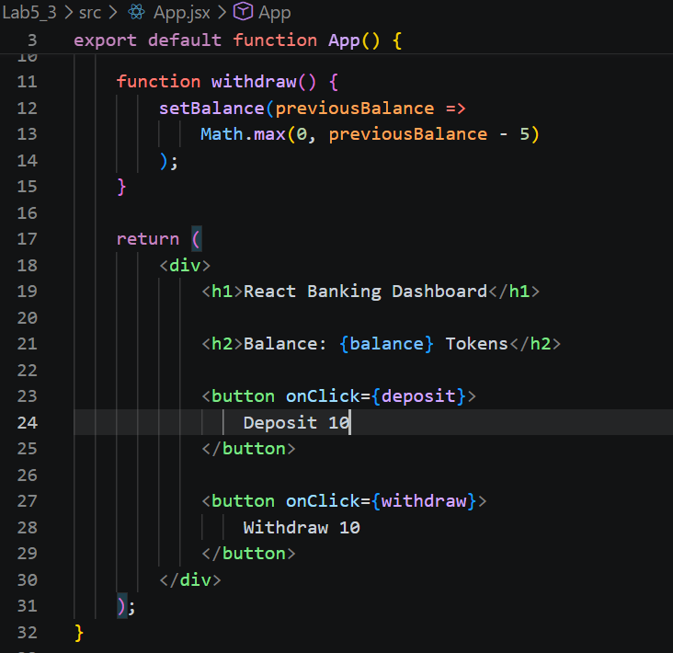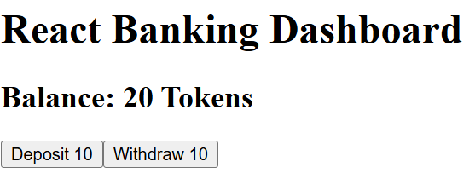
Part 5. Exercise 4. React Event Handling

Step 10. Handle Button Clicks
React uses event handlers to respond to user actions.
Example:
<button onClick={deposit}>
Deposit
</button>
When the user clicks the button, React executes the deposit function.
Unlike traditional JavaScript DOM manipulation, React normally manages UI updates through state rather than manually changing textContent.

Step 11. Handle User Input
Replace src/App.jsx with:
import { useState } from "react";

export default function App() {

const [balance, setBalance] = useState(20);
const [amount, setAmount] = useState("5");
const [message, setMessage] = useState("");

function deposit() {

const value = Number(amount);

if (
amount.trim() === "" ||
!Number.isSafeInteger(value) ||
value <= 0 ||
!Number.isSafeInteger(balance + value)
) {
setMessage("Invalid deposit amount.");
return;
}

setBalance(previous => previous + value);
setMessage("Deposit successful!");
}

return (
<div>
<h1>React Banking Dashboard</h1>

<h2>Balance: {balance} Tokens</h2>

<input
type="number"
value={amount}
onChange={(event) =>
setAmount(event.target.value)
}
/>

<button onClick={deposit}>
Deposit
</button>

<p>{message}</p>
</div>
);
}
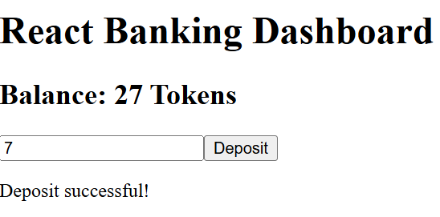

Explanation
The statement:
onChange={(event) => setAmount(event.target.value)}
updates the React state whenever the input changes.
The statement:
value={amount}
connects the input field to the state variable.
This is called a controlled input.

Student Task 4
Add a Withdraw button that:
- Reads the entered amount.
- Validates the amount.
- Checks whether the balance is sufficient.
- Updates the balance if the withdrawal is valid.
- Displays an error message if the withdrawal fails.
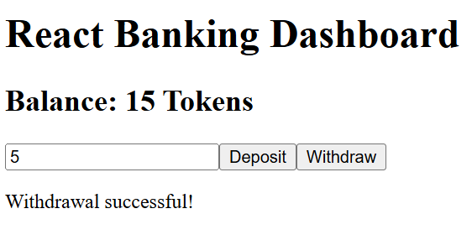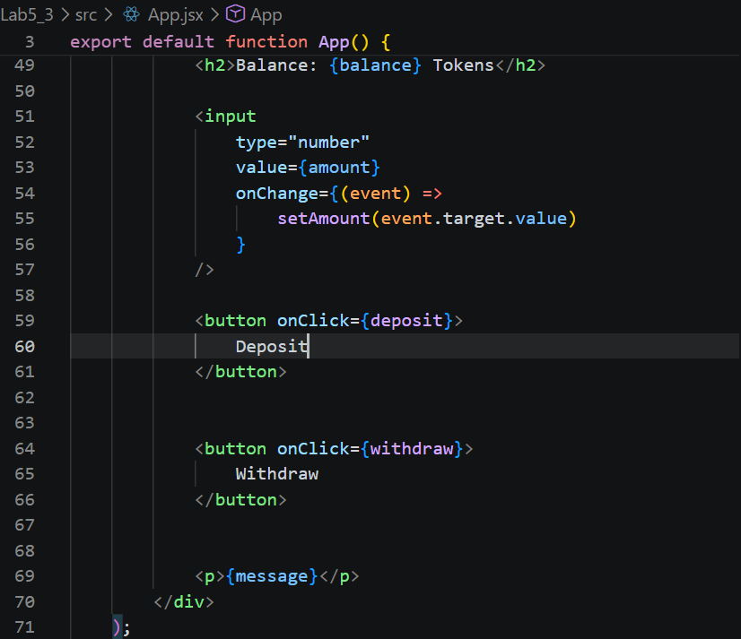
Part 6. Exercise 5. Rendering Lists with map()

Step 12. Understand List Rendering
React can display multiple items from an array using map().
Example:
const accounts = [
{ name: "Alice", balance: 20 },
{ name: "Bob", balance: 10 },
{ name: "Carol", balance: 15 },
{ name: "David", balance: 30 }
];
Instead of writing four account cards manually, we can generate them from the array.

Step 13. Render Account Cards Dynamically
Replace src/App.jsx with:
const accounts = [
{ name: "Alice", balance: 20 },
{ name: "Bob", balance: 10 },
{ name: "Carol", balance: 15 },
{ name: "David", balance: 30 }
];

function AccountCard({ name, balance }) {

return (
<div className="account-card">
<h3>{name}</h3>
<h2>{balance} Tokens</h2>
</div>
);
}

export default function App() {

return (
<div>
<h1>React Banking Dashboard</h1>

{accounts.map((account) => (
<AccountCard
key={account.name}
name={account.name}
balance={account.balance}
/>
))}
</div>
);
}

Explanation
The expression:
accounts.map((account) => (...))
creates one AccountCard component for each account in the array.
The key prop helps React identify each item when rendering a list.
Checkpoint 2: The application should display four accounts without manually repeating the account card markup.
Part 7. Integrated Mini Project – React Banking Dashboard

4. Project Objective
Develop a React application that manages simulated token transfers between four accounts.
The application must use:
- Functional React components.
- JSX.
- Props.
- useState.
- Event handling.
- Dynamic list rendering.
- Input validation.
- Transaction history.

5. Expected Application

React Banking Dashboard
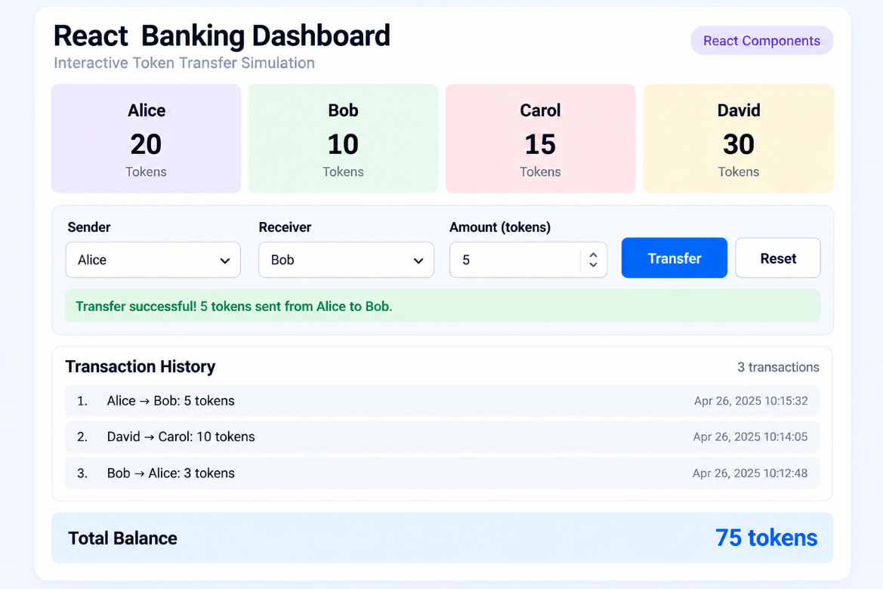

Step 14. Implement the Complete React Application
Open src/App.jsx and replace its contents with the following code.
import { useState } from "react";

// STEP 1. Initial account data

const initialAccounts = [
{ name: "Alice", balance: 20 },
{ name: "Bob", balance: 10 },
{ name: "Carol", balance: 15 },
{ name: "David", balance: 30 }
];

// STEP 2. Account Card Component

function AccountCard({ name, balance }) {

return (
<div className={`account ${name.toLowerCase()}`}>
<h3>{name}</h3>
<h2>{balance}</h2>
<p>Tokens</p>
</div>
);
}

// STEP 3. Transfer Form Component

function TransferForm({
accounts,
sender,
receiver,
amount,
setSender,
setReceiver,
setAmount,
onTransfer,
onReset
}) {

return (
<div className="transfer-form">

<div className="form-row">

<div>
<label htmlFor="sender">Sender</label>

<select
id="sender"
value={sender}
onChange={(event) =>
setSender(event.target.value)
}
>
{accounts.map((account) => (
<option
key={account.name}
value={account.name}
>
{account.name}
</option>
))}
</select>
</div>

<div>
<label htmlFor="receiver">Receiver</label>

<select
id="receiver"
value={receiver}
onChange={(event) =>
setReceiver(event.target.value)
}
>
{accounts.map((account) => (
<option
key={account.name}
value={account.name}
>
{account.name}
</option>
))}
</select>
</div>

</div>

<label htmlFor="amount">
Amount (tokens)
</label>

<input
id="amount"
type="number"
min="1"
step="1"
value={amount}
onChange={(event) =>
setAmount(event.target.value)
}
/>

<div className="buttons">
<button
id="transferBtn"
onClick={onTransfer}
>
Transfer
</button>

<button
id="resetBtn"
onClick={onReset}
>
Reset
</button>
</div>

</div>
);
}

// STEP 4. Transaction History Component

function TransactionHistory({ transactions }) {

return (
<div>

<div className="history-header">
<h3>Transaction History</h3>

<span>
{transactions.length} transactions
</span>
</div>

<div className="history">

{transactions.length === 0 ? (

<p>No transactions yet.</p>

) : (

transactions.map((tx, index) => (

<div
className="transaction"
key={tx.id}
>
{index + 1}. {tx.from} → {tx.to}: {tx.amount} tokens
</div>

))

)}

</div>

</div>
);
}

// STEP 5. Main App Component

export default function App() {

const [accounts, setAccounts] = useState(
initialAccounts.map(account => ({ ...account }))
);

const [sender, setSender] = useState("Alice");
const [receiver, setReceiver] = useState("Bob");
const [amount, setAmount] = useState("5");

const [transactions, setTransactions] = useState([]);

const [status, setStatus] = useState(
"Ready to transfer tokens."
);

const [statusColor, setStatusColor] = useState("#666");

// STEP 6. Transfer Function

function transfer() {

const value = Number(amount);

if (sender === receiver) {

setStatus(
"Error: Sender and receiver must be different."
);

setStatusColor("red");
return;
}

if (
amount.trim() === "" ||
!Number.isSafeInteger(value) ||
value <= 0
) {

setStatus(
"Error: Enter a valid positive integer amount."
);

setStatusColor("red");
return;
}

const senderAccount =
accounts.find(account => account.name === sender);

const receiverAccount =
accounts.find(account => account.name === receiver);

if (!senderAccount || !receiverAccount) {

setStatus("Error: Account not found.");
setStatusColor("red");
return;
}

if (senderAccount.balance < value) {

setStatus("Error: Insufficient balance.");
setStatusColor("red");
return;
}

if (
!Number.isSafeInteger(receiverAccount.balance + value)
) {

setStatus("Error: Balance exceeds supported range.");
setStatusColor("red");
return;
}

// Update balances without mutating existing state

setAccounts(previousAccounts =>
previousAccounts.map(account => {

if (account.name === sender) {
return {
...account,
balance: account.balance - value
};
}

if (account.name === receiver) {
return {
...account,
balance: account.balance + value
};
}

return account;
})
);

setTransactions(previousTransactions => [

...previousTransactions,

{
id: crypto.randomUUID(),
from: sender,
to: receiver,
amount: value
}

]);

setStatus(
`Transfer successful! ${value} tokens sent from ${sender} to ${receiver}.`
);

setStatusColor("green");
}

// STEP 7. Reset Function

function reset() {

setAccounts(
initialAccounts.map(account => ({ ...account }))
);

setSender("Alice");
setReceiver("Bob");
setAmount("5");

setTransactions([]);

setStatus("Simulation reset.");
setStatusColor("#666");
}

// STEP 8. Calculate Total Balance

const totalBalance = accounts.reduce(
(sum, account) => sum + account.balance,
0
);

// STEP 9. Render the Dashboard

return (

<div className="container">

<header>
<h1>React Banking Dashboard</h1>
<span className="badge">
React Components
</span>
</header>

<p className="subtitle">
Interactive Token Transfer Simulation
</p>

<div className="accounts">

{accounts.map(account => (

<AccountCard
key={account.name}
name={account.name}
balance={account.balance}
/>

))}

</div>

<TransferForm
accounts={accounts}
sender={sender}
receiver={receiver}
amount={amount}
setSender={setSender}
setReceiver={setReceiver}
setAmount={setAmount}
onTransfer={transfer}
onReset={reset}
/>

<p
id="status"
style={{ color: statusColor }}
>
{status}
</p>

<hr />

<TransactionHistory
transactions={transactions}
/>

<div className="total">
<strong>Total Balance</strong>

<strong>{totalBalance} tokens</strong>
</div>

<p className="note">
This is a local React simulation,
not a blockchain transaction.
</p>

</div>

);
}

Step 15. Add the Complete CSS
Open src/styles.css and paste:
* {
box-sizing: border-box;
}

body {
font-family: Arial, sans-serif;
background: #f5f6fa;
color: #222;
margin: 0;
padding: 25px;
}

.container {
max-width: 900px;
margin: auto;
background: white;
padding: 25px;
border: 1px solid #ddd;
border-radius: 18px;
}

header {
display: flex;
justify-content: space-between;
align-items: center;
gap: 12px;
}

h1 {
font-size: 26px;
margin: 0;
}

.badge {
background: #ede9fe;
padding: 8px 12px;
border-radius: 20px;
font-size: 13px;
}

.subtitle {
color: #666;
}

.accounts {
display: grid;
grid-template-columns: repeat(4, minmax(0, 1fr));
gap: 12px;
margin: 25px 0;
}

.account {
min-width: 0;
text-align: center;
padding: 15px 8px;
border-radius: 12px;
}

.account h3 {
font-size: 22px;
margin: 10px 0;
}

.account h2 {
font-size: 32px;
margin: 10px 0;
}

.account p {
margin: 5px;
}

.account.alice {
background: #ede9fe;
}

.account.bob {
background: #e4f8e9;
}

.account.carol {
background: #ffe8ec;
}

.account.david {
background: #fff3d6;
}

.form-row {
display: grid;
grid-template-columns: 1fr 1fr;
gap: 15px;
}

label {
display: block;
margin: 15px 0 8px;
font-weight: bold;
}

select,
input {
width: 100%;
padding: 14px;
border: 1px solid #ccc;
border-radius: 10px;
font-size: 16px;
}

.buttons {
display: flex;
gap: 10px;
margin-top: 20px;
}

button {
padding: 14px 20px;
border-radius: 12px;
cursor: pointer;
font-size: 16px;
}

#transferBtn {
flex: 1;
background: #111;
color: white;
border: none;
}

#resetBtn {
background: white;
border: 1px solid #ccc;
}

#status {
min-height: 24px;
margin-top: 20px;
}

hr {
border: 0;
border-top: 1px solid #eee;
margin: 25px 0;
}

.history-header,
.total {
display: flex;
justify-content: space-between;
align-items: center;
gap: 12px;
}

.history-header span {
color: #777;
font-size: 14px;
}

.history {
margin: 15px 0;
color: #555;
}

.transaction {
background: #f1f4f8;
padding: 14px;
border-radius: 10px;
margin-bottom: 8px;
}

.total {
margin-top: 30px;
}

.note {
color: #777;
font-size: 13px;
}

@media (max-width: 700px) {
.accounts {
grid-template-columns: repeat(2, minmax(0, 1fr));
}
}

@media (max-width: 400px) {
.accounts {
grid-template-columns: 1fr;
}

.form-row {
grid-template-columns: 1fr;
}
}

Step 16. Run the React Banking Dashboard
After entering the code:
- Open the Preview panel.
- Confirm that four account cards are displayed.
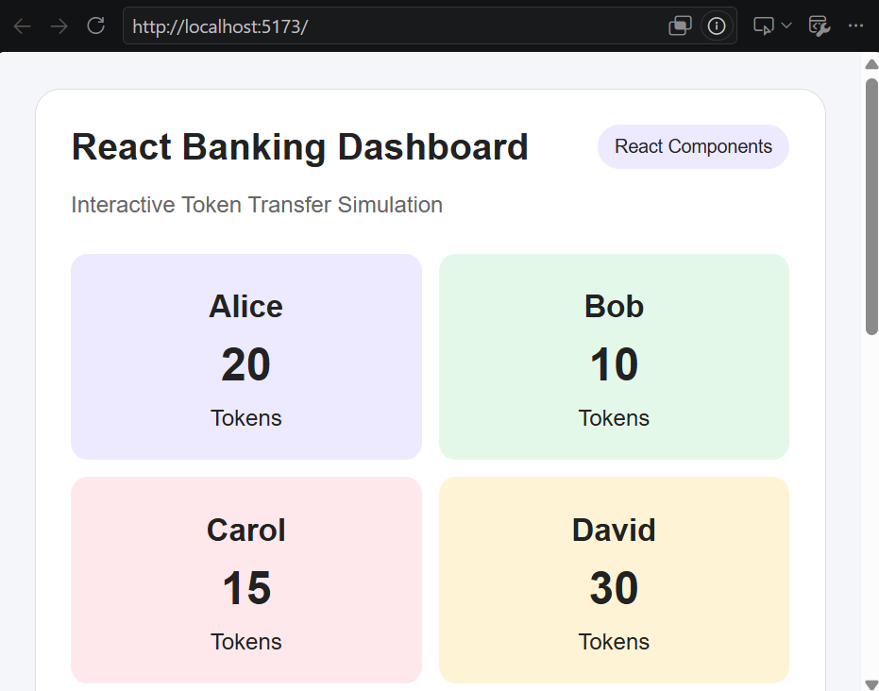
- Verify that the Sender and Receiver dropdowns contain Alice, Bob, Carol, and David.
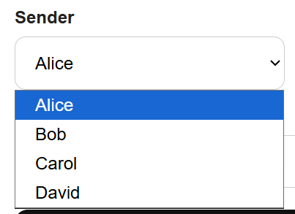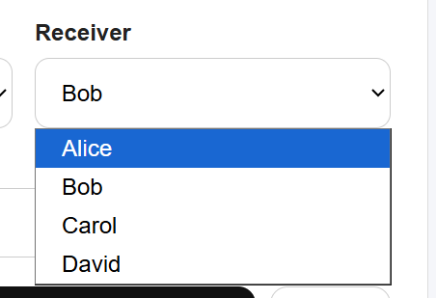
- Check that the initial total balance is 75 tokens.
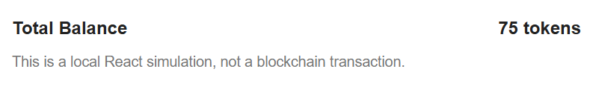
- Test a transfer between two accounts.
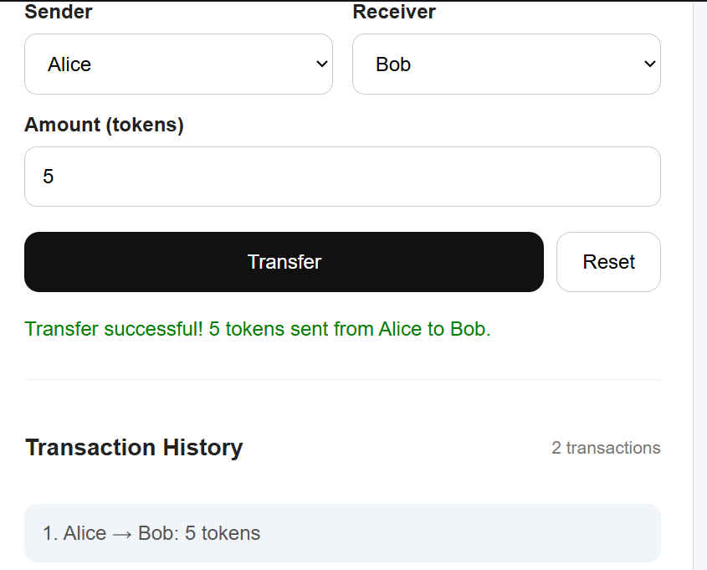
Expected Initial Balances
Account | Initial Balance
Alice | 20
Bob | 10
Carol | 15
David | 30
Total | 75
Part 8. Testing the React Application

Step 17. Test Successful Transfers
Run the following test cases in order, without resetting between them.
Test Case | Sender | Receiver | Amount | Expected Result
TC01 | Alice | Bob | 5 | Alice 15, Bob 15
TC02 | David | Carol | 10 | David 20, Carol 25
TC03 | Bob | Alice | 3 | Bob 12, Alice 18
TC01:
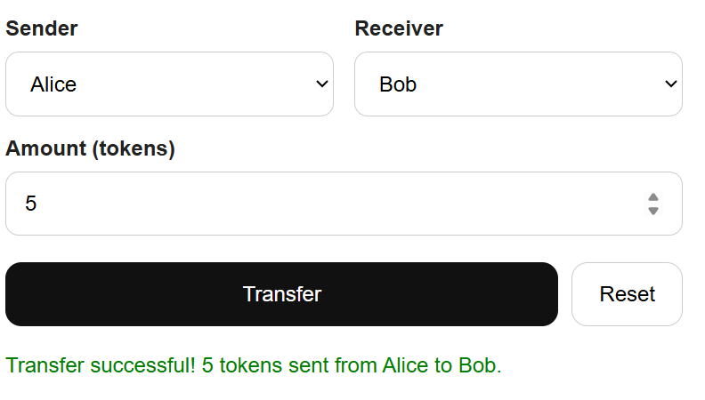
TC02:
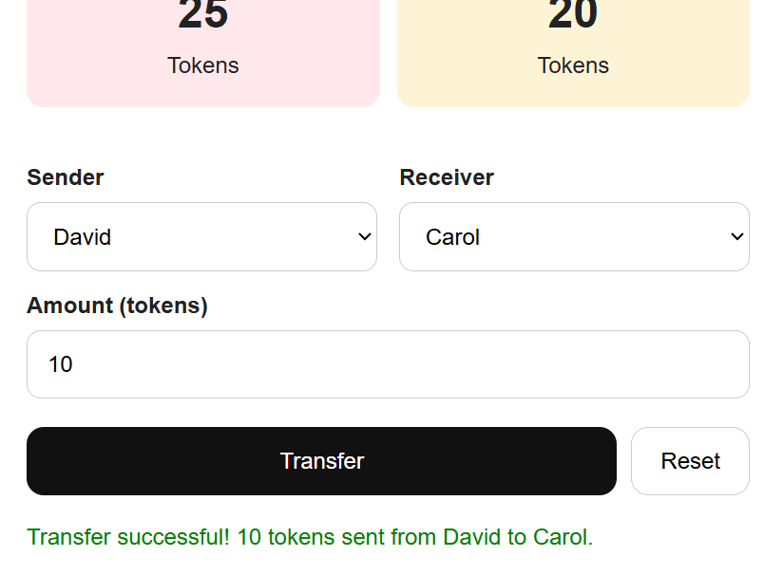
TC03:
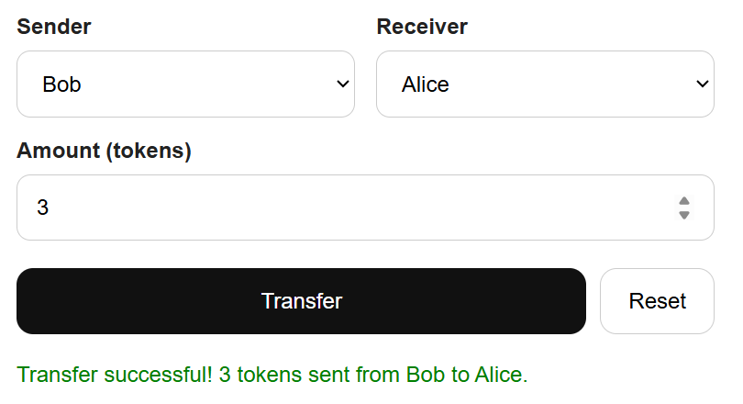
After TC03, the balances should be:
Account | Final Balance
Alice | 18
Bob | 12
Carol | 25
David | 20
Total | 75
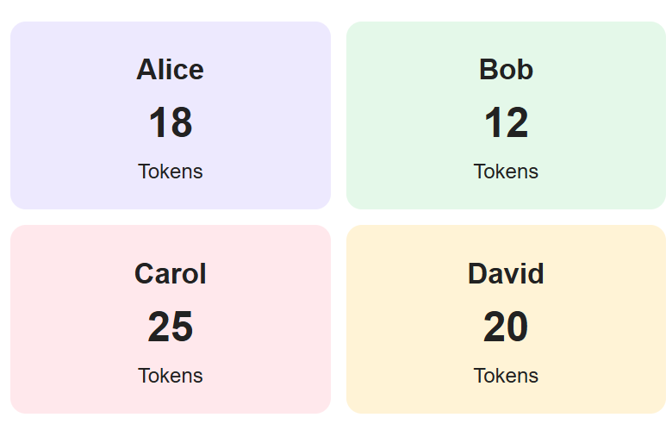

Step 18. Test Invalid Transactions
Test Case | Action | Expected Result
TC04 | Transfer 100 tokens from Alice to Bob | Insufficient balance  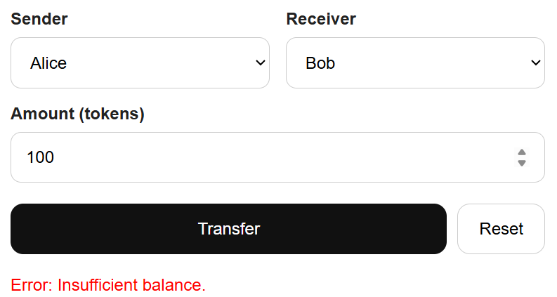
TC05 | Transfer from Alice to Alice | Sender and receiver must be different  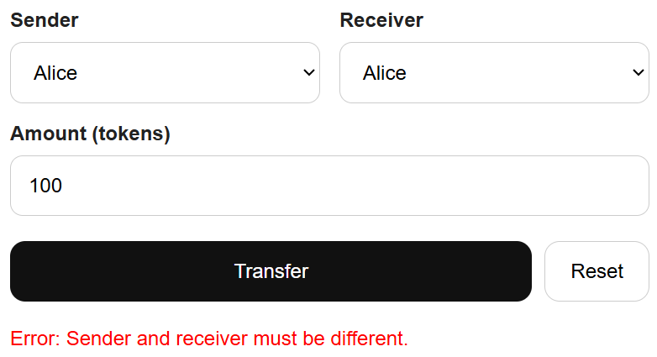
TC06 | Transfer 0 tokens | Invalid amount  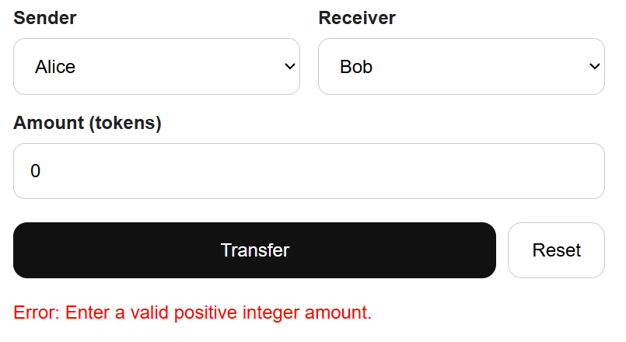
TC07 | Transfer -5 tokens | Invalid amount  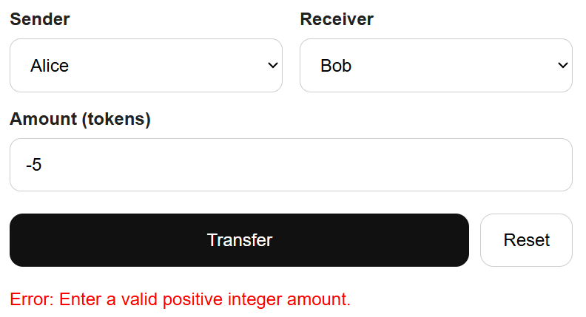
TC08 | Transfer 2.5 tokens | Invalid amount  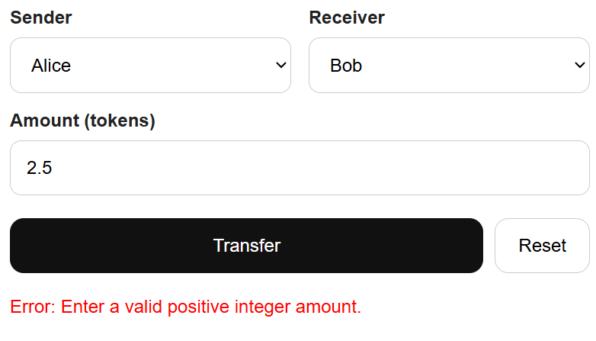
TC09 | Click Reset | Restore initial balances and clear history  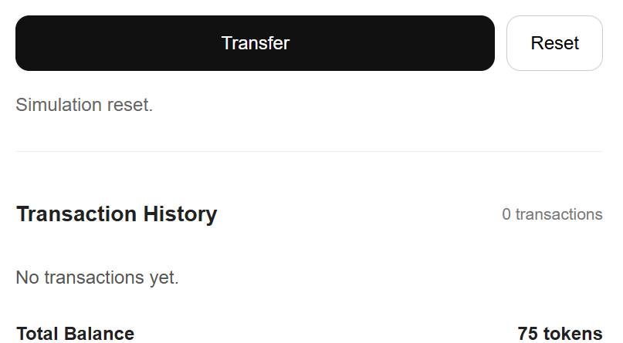
Failed transactions must not change account balances or add transaction records.

Step 19. Verify React State Updates
After each successful transfer, confirm that:
- The sender's balance decreases.
- The receiver's balance increases.
- The total balance remains 75 tokens.
- The transaction history displays the new transfer.
- The interface updates without reloading the page.
  - Exactly
Part 9. Student Practice

Exercise 1. Add a Fifth Account
Add a new account named Emma with an initial balance of 25 tokens.
The application should automatically display Emma's account card and include Emma in the Sender and Receiver dropdowns.
Expected total balance: 100 tokens.
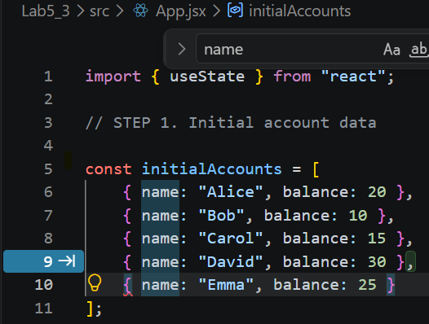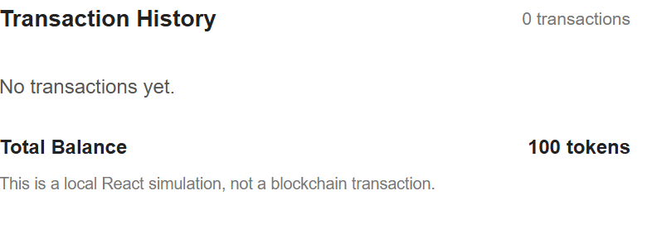

Exercise 2. Create a Summary Component
Create a new React component called AccountSummary.
The component should display:
- Number of accounts.
- Total tokens.
- Number of successful transactions.
Pass the required values through props.
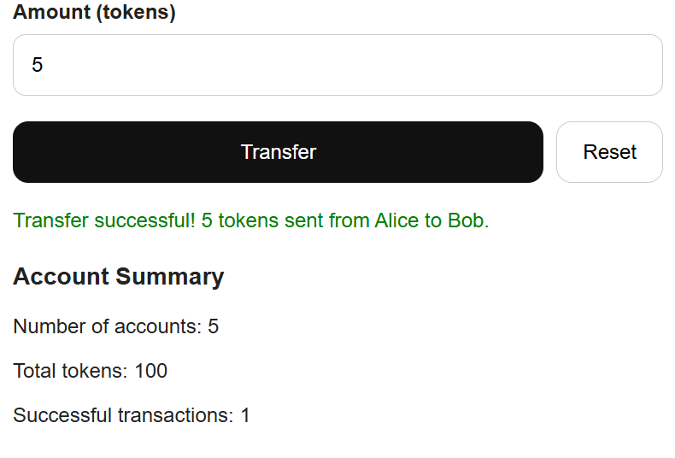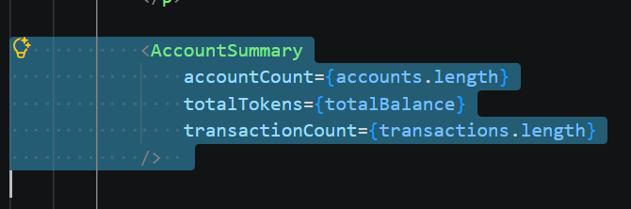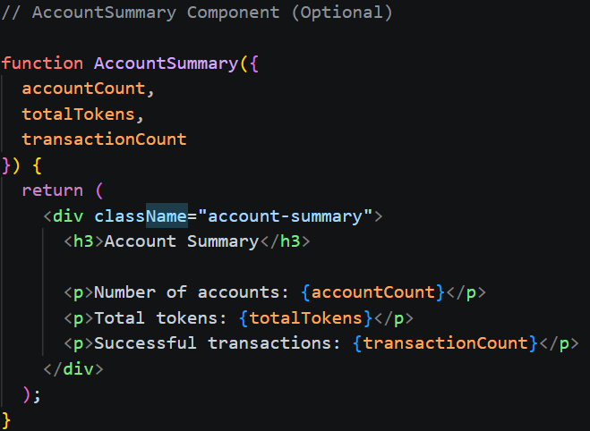

Exercise 3. Highlight the Sender and Receiver
Modify the AccountCard component so that the selected sender and receiver are visually highlighted.
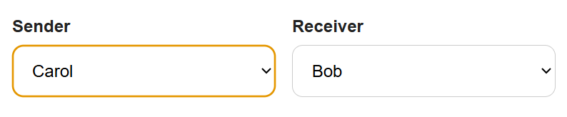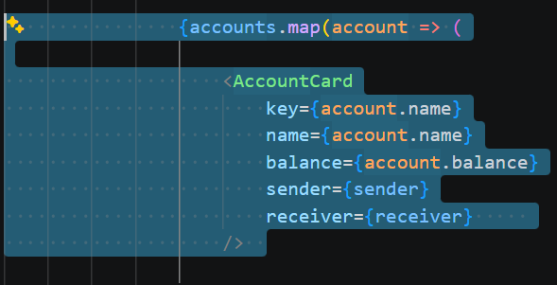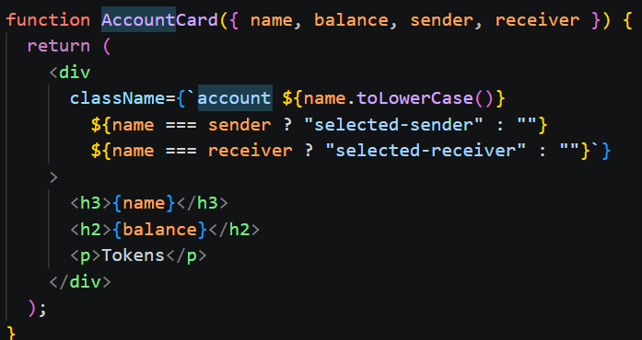
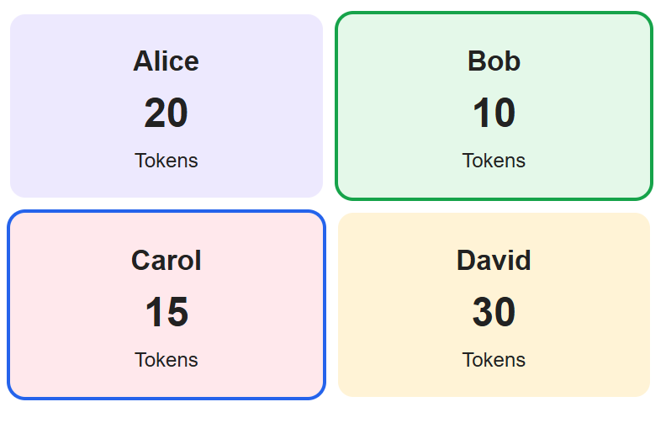

Exercise 4. Add a Clear History Button
Create a button that clears the transaction history without resetting account balances.
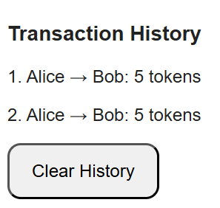

Exercise 5. Add Transaction Timestamps
Extend each transaction object to include the date and time when the transfer was completed.
Display the timestamp in the TransactionHistory component.
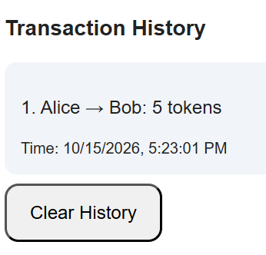

LAB 5.4 – React State and User Events
- Lab Topic: React State, Event Handling, Controlled Inputs, and Dynamic UI Updates
- Development Environment: PlayCode – Online React Editor
- Integrated Mini Project: Interactive Token Wallet Dashboard

1. Lab Overview
In Lab 5.3, students learned how to create React components, use JSX, and pass data between components using props.
In Lab 5.4, students will focus on managing application state and responding to user events in React.
Students will build an Interactive Token Wallet Dashboard that allows users to select an account, deposit and withdraw simulated tokens, view updated balances, and track transaction history.
The application runs locally in the browser. It does not connect to a real cryptocurrency wallet, Ethereum network, or smart contract.

2. Learning Objectives
By the end of this lab, students should be able to:
- Explain the purpose of state in React applications.
- Use the useState Hook to store and update data.
- Handle user events using onClick and onChange.
- Create controlled input fields.
- Update objects and arrays in React state without direct mutation.
- Render conditional messages based on application state.
- Disable interface controls during simulated transaction processing.
- Build an interactive wallet dashboard using React.

3. Lab Activities
Part | Activity | Expected Outcome
1 | React environment setup | Prepare a React project
2 | Understanding useState | Create an interactive balance counter
3 | Handling user events | Respond to button clicks
4 | Controlled inputs | Read transaction amounts
5 | Conditional rendering | Display success and error messages
6 | Updating arrays and objects | Manage multiple accounts
7 | Integrated Mini Project | Build an Interactive Token Wallet Dashboard
8 | Testing | Verify wallet operations
9 | Student Practice | Extend the dashboard
10 | Lab Submission | Submit code and screenshots
Part 1. Prepare the React Development Environment

Step 1. Open PlayCode React
- Open https://playcode.io/react.
- Start a new React project.
- Locate the file explorer, editor, Preview, and Console panels.
- Create a separate project for Lab 5.4 to preserve your Lab 5.3 work.
Use the following project structure:
Interactive Token Wallet Dashboard
│
├── index.html
│
└── src
├── main.jsx
├── App.jsx
└── styles.css
If the React template already contains these files, reuse them.

Step 2. Prepare index.html:
<!DOCTYPE html>
<html lang="en">
<head>
<meta charset="UTF-8">

<meta name="viewport"
content="width=device-width, initial-scale=1.0">

<title>Interactive Token Wallet Dashboard</title>
</head>

<body>
<div id="root"></div>

<script type="module" src="/src/main.jsx"></script>
</body>

</html>

Step 3. Prepare src/main.jsx:
import React from "react";
import { createRoot } from "react-dom/client";

import App from "./App.jsx";
import "./styles.css";

createRoot(document.getElementById("root")).render(
<React.StrictMode>
<App />
</React.StrictMode>

);

Checkpoint 1: The React project is ready. The application interface will appear after the App component is created.
Part 2. Exercise 1. Understanding React State

Step 4. Create a State Variable
React state allows components to remember information between renders.
Open src/App.jsx and enter:
import { useState } from "react";

export default function App() {

const [balance, setBalance] = useState(20);

return (
<div>
<h1>Token Wallet</h1>
<h2>Balance: {balance} tokens</h2>
</div>
);
}

Expected Output
Token Wallet
Balance: 20 tokens
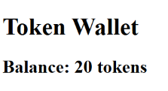

Explanation
const [balance, setBalance] = useState(20);
Element | Purpose
useState(20) | Creates state with initial value 20
balance | Stores the current balance
setBalance() | Updates the balance
{balance} | Displays the current state in JSX
When state changes, React renders the component again with the updated value.

Step 5. Update State Using a Button
Replace src/App.jsx with:
import { useState } from "react";

export default function App() {

const [balance, setBalance] = useState(20);

function deposit() {
setBalance(previous => previous + 5);
}

return (
<div>
<h1>Token Wallet</h1>

<h2>Balance: {balance} tokens</h2>

<button onClick={deposit}>
Deposit 5 Tokens
</button>
</div>
);
}

Click Deposit 5 Tokens twice.
Expected Result: The balance changes from 20 to 25, then to 30 tokens.
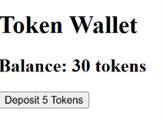

Student Task 1
Add a Withdraw 5 Tokens button. Prevent the balance from becoming negative.
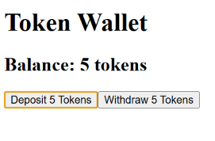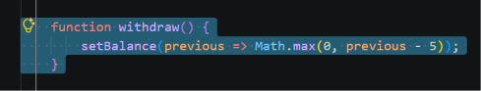
Part 3. Exercise 2. Handling User Events

Step 6. Understand React Events
React applications respond to user interactions through event handlers.
Common React events include:
Event | Purpose
onClick | Handles button clicks
onChange | Handles input changes
onSubmit | Handles form submissions
onFocus | Handles an element receiving focus
onBlur | Handles an element losing focus

Step 7. Handle Button Clicks
Replace src/App.jsx with:
import { useState } from "react";

export default function App() {

const [message, setMessage] = useState(
"No action performed."
);

function connectWallet() {
setMessage("Wallet connected (simulation).");
}

function disconnectWallet() {
setMessage("Wallet disconnected.");
}

return (
<div>
<h1>Wallet Event Demo</h1>

<button onClick={connectWallet}>
Connect Wallet
</button>

<button onClick={disconnectWallet}>
Disconnect Wallet
</button>

<p>{message}</p>
</div>
);
}

Expected Behavior
- Clicking Connect Wallet displays Wallet connected (simulation).
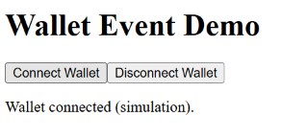
- Clicking Disconnect Wallet displays Wallet disconnected.
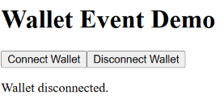
Important: These buttons only change local React state. They do not connect to MetaMask or any blockchain wallet.

Student Task 2
Add a state variable named isConnected and use it to display:
Wallet Status: Connected
or:
Wallet Status: Disconnected
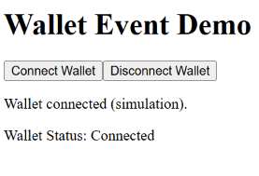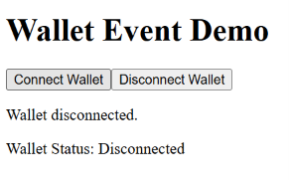
Part 4. Exercise 3. Controlled Inputs

Step 8. Understand Controlled Components
A controlled input is an HTML input whose value is managed by React state.
Replace src/App.jsx with:
import { useState } from "react";

export default function App() {

const [amount, setAmount] = useState("5");

return (
<div>
<h1>Transaction Amount</h1>

<input
type="number"
value={amount}
onChange={(event) =>
setAmount(event.target.value)
}
/>

<p>Entered Amount: {amount} tokens</p>
</div>
);
}

Step 9. Test the Controlled Input
- Enter 10 in the input field.
- Observe the displayed amount.
- Change the amount to 25.
- Confirm that the displayed value updates immediately.
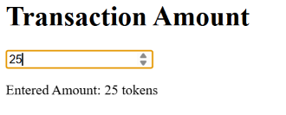

Explanation
value={amount}
Connects the input value to React state.
onChange={(event) => setAmount(event.target.value)}
Updates the state when the user enters a new value.
Note: Input values are strings. Use Number(amount) when a numeric value is needed.

Student Task 3
Add a second controlled input for the wallet owner's name. Display the name and amount below the inputs.
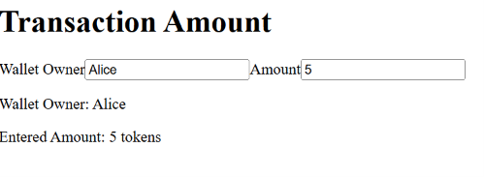
Part 5. Exercise 4. Conditional Rendering
Step 10. Display Messages Based on State
React can display different interface elements depending on state values.
Replace src/App.jsx with:
import { useState } from "react";

export default function App() {

const [balance, setBalance] = useState(20);
const [message, setMessage] = useState("");

function withdraw() {

if (balance < 10) {
setMessage("Insufficient balance.");
return;
}

setBalance(previous => previous - 10);
setMessage("Withdrawal successful!");
}

return (
<div>
<h1>Conditional Rendering Demo</h1>

<h2>Balance: {balance} tokens</h2>

<button onClick={withdraw}>
Withdraw 10 Tokens
</button>

{message && <p>{message}</p>}

{balance === 0 && (
<p>Your wallet balance is zero.</p>
)}
</div>
);
}

Expected Behavior
- First withdrawal: Balance becomes 10.
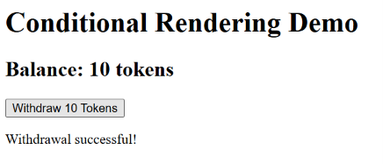
- Second withdrawal: Balance becomes 0.
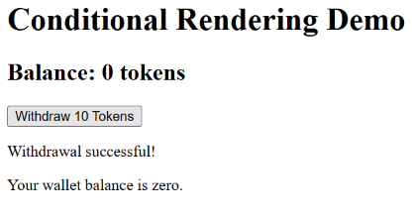
- Third withdrawal: An insufficient balance message appears.
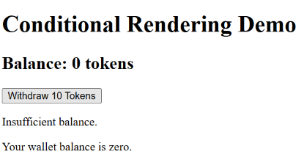

Explanation
{message && <p>{message}</p>}
Displays a paragraph only when message is not empty.
{balance === 0 && (
<p>Your wallet balance is zero.</p>
)}
Displays a warning only when the balance is zero.

Student Task 4
Display a warning when the balance is less than 5 tokens.
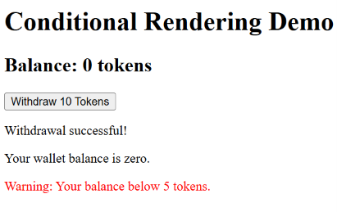
Part 6. Exercise 5. Updating Arrays and Objects in State

Step 11. Store Multiple Accounts
In React, arrays and objects stored in state should be updated without directly modifying the existing values.
Replace src/App.jsx with:
import { useState } from "react";

const initialAccounts = [
{ name: "Alice", balance: 20 },
{ name: "Bob", balance: 10 },
{ name: "Carol", balance: 15 },
{ name: "David", balance: 30 }
];

export default function App() {

const [accounts, setAccounts] = useState(
initialAccounts
);

function rewardAlice() {

setAccounts(previousAccounts =>
previousAccounts.map(account => {

if (account.name === "Alice") {
return {
...account,
balance: account.balance + 5
};
}

return account;
})
);
}

return (
<div>
<h1>Account State Demo</h1>

{accounts.map(account => (
<p key={account.name}>
{account.name}: {account.balance} tokens
</p>
))}

<button onClick={rewardAlice}>
Reward Alice +5
</button>
</div>
);
}

Expected Result: Each click increases Alice's balance by 5 tokens without changing the other accounts.
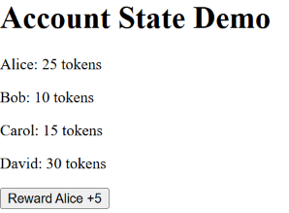

Explanation
The map() method creates a new array.
The spread operator:
...account
copies the existing account properties before changing the balance.
This avoids directly mutating the existing React state.

Student Task 5
Add a button that rewards Bob with 3 tokens.
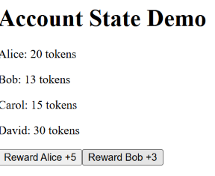
Part 7. Integrated Mini Project - Interactive Token Wallet Dashboard

4. Project Objective
Build a React application that simulates wallet connections and token operations for four accounts.
The application must allow users to:
- Connect and disconnect a simulated wallet.
- Select an account.
- View the selected account's balance.
- Deposit tokens.
- Withdraw tokens.
- View transaction history.
- Display processing, success, and error messages.
- Reset the simulation.

5. Expected Application Interface
The following is an interactive preview of the dashboard's core features. The full PlayCode application below also simulates a processing delay.

Token Wallet Dashboard
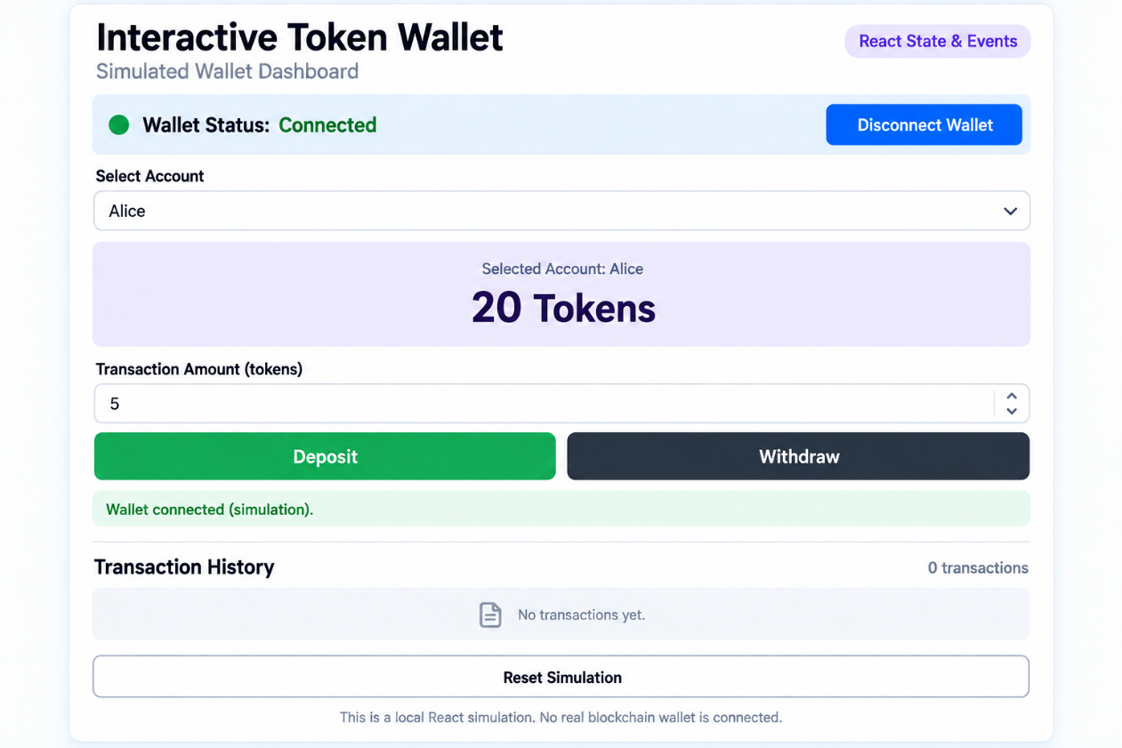

Step 12. Implement the Complete React Application
Open src/App.jsx and replace its contents with the following code:
import { useState } from "react";

// STEP 1. Initial data

const initialAccounts = [
{ name: "Alice", balance: 20 },
{ name: "Bob", balance: 10 },
{ name: "Carol", balance: 15 },
{ name: "David", balance: 30 }
];

const processingDelay = 1500;

// STEP 2. Reusable account selector

function AccountSelector({
accounts,
selectedAccount,
onAccountChange,
disabled
}) {

return (
<div>
<label htmlFor="account">Select Account</label>

<select
id="account"
value={selectedAccount}
onChange={(event) =>
onAccountChange(event.target.value)
}
disabled={disabled}
>
{accounts.map(account => (
<option
key={account.name}
value={account.name}
>
{account.name}
</option>
))}
</select>
</div>
);
}

// STEP 3. Balance display component

function BalanceCard({ name, balance }) {

return (
<div className="balance-card">
<p>Selected Account: {name}</p>

<h2>{balance} Tokens</h2>
</div>
);
}

// STEP 4. Transaction history component

function TransactionHistory({ transactions }) {

return (
<div>
<div className="history-header">
<h3>Transaction History</h3>

<span>
{transactions.length} transactions
</span>
</div>

{transactions.length === 0 ? (

<p>No transactions yet.</p>

) : (

transactions.map((tx, index) => (

<div
className="transaction"
key={tx.id}
>
{index + 1}. {tx.account}:
{" "}{tx.type}
{" "}{tx.type === "Deposit" ? "+" : "-"}
{tx.amount} tokens
{" "} | Balance: {tx.balance}
</div>

))

)}
</div>
);
}

// STEP 5. Main App

export default function App() {

const [accounts, setAccounts] = useState(
initialAccounts.map(account => ({ ...account }))
);

const [selectedAccount, setSelectedAccount] =
useState("Alice");

const [amount, setAmount] = useState("5");

const [isConnected, setIsConnected] = useState(false);

const [isProcessing, setIsProcessing] = useState(false);

const [transactions, setTransactions] = useState([]);

const [message, setMessage] = useState(
"Connect a wallet to begin."
);

const [messageColor, setMessageColor] =
useState("#666");

// STEP 6. Get the selected account

const currentAccount = accounts.find(
account => account.name === selectedAccount
);

const currentBalance = currentAccount
? currentAccount.balance
: 0;

// STEP 7. Connect or disconnect wallet

function toggleWallet() {

if (isProcessing) {
return;
}

setIsConnected(previous => !previous);

if (isConnected) {
setMessage("Wallet disconnected.");
} else {
setMessage("Wallet connected (simulation).");
}

setMessageColor("#666");
}

// STEP 8. Validate amount

function getValidAmount() {

const value = Number(amount);

if (
amount.trim() === "" ||
!Number.isSafeInteger(value) ||
value <= 0
) {
throw new Error(
"Enter a valid positive integer amount."
);
}

return value;
}

// STEP 9. Simulate processing delay

function waitForProcessing() {

return new Promise(resolve => {
setTimeout(resolve, processingDelay);
});
}

// STEP 10. Handle transactions

async function handleTransaction(type) {

if (!isConnected || isProcessing) {
return;
}

let started = false;

try {

const value = getValidAmount();

if (!currentAccount) {
throw new Error("Account not found.");
}

setIsProcessing(true);
started = true;

setMessage(
`Processing ${type.toLowerCase()}... Please wait.`
);

setMessageColor("#2563eb");

await waitForProcessing();

if (
type === "Withdraw" &&
value > currentAccount.balance
) {
throw new Error("Insufficient balance.");
}

if (
type === "Deposit" &&
!Number.isSafeInteger(currentAccount.balance + value)
) {
throw new Error(
"Balance exceeds supported range."
);
}

const newBalance =
type === "Deposit"
? currentAccount.balance + value
: currentAccount.balance - value;

setAccounts(previousAccounts =>
previousAccounts.map(account =>
account.name === selectedAccount
? { ...account, balance: newBalance }
: account
)
);

setTransactions(previousTransactions => [
...previousTransactions,
{
id: crypto.randomUUID(),
account: selectedAccount,
type: type,
amount: value,
balance: newBalance
}
]);

setMessage(
`${type} successful! ${value} tokens processed.`
);

setMessageColor("green");

} catch (error) {

setMessage(
"Transaction Failed: " + error.message
);

setMessageColor("red");

} finally {

if (started) {
setIsProcessing(false);
}

}
}

// STEP 11. Reset application

function reset() {

if (isProcessing) {
return;
}

setAccounts(
initialAccounts.map(account => ({ ...account }))
);

setSelectedAccount("Alice");
setAmount("5");

setIsConnected(false);
setTransactions([]);

setMessage("Simulation reset.");
setMessageColor("#666");
}

// STEP 12. Render interface

return (
<div className="container">

<header>
<h1>Interactive Token Wallet</h1>

<span className="badge">
React State & Events
</span>
</header>

<p className="subtitle">
Simulated Wallet Dashboard
</p>

<div className="wallet-status">
<strong>
Wallet Status:
{" "}
{isConnected
? "Connected"
: "Disconnected"}
</strong>

<button
id="connectBtn"
onClick={toggleWallet}
disabled={isProcessing}
>
{isConnected
? "Disconnect Wallet"
: "Connect Wallet"}
</button>
</div>

<AccountSelector
accounts={accounts}
selectedAccount={selectedAccount}
onAccountChange={setSelectedAccount}
disabled={!isConnected || isProcessing}
/>

<BalanceCard
name={selectedAccount}
balance={currentBalance}
/>

<label htmlFor="amount">
Transaction Amount (tokens)
</label>

<input
id="amount"
type="number"
min="1"
step="1"
value={amount}
onChange={(event) =>
setAmount(event.target.value)
}
disabled={!isConnected || isProcessing}
/>

<div className="buttons">

<button
id="depositBtn"
onClick={() =>
handleTransaction("Deposit")
}
disabled={!isConnected || isProcessing}
>
Deposit
</button>

<button
id="withdrawBtn"
onClick={() =>
handleTransaction("Withdraw")
}
disabled={!isConnected || isProcessing}
>
Withdraw
</button>

</div>

<p
id="message"
style={{ color: messageColor }}
>
{message}
</p>

<hr />

<TransactionHistory
transactions={transactions}
/>

<button
id="resetBtn"
onClick={reset}
disabled={isProcessing}
>
Reset Simulation
</button>

<p className="note">
This is a local React simulation.
No real blockchain wallet is connected.
</p>

</div>
);
}

Step 13. Add the Complete CSS
Open src/styles.css, delete the existing CSS, and paste:
* {
box-sizing: border-box;
}

body {
font-family: Arial, sans-serif;
background: #f5f6fa;
color: #222;
margin: 0;
padding: 25px;
}

.container {
max-width: 800px;
margin: auto;
background: white;
padding: 28px;
border: 1px solid #ddd;
border-radius: 18px;
}

header {
display: flex;
align-items: center;
justify-content: space-between;
gap: 12px;
}

h1 {
margin: 0;
font-size: 26px;
}

.badge {
background: #ede9fe;
padding: 8px 12px;
border-radius: 20px;
font-size: 13px;
}

.subtitle {
color: #666;
}

.wallet-status {
display: flex;
justify-content: space-between;
align-items: center;
gap: 12px;
background: #f1f4f8;
padding: 15px;
margin: 25px 0;
border-radius: 12px;
}

#connectBtn {
background: #2563eb;
color: white;
border: none;
}

.balance-card {
text-align: center;
background: #ede9fe;
border-radius: 15px;
padding: 28px;
margin: 25px 0;
}

.balance-card p {
color: #555;
}

.balance-card h2 {
font-size: 36px;
margin: 10px 0;
}

label {
display: block;
margin: 15px 0 8px;
font-weight: bold;
}

select,
input {
width: 100%;
padding: 14px;
border: 1px solid #ccc;
border-radius: 10px;
font-size: 16px;
}

.buttons {
display: grid;
grid-template-columns: 1fr 1fr;
gap: 12px;
margin-top: 20px;
}

button {
padding: 14px 20px;
border-radius: 10px;
cursor: pointer;
font-size: 16px;
}

#depositBtn {
background: #16a34a;
color: white;
border: none;
}

#withdrawBtn {
background: #111827;
color: white;
border: none;
}

#resetBtn {
width: 100%;
margin-top: 20px;
background: white;
border: 1px solid #ccc;
}

button:disabled {
opacity: 0.5;
cursor: not-allowed;
}

#message {
min-height: 24px;
margin: 20px 0;
}

hr {
border: 0;
border-top: 1px solid #eee;
margin: 25px 0;
}

.history-header {
display: flex;
justify-content: space-between;
align-items: center;
gap: 12px;
}

.history-header span {
color: #777;
font-size: 14px;
}

.transaction {
background: #f1f4f8;
padding: 14px;
margin: 8px 0;
border-radius: 10px;
}

.note {
color: #777;
font-size: 13px;
margin-top: 20px;
}

@media (max-width: 600px) {
header,
.wallet-status {
flex-direction: column;
align-items: flex-start;
}

.buttons {
grid-template-columns: 1fr;
}
}

Step 14. Run the Application
- Open the Preview panel.
- Confirm that the wallet status is Disconnected.
- Click Connect Wallet.
- Select an account.
- Enter a transaction amount.
- Click Deposit or Withdraw.
- Observe the processing message and balance update.
Expected Initial Account Balances
Account | Initial Balance
Alice | 20
Bob | 10
Carol | 15
David | 30
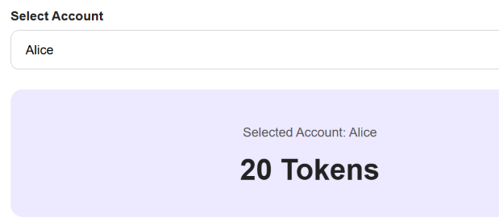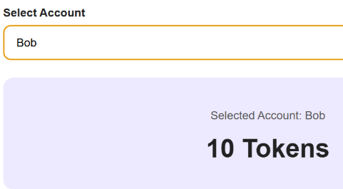
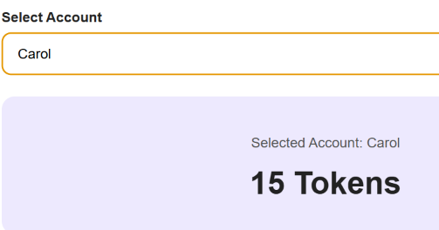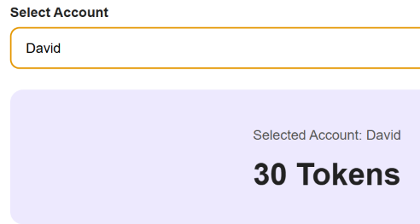
Checkpoint 2: The application should update the selected account's balance without reloading the page. => OK
Part 8. Testing the React Application

Step 15. Test Wallet Connection Events
Test Case | Action | Expected Result
TC01 | Open application | Wallet disconnected  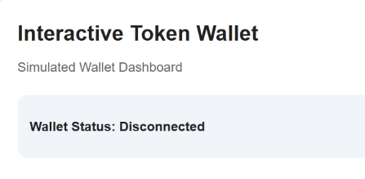
TC02 | Click Connect Wallet | Wallet connected  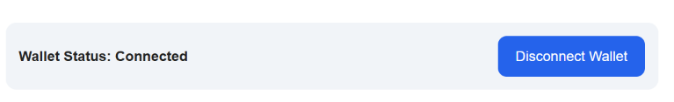
TC03 | Click Disconnect Wallet | Wallet disconnected  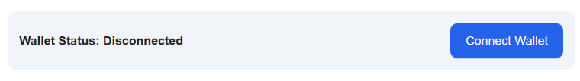
TC04 | Attempt transaction while disconnected | Deposit and Withdraw buttons disabled  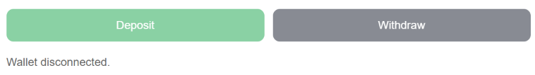

Step 16. Test Successful Transactions
Connect the simulated wallet and select Alice.
Run the following tests sequentially:
Test Case | Action | Expected Alice Balance
TC05 | Deposit 5 tokens | 25  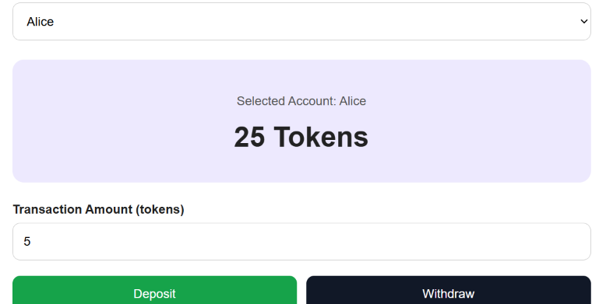
TC06 | Withdraw 8 tokens | 17  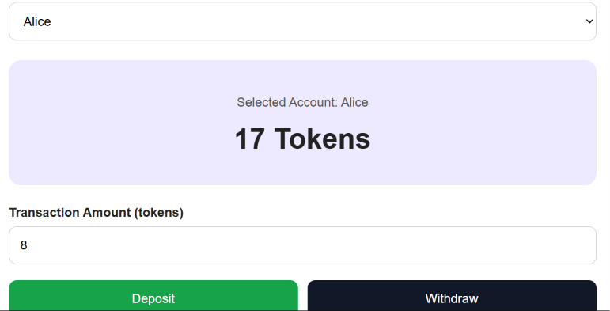
TC07 | Deposit 10 tokens | 27  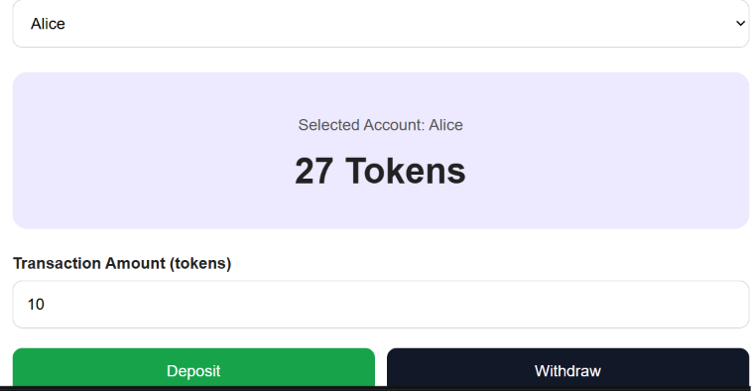
Each transaction should display a processing message for approximately 1.5 seconds before the balance changes.

Step 17. Test Invalid Transactions
Continue with Alice's balance at 27 tokens.
Test Case | Action | Expected Result
TC08 | Withdraw 100 tokens | Insufficient balance  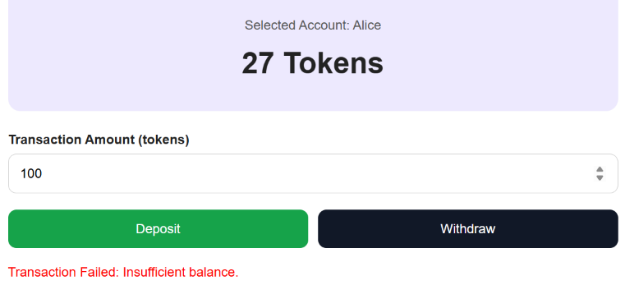
TC09 | Deposit 0 tokens | Invalid amount  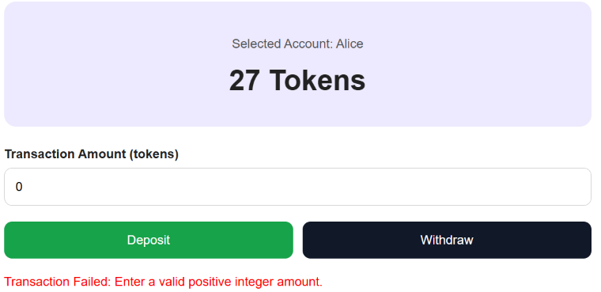
TC10 | Withdraw -5 tokens | Invalid amount  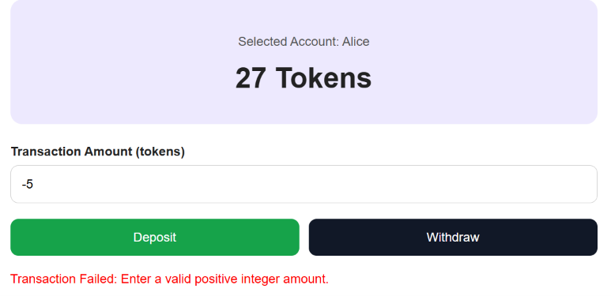
TC11 | Deposit 2.5 tokens | Invalid amount  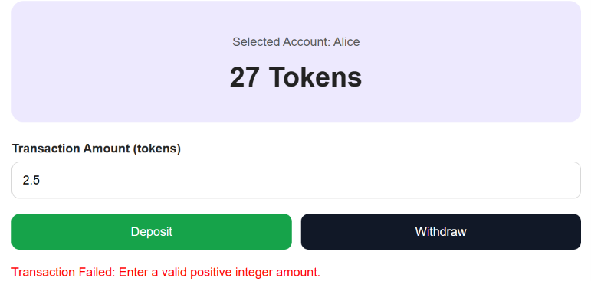
TC12 | Click Reset | Initial balances restored  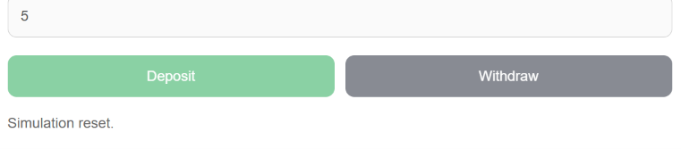
Failed transactions must not update the balance or transaction history.

Step 18. Test Account Selection
- Connect the wallet.
- Select Bob.
- Deposit 5 tokens.
- Verify Bob's balance changes from 10 to 15.
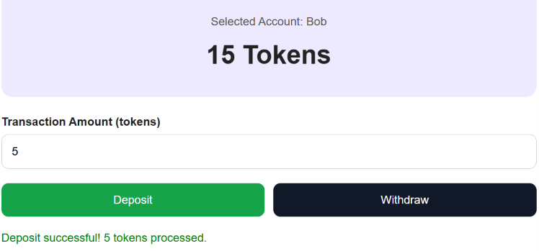
- Select Alice.
- Verify Alice's balance is unchanged.
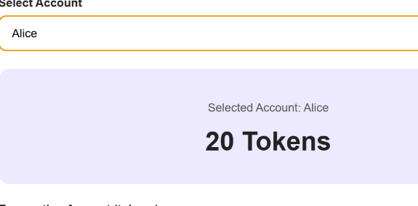
This demonstrates that React state can manage multiple account objects independently.
Part 9. Student Practice

Exercise 1. Add a Fifth Account
Add Emma with an initial balance of 25 tokens.
The new account must appear in the account selector and support deposits and withdrawals.
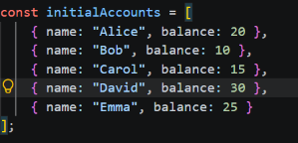

Exercise 2. Display All Account Balances
Create an AccountList component that displays the balances of Alice, Bob, Carol, David, and Emma.
The balances must update dynamically when transactions are processed.
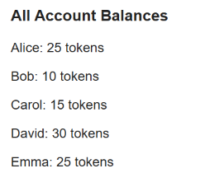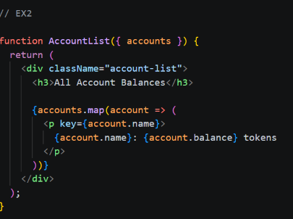

Exercise 3. Add a Transaction Summary
Display the total number of successful deposits, total number of successful withdrawals, and total number of transactions.
Use the transactions state array.
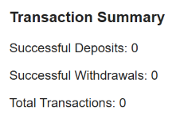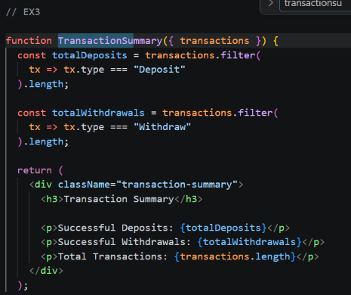

Exercise 4. Add a Clear History Button
Create a button that clears the transaction history without changing any account balances.
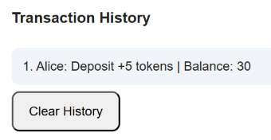

Exercise 5. Highlight Low Balances
Modify the BalanceCard component to change its background color when the selected account's balance is below 5 tokens.
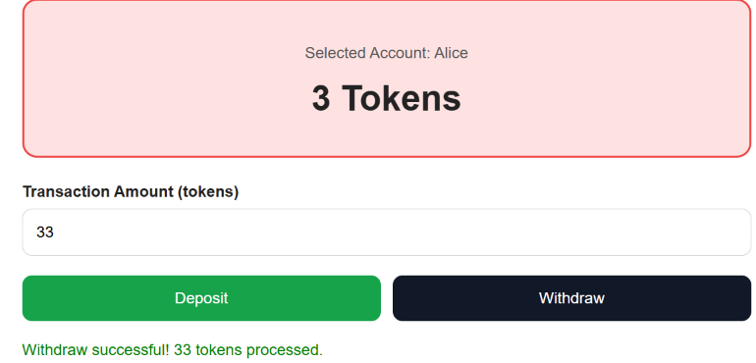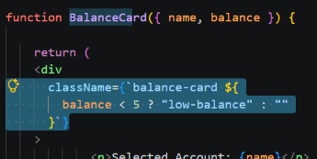

LAB 5.5 – Smart Contract Development and Deployment
Lab Topic: Solidity Smart Contracts, Compilation, Deployment, and Testing
Development Environment: Remix IDE
Integrated Mini Project: Simple Token Bank Smart Contract

1. Lab Overview
In previous labs, students developed banking and wallet simulations using JavaScript and React.
- Lab 5.1: JavaScript fundamentals and transaction logic.
- Lab 5.2: Asynchronous JavaScript and error handling.
- Lab 5.3: React components, JSX, and props.
- Lab 5.4: React state and user events.
These applications stored account balances in browser memory. Their transactions were simulations rather than blockchain transactions.
In Lab 5.5, students will develop a real Solidity smart contract, compile it, deploy it to a local Ethereum-compatible test environment, and interact with it through Remix IDE.
The integrated mini project, Simple Token Bank, will allow users to deposit and withdraw test Ether, view balances, and inspect transaction events.
Students will use Remix's simulated blockchain, so no real Ether, external wallet, or paid blockchain network is required.

2. Learning Objectives
By the end of this lab, students should be able to:
- Explain the purpose of smart contracts in blockchain applications.
- Understand the basic structure of a Solidity contract.
- Declare state variables and use mappings.
- Implement functions that read and modify blockchain state.
- Use require() to validate transactions.
- Understand msg.sender, msg.value, and payable.
- Compile and deploy a Solidity smart contract using Remix IDE.
- Test deposit and withdrawal transactions.
- Inspect transaction events and understand gas fees.
- Explain the difference between a browser-based banking simulation and a deployed smart contract.

3. Lab Activities
Part | Activity | Expected Outcome
1 | Remix IDE setup | Prepare a Solidity development environment
2 | First smart contract | Create and compile a simple contract
3 | State variables and functions | Read and update contract state
4 | Mappings and addresses | Store balances for multiple users
5 | Validation and events | Implement transaction rules
6 | Contract deployment | Deploy to Remix VM
7 | Integrated Mini Project | Build Simple Token Bank
8 | Testing and debugging | Verify deposits, withdrawals, and failures
9 | Student Practice | Extend the smart contract
10 | Lab Submission | Submit Solidity source code and evidence
Part 1. Prepare the Smart Contract Development Environment

Step 1. Open Remix IDE
- Open https://remix.ethereum.org.
- Wait for Remix IDE to load.
- Locate the File Explorer, Solidity Compiler, and Deploy & Run Transactions panels.
- Create a new workspace named INS3278_Lab55, or use an existing Solidity workspace.
- Create a folder named contracts.
Use the following project structure:
INS3278_Lab55
│
└── contracts
├── HelloBlockchain.sol
├── BalanceCounter.sol
├── AccountRegistry.sol
└── SimpleTokenBank.sol
Remix is a browser-based Solidity development environment. Unlike PlayCode, it provides built-in tools for compiling and deploying smart contracts.

Step 2. Understand the Remix Interface
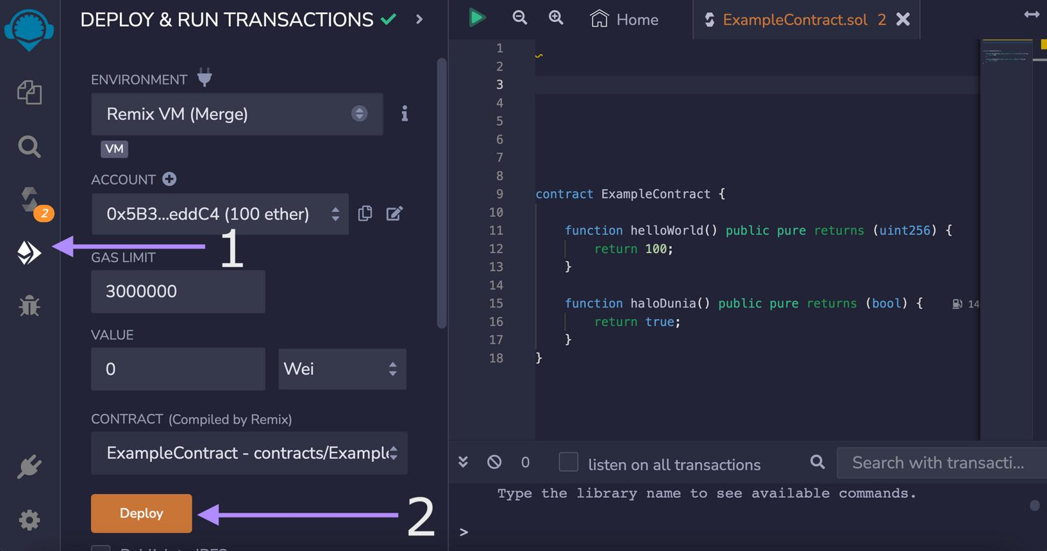
The main Remix tools used in this lab are:
Tool | Purpose
File Explorer | Create and edit Solidity files
Solidity Compiler | Compile Solidity source code
Deploy & Run Transactions | Deploy contracts and call functions
Terminal | Display deployment details, transactions, and errors

Step 3. Select the Local Blockchain Environment
In Deploy & Run Transactions, select a Remix VM environment.
Depending on the Remix version, its label may include the name of an Ethereum hard fork.
Remix VM provides simulated accounts with test Ether. Transactions execute in a local simulated blockchain environment.
Important: Do not select Mainnet or deploy to a public network for this lab.
Checkpoint 1: Students should be able to create Solidity files and identify the Remix VM environment.
Part 2. Exercise 1. Create Your First Smart Contract

Step 4. Create HelloBlockchain.sol
Create the file:
contracts/HelloBlockchain.sol
Enter:
// SPDX-License-Identifier: MIT
pragma solidity ^0.8.20;

contract HelloBlockchain {

string public message = "Hello Blockchain!";

function updateMessage(
string memory newMessage
) public {

message = newMessage;
}
}

Step 5. Understand the Contract
Solidity Code | Purpose
SPDX-License-Identifier | Identifies the source code license
pragma solidity ^0.8.20 | Specifies compatible Solidity compiler versions
contract HelloBlockchain | Declares a smart contract
string public message | Stores a text value in contract state
updateMessage() | Changes the stored message
The public keyword automatically creates a getter function for the message variable.

Step 6. Compile the Contract
- Open the Solidity Compiler panel.
- Select a compiler version compatible with ^0.8.20.
- Click Compile HelloBlockchain.sol.
- Check for compilation errors.
Expected Result: The contract compiles successfully.
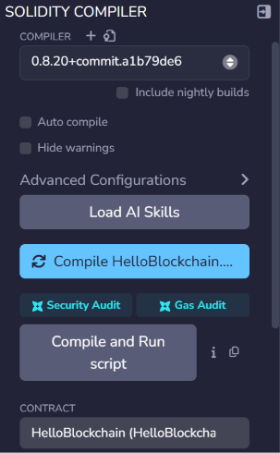

Step 7. Deploy the Contract
- Open Deploy & Run Transactions.
- Select a Remix VM environment.
- Select HelloBlockchain from the contract dropdown.
- Click Deploy.
- Expand the deployed contract under Deployed Contracts.
Click the message button.
Expected output:
Hello Blockchain!
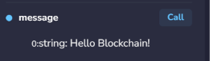
Enter:
Welcome to INS3278!
in the updateMessage field, then execute the function.
Click message again.
Expected output:
Welcome to INS3278!
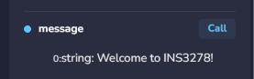

Student Task 1
Modify the contract to store a second public string variable named courseName with the value:
Blockchain for Financial Projects
Compile, deploy, and read the variable.
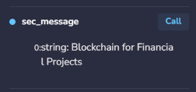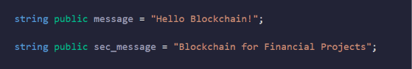
Part 3. Exercise 2. State Variables and Functions

Step 8. Create BalanceCounter.sol
Create:
contracts/BalanceCounter.sol
Enter:
// SPDX-License-Identifier: MIT
pragma solidity ^0.8.20;

contract BalanceCounter {

uint256 public balance = 20;

function deposit(uint256 amount) public {

require(amount > 0, "Amount must be positive");

balance += amount;
}

function withdraw(uint256 amount) public {

require(amount > 0, "Amount must be positive");

require(
balance >= amount,
"Insufficient balance"
);

balance -= amount;
}
}

Step 9. Compile and Deploy
Compile and deploy the contract using Remix VM.
Run the following tests:
Test Case | Function | Amount | Expected Balance
TC01 | Initial state | — | 20  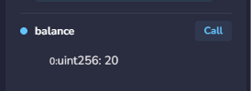
TC02 | deposit | 5 | 25  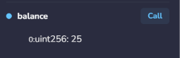
TC03 | withdraw | 8 | 17  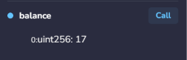
TC04 | deposit | 10 | 27  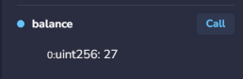
TC05 | withdraw | 100 | Reverted; balance remains 27  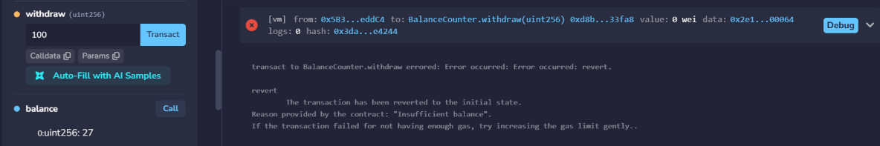

Explanation
uint256 represents a nonnegative integer.
require() checks whether a condition is satisfied. If the condition is false, the transaction reverts.
For example:
require(
balance >= amount,
"Insufficient balance"
);
prevents withdrawals that exceed the available balance.
Important: This exercise stores a numeric counter. It does not transfer Ether or tokens, and all callers modify the same counter.

Student Task 2
Add a public function named resetBalance() that resets the balance to 20.
For this introductory exercise, the function may be callable by any account. Access control will be considered in later exercises.
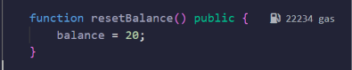
Part 4. Exercise 3. Mappings and Ethereum Addresses

Step 10. Understand Ethereum Addresses
Ethereum uses addresses to identify accounts.
A Solidity contract can identify the account that calls a function using:
msg.sender
For example, when Alice calls a contract, msg.sender refers to Alice's Ethereum address.

Step 11. Create AccountRegistry.sol
Create:
contracts/AccountRegistry.sol
Enter:
// SPDX-License-Identifier: MIT
pragma solidity ^0.8.20;

contract AccountRegistry {

mapping(address => uint256) public balances;

function addTokens(uint256 amount) public {

require(amount > 0, "Amount must be positive");

balances[msg.sender] += amount;
}

function getMyBalance()
public
view
returns (uint256)
{
return balances[msg.sender];
}
}

Step 12. Test Multiple Accounts
- Compile and deploy the contract.
- Select the first Remix VM account.
- Call addTokens(20).
- Call getMyBalance().
Expected result:
20
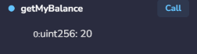
Change to a second Remix VM account.
Call getMyBalance().
Expected result:
0
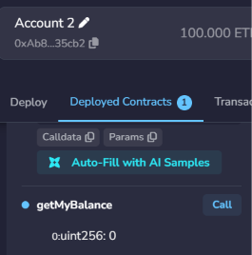
Call addTokens(10) using the second account.
Expected result:
10
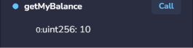
Return to the first account and call getMyBalance().
Expected result:
20
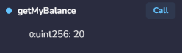

Explanation
mapping(address => uint256) public balances;
stores a separate balance for each Ethereum address.
The mapping is similar to a JavaScript object that associates an account identifier with a numeric value.
Important: addTokens() updates an internal accounting value only. It does not mint a cryptocurrency or transfer Ether.

Student Task 3
Add a function named removeTokens(uint256 amount) that subtracts tokens from the caller's recorded balance.
The function must reject zero amounts and insufficient balances.
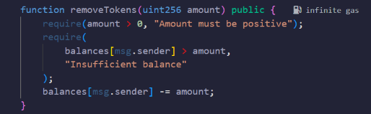
Part 5. Exercise 4. Transaction Validation and Events

Step 13. Understand Smart Contract Events
Smart contracts can emit events to record information in transaction logs.
Events are useful for DApps because front-end applications can read them to display transaction activity.

Step 14. Add an Event
Create a new contract or extend AccountRegistry.sol with the following example:
// SPDX-License-Identifier: MIT
pragma solidity ^0.8.20;

contract EventDemo {

mapping(address => uint256) public balances;

event TokensAdded(
address indexed account,
uint256 amount,
uint256 newBalance
);

function addTokens(uint256 amount) public {

require(amount > 0, "Invalid amount");

balances[msg.sender] += amount;

emit TokensAdded(
msg.sender,
amount,
balances[msg.sender]
);
}
}

Compile and deploy the contract.
Call:
addTokens(5)
Inspect the transaction details in the Remix Terminal.
The emitted event should contain the caller's address, the amount 5, and the updated balance.

Explanation
Keyword | Purpose
event | Declares a transaction event
emit | Records the event in transaction logs
indexed | Makes an event parameter searchable by topic
require() | Rejects transactions that violate conditions

Student Task 4
Add a TokensRemoved event to a withdrawal function and emit it after a successful withdrawal.
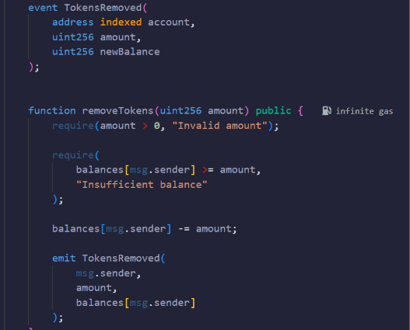
Part 6. Exercise 5. Smart Contract Deployment

Step 15. Understand Contract Deployment
A Solidity smart contract must be compiled into bytecode before it can be deployed to an Ethereum-compatible blockchain.
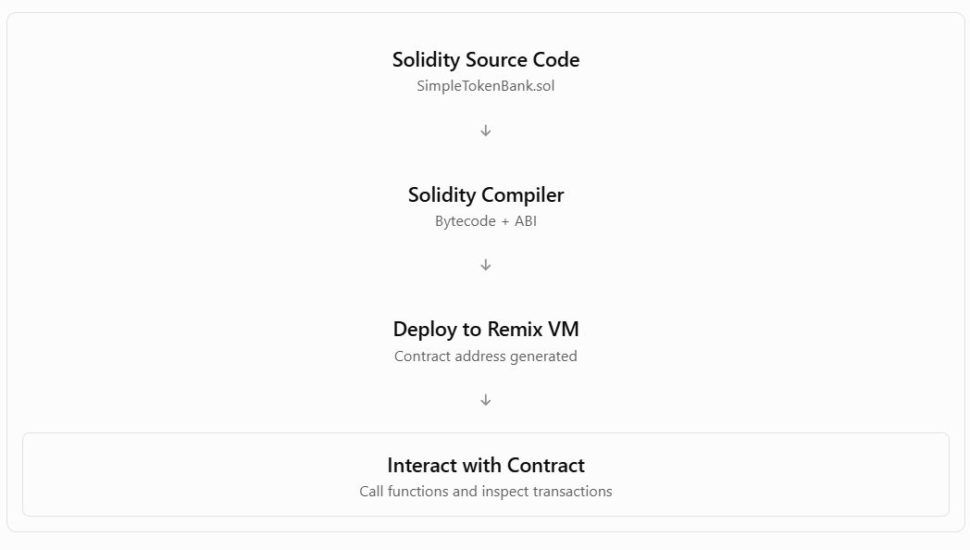
The ABI (Application Binary Interface) describes how external applications interact with a smart contract. The contract address identifies the deployed contract.

Step 16. Understand Gas Fees
Ethereum transactions require computational resources measured in gas.
Operation | Gas Required?
Deploy a contract | Yes
Change a state variable | Yes
Deposit Ether | Yes
Withdraw Ether | Yes
Read a view function directly in Remix | No transaction gas charged
A read-only call does not require an on-chain transaction when executed locally through Remix. If another contract invokes that function as part of a transaction, its execution still consumes gas.
In Remix VM, gas costs are simulated using test Ether.

Step 17. Inspect a Deployment Transaction
Deploy one of the contracts from the previous exercises.
In the Remix Terminal, inspect:
- Transaction hash.
- Contract address.
- Gas used.
- Transaction status.
- Function execution details.
Record the contract address and transaction hash for the lab submission.
Checkpoint 3: Students should be able to distinguish contract deployment from calling a function on an already deployed contract.
Part 7. Integrated Mini Project – Simple Token Bank

Step 18. Project Requirements
Build a Solidity smart contract that allows multiple Ethereum accounts to deposit and withdraw test Ether.
The contract must support:
- Depositing Ether into the contract.
- Recording individual account balances.
- Withdrawing previously deposited Ether.
- Preventing withdrawals that exceed an account's balance.
- Rejecting zero-value deposits and withdrawals.
- Displaying the caller's deposited balance.
- Displaying the total Ether held by the contract.
- Emitting deposit and withdrawal events.
Unlike the earlier BalanceCounter and AccountRegistry exercises, this project handles actual Ether transfers within Remix VM.

Step 19. Create SimpleTokenBank.sol
Create:
contracts/SimpleTokenBank.sol
Paste the following complete source code:
// SPDX-License-Identifier: MIT
pragma solidity ^0.8.20;

contract SimpleTokenBank {

// STEP 1. Account balances in wei

mapping(address => uint256) public balances;

// STEP 2. Transaction events

event Deposited(
address indexed account,
uint256 amount,
uint256 newBalance
);

event Withdrawn(
address indexed account,
uint256 amount,
uint256 newBalance
);

// STEP 3. Deposit Ether

function deposit() external payable {

require(
msg.value > 0,
"Deposit amount must be greater than zero"
);

balances[msg.sender] += msg.value;

emit Deposited(
msg.sender,
msg.value,
balances[msg.sender]
);
}

// STEP 4. Withdraw Ether

function withdraw(uint256 amount) external {

require(
amount > 0,
"Withdrawal amount must be greater than zero"
);

require(
balances[msg.sender] >= amount,
"Insufficient balance"
);

// Update state before sending Ether

balances[msg.sender] -= amount;

// Transfer Ether to the caller

(bool success, ) = payable(msg.sender).call{
value: amount
}("");

require(
success,
"Ether transfer failed"
);

emit Withdrawn(
msg.sender,
amount,
balances[msg.sender]
);
}

// STEP 5. Get caller's balance

function getMyBalance()
external
view
returns (uint256)
{
return balances[msg.sender];
}

// STEP 6. Get total contract balance

function getContractBalance()
external
view
returns (uint256)
{
return address(this).balance;
}
}

Explanation of the Main Functions
Function | Purpose
deposit() | Accepts Ether and credits the sender
withdraw(amount) | Sends previously deposited Ether back to the sender
getMyBalance() | Returns the caller's recorded balance in wei
getContractBalance() | Returns the total Ether held by the contract in wei
balances(address) | Returns the recorded balance for a specified address

Important Solidity Concepts
msg.sender identifies the caller of the current function.
msg.value is the amount of Ether sent with the call, measured in wei.
payable allows a function to receive Ether.
address(this).balance returns the contract's actual Ether balance.
The contract uses the Checks-Effects-Interactions pattern: validate the withdrawal, update the stored balance, and then transfer Ether. This is an important defense against reentrancy vulnerabilities.

Step 20. Understand Ether Units
Ethereum uses wei as its smallest unit.
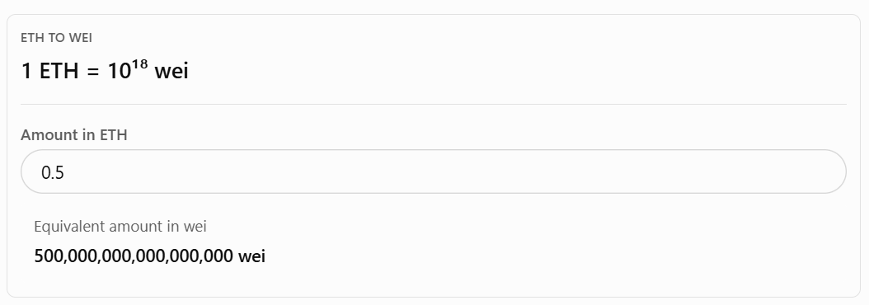
For example, when depositing 0.5 ETH, the contract records: 500000000000000000 wei

Step 21. Compile the Smart Contract
- Open SimpleTokenBank.sol.
- Select the Solidity Compiler.
- Choose a compiler version compatible with ^0.8.20.
- Click Compile SimpleTokenBank.sol.
- Confirm that compilation succeeds.
If errors occur, inspect the line numbers and correct the source code before continuing.

Step 22. Deploy to Remix VM
- Open Deploy & Run Transactions.
- Select a Remix VM environment.
- Select the first test account.
- Set VALUE to 0.
- Select SimpleTokenBank.
- Click Deploy.
- Expand the deployed contract.
Expected Result: The deployed contract displays the functions deposit, withdraw, getMyBalance, getContractBalance, and balances.
The contract initially holds no Ether.
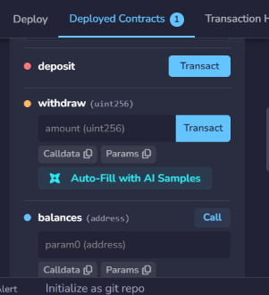

Step 23. Test the Deposit Function
In Remix:
- Select Account 1.
- Set the VALUE field to 1.
- Select the unit ether.
- Click deposit.
- Call getMyBalance().
Expected output:
1000000000000000000
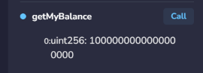
Call getContractBalance().
Expected output:
1000000000000000000
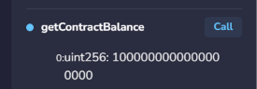
Explanation: Account 1 has deposited 1 ETH into the smart contract.

Step 24. Test the Withdrawal Function
Before calling withdraw, set the Remix VALUE field back to 0.
Enter:
500000000000000000
as the amount parameter.
Click withdraw.
Call getMyBalance() again.
Expected output:
500000000000000000
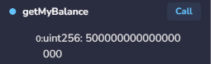
Call getContractBalance().
Expected output:
500000000000000000
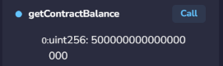
Account 1 has withdrawn 0.5 ETH, leaving 0.5 ETH deposited in the contract.

Step 25. Test Multiple Accounts
Select a second Remix VM account.
Set VALUE to 2 ether and click deposit.
Call getMyBalance().
Expected output:
2000000000000000000
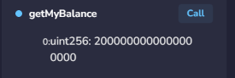
Call getContractBalance().
Expected output:
2500000000000000000
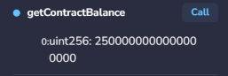
The contract now holds 2.5 ETH in total:
- Account 1: 0.5 ETH.
- Account 2: 2 ETH.
Return to Account 1 and call getMyBalance().
Expected output:
500000000000000000
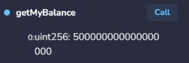
Each account's recorded balance is independent.
Part 8. Testing and Debugging

Step 26. Run the Test Cases
Use a newly deployed SimpleTokenBank contract to ensure that all tests begin with zero balances.
Test Case | Account | Operation | Expected Result
TC01 | Account 1 | Read initial balance | 0 ETH  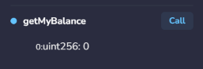
TC02 | Account 1 | Deposit 1 ETH | Account 1 balance = 1 ETH  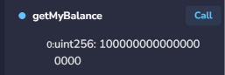
TC03 | Account 1 | Withdraw 0.5 ETH | Account 1 balance = 0.5 ETH  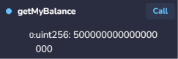
TC04 | Account 2 | Deposit 2 ETH | Account 2 balance = 2 ETH  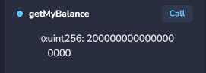
TC05 | Account 1 | Withdraw 1 ETH | Reverted: insufficient balance  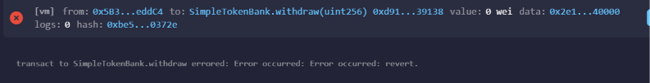
TC06 | Account 1 | Deposit 0 ETH | Reverted: invalid deposit  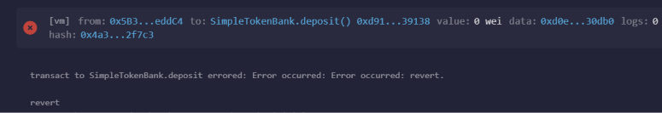
TC07 | Account 1 | Withdraw 0 wei | Reverted: invalid withdrawal
TC08 | Account 2 | Withdraw 1 ETH | Account 2 balance = 1 ETH  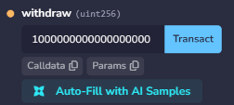
TC09 | Any account | Read contract balance | 1.5 ETH  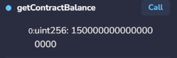
For TC05, the withdrawal input is:
1000000000000000000
For TC08, use the same amount and make sure the VALUE field is 0.
The expected final recorded balances are:
Account | Final Deposited Balance
Account 1 | 0.5 ETH
Account 2 | 1.0 ETH
Total | 1.5 ETH
The values above describe balances held inside the smart contract, not the accounts' remaining wallet balances. Wallet balances also change because transactions consume simulated gas.

Step 27. Inspect Transaction Events
After a successful deposit or withdrawal:
- Open the Remix Terminal.
- Expand the corresponding transaction.
- Locate the emitted event.
- Inspect the account address, amount, and updated balance.
For a 1 ETH deposit, the Deposited event should contain an amount of:
1000000000000000000
For a successful 0.5 ETH withdrawal, the Withdrawn event should contain:
500000000000000000

Step 28. Understand Common Errors
Error | Possible Cause | Solution
Compilation error | Incorrect Solidity syntax | Check compiler messages and line numbers
Insufficient balance | Withdrawal exceeds deposited balance | Check getMyBalance()
Deposit amount must be greater than zero | Remix VALUE is 0 | Enter a positive VALUE and choose the correct unit
Withdrawal amount must be greater than zero | Withdrawal input is 0 | Enter a positive wei amount
Unexpected balance | Wrong account selected | Verify the active Remix account
Contract not visible | Contract not deployed or environment changed | Check Deployed Contracts and the selected environment
Part 9. Student Practice

Exercise 1. Add a Minimum Deposit
Modify deposit() so that users must deposit at least 0.01 ETH.
Hint:
require(
msg.value >= 0.01 ether,
"Minimum deposit is 0.01 ETH"
);
Test deposits of 0.005 ETH, 0.01 ETH, and 0.1 ETH.
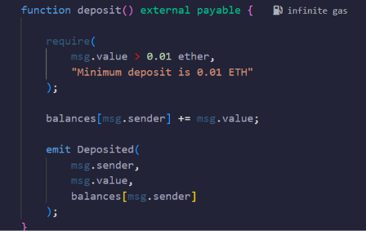

Exercise 2. Add a Maximum Withdrawal
Modify withdraw() so that a single withdrawal cannot exceed 1 ETH.
Test withdrawals above and below this limit.
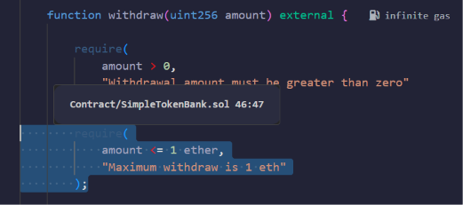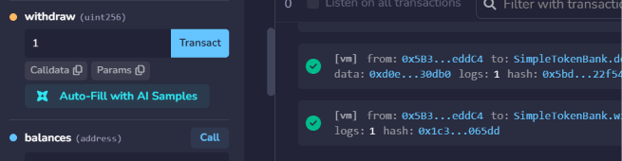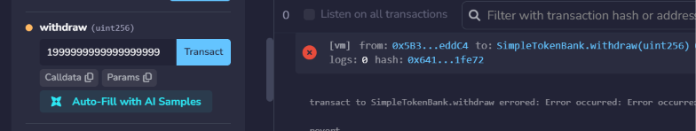

Exercise 3. Add a Transaction Counter
Create a public state variable named:
uint256 public transactionCount;
Increase the counter after every successful deposit or withdrawal.
Verify that failed transactions do not increase the counter.
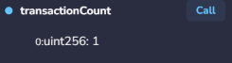

Exercise 4. Add a Deposit Statistics Function
Create a function named getAccountSummary() that returns the caller's deposited balance and the total Ether held by the contract.
Use the view keyword.
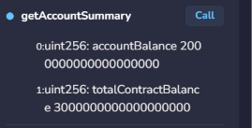

Exercise 5. Add a Transfer Function
Extend the contract with:
function transferBalance(
address receiver,
uint256 amount
) external
The function should transfer a portion of the sender's recorded deposited balance to another account's recorded balance.
Requirements:
- Reject zero-value transfers.
- Reject transfers to the zero address.
- Reject transfers to the sender's own address.
- Reject insufficient balances.
- Emit a BalanceTransferred event.
- Do not send Ether outside the contract during an internal balance transfer.
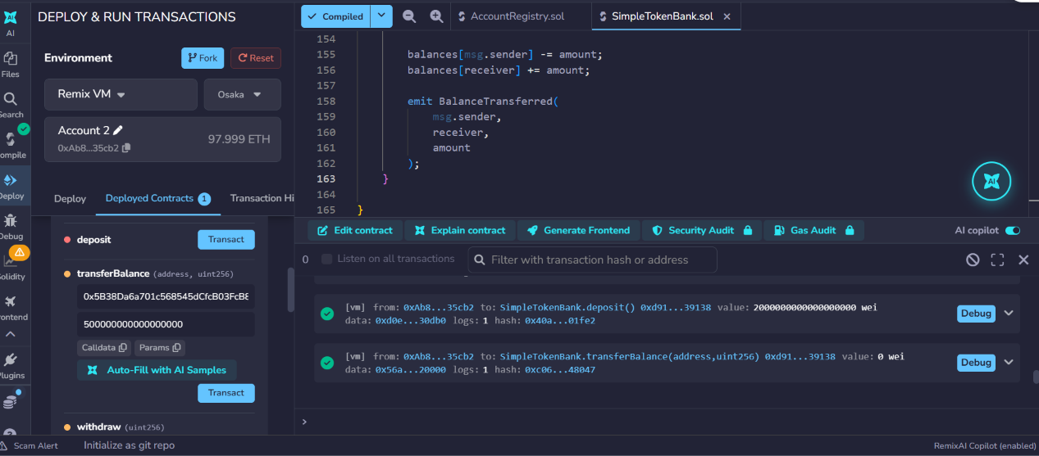

LAB 5.6 – Wallet Connection and Web3.js Integration
- Lab Topic: Ethereum Wallet Connection, Web3.js, and Smart Contract Integration
- Development Environment: PlayCode React, MetaMask, and Remix IDE
- Integrated Mini Project: Web3 Token Bank DApp

1. Lab Overview
In Lab 5.5, students developed and deployed a Solidity smart contract called SimpleTokenBank using Remix IDE.
In Lab 5.6, students will connect a React application to an Ethereum wallet using MetaMask and Web3.js.
Students will learn how a decentralized application (DApp) communicates with a blockchain through a wallet provider.
The integrated mini project, Web3 Token Bank DApp, will allow students to:
- Connect a MetaMask wallet.
- Display the connected Ethereum address.
- Display the wallet's ETH balance.
- Identify the connected blockchain network.
- Connect to the SimpleTokenBank smart contract.
- Read the user's deposited balance from the contract.
- Deposit test ETH into the contract.
- Withdraw previously deposited test ETH.
- Display transaction status and transaction hashes.
Important: Unlike the previous React banking simulations, this lab interacts with an Ethereum-compatible blockchain. Students must use a test network and test ETH only.

2. Learning Objectives
By the end of this lab, students should be able to:
- Explain the role of an Ethereum wallet in a DApp.
- Connect a React application to MetaMask.
- Understand the role of window.ethereum.
- Initialize Web3.js using an injected wallet provider.
- Retrieve the connected Ethereum account.
- Read an ETH balance using Web3.js.
- Detect the connected blockchain network.
- Create a JavaScript contract instance using its ABI and address.
- Call read-only smart contract functions.
- Send transactions to a smart contract and handle errors.

3. Lab Activities
Part | Activity | Expected Outcome
1 | Environment preparation | Prepare MetaMask, Remix, and PlayCode
2 | Wallet detection | Detect an injected Ethereum provider
3 | Wallet connection | Request wallet account access
4 | Web3.js fundamentals | Read wallet address, balance, and network
5 | React wallet state | Manage connection and account changes
6 | Smart contract connection | Load the ABI and contract address
7 | Integrated Mini Project | Build Web3 Token Bank DApp
8 | Testing | Verify wallet and contract operations
9 | Student Practice | Extend the DApp
10 | Lab Submission | Submit source code and test evidence
Part 1. Prepare the Development Environment

Step 1. Prepare MetaMask
Install MetaMask using the official website:
https://metamask.io
Use a desktop browser that supports the MetaMask extension.
- Install or open MetaMask.
- Create a dedicated learning wallet or use a wallet intended only for testing.
- Securely store its recovery phrase outside the lab environment.
- Enable the display of test networks in MetaMask.
- Select Sepolia, an Ethereum test network.
Security rules: Never share a recovery phrase or private key, never paste it into PlayCode or Remix, and never use a wallet containing real funds for classroom experiments.

Step 2. Obtain Sepolia Test ETH
Sepolia transactions require test ETH to pay gas fees.
Use an appropriate Sepolia faucet to request test ETH for the wallet address. Faucet availability and eligibility requirements may change.
Students should verify that their MetaMask balance is sufficient to cover both the deposit and gas fees.
For this lab, small test amounts such as 0.001 ETH are sufficient.

Step 3. Prepare the Smart Contract
Open Remix IDE.
Use the SimpleTokenBank.sol contract from Lab 5.5.
For reference, the contract contains the following functions:
function deposit() external payable;

function withdraw(uint256 amount) external;

function getMyBalance()
external
view
returns (uint256);

function getContractBalance()
external
view
returns (uint256);
The deposit() function accepts ETH, and the withdraw() function sends deposited ETH back to the caller.

Step 4. Deploy the Contract to Sepolia
In Remix:
- Open SimpleTokenBank.sol.
- Compile the contract.
- Open Deploy & Run Transactions.
- Select Injected Provider – MetaMask, or the equivalent injected-provider option shown in the installed Remix version.
- Approve the connection in MetaMask.
- Confirm that MetaMask is connected to Sepolia.
- Select SimpleTokenBank.
- Click Deploy.
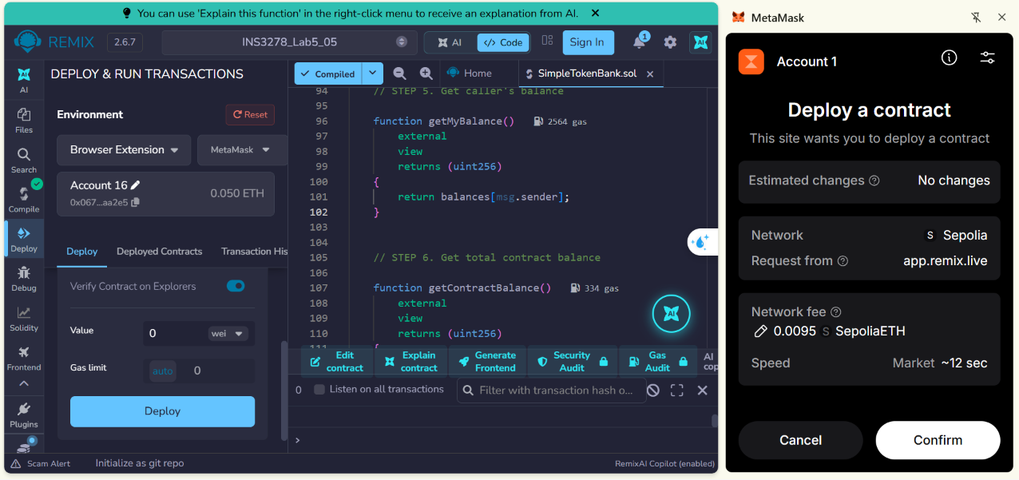
- Review the transaction in MetaMask and confirm it.

- Wait until the deployment transaction is confirmed.
Copy the deployed contract address.
Example address format:
//0x1234567890abcdef1234567890abcdef12345678

0x8e66B3b30ac0053e222dB885cC3bF455020CF499
This is an illustrative address, not a deployed contract address. Students must use the actual address generated by Remix.
Important: A contract deployed in Remix VM cannot be accessed directly from MetaMask on Sepolia. Students must deploy a new contract to Sepolia for this lab.

Step 5. Export the Contract ABI
After compiling SimpleTokenBank.sol:
- Open the Solidity Compiler panel.
- Locate the ABI option.
- Copy the contract ABI.
- Save it for the React project.
The ABI describes the functions and events that the DApp can access.

Step 6. Create a PlayCode React Project
Open PlayCode React.
Create a new project with the following structure:
Web3 Token Bank DApp
│
├── index.html
│
└── src
├── main.jsx
├── App.jsx
├── contract.js
└── styles.css
Install or add the web3 package through PlayCode's dependency manager. Use a Web3.js 4.x version.
The examples in this lab use the Web3.js v4 API.
Environment note: MetaMask must inject its provider into the page where the DApp actually runs. Some embedded editor previews run inside restricted frames. If MetaMask is not detected, open the application in a standalone preview or a browser-hosted project URL that supports wallet injection. If the PlayCode preview still does not expose the provider, use a local React development environment for the wallet-connection steps rather than bypassing wallet security.
Part 2. Exercise 1. Detect an Ethereum Wallet

Step 7. Understand window.ethereum
MetaMask and compatible browser wallets can expose an Ethereum provider to websites.
In many desktop browser setups, this provider is accessible through:
window.ethereum
The provider allows the DApp to request accounts, submit transactions, and query the connected network.
It does not give the DApp direct access to the user's private key.

Step 8. Detect MetaMask
Create the following React component in src/App.jsx:
import { useState } from "react";

export default function App() {

const [message, setMessage] = useState(
"Wallet not checked."
);

function checkWallet() {

if (typeof window.ethereum === "undefined") {
setMessage(
"No Ethereum wallet provider detected."
);
return;
}

setMessage("Ethereum wallet provider detected!");
}

return (
<div>
<h1>Wallet Detection</h1>

<button onClick={checkWallet}>
Check Wallet
</button>

<p>{message}</p>
</div>
);
}

Expected Result
If a compatible wallet provider is available:
Ethereum wallet provider detected!
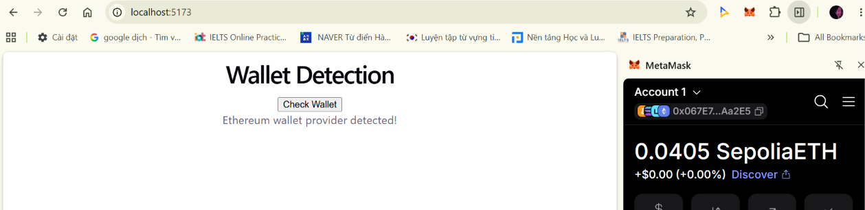
Otherwise:
No Ethereum wallet provider detected.
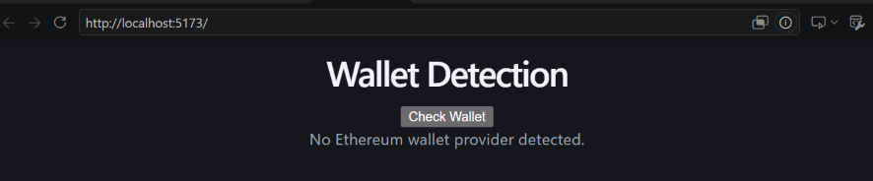
Checkpoint 1: The application correctly detects whether an injected Ethereum provider is available.

Part 3. Exercise 2. Connect to MetaMask

Step 9. Request Wallet Access
A DApp should request wallet access in response to a user action, such as clicking a Connect Wallet button.
Replace src/App.jsx with:
import { useState } from "react";

export default function App() {

const [account, setAccount] = useState("");
const [message, setMessage] = useState(
"Wallet disconnected."
);

async function connectWallet() {

try {

if (!window.ethereum) {
throw new Error(
"Please install or enable MetaMask."
);
}

const accounts = await window.ethereum.request({
method: "eth_requestAccounts"
});

if (accounts.length === 0) {
throw new Error("No account selected.");
}

setAccount(accounts[0]);

setMessage("Wallet connected successfully!");

} catch (error) {

setMessage(
"Connection failed: " + error.message
);

}
}

return (
<div>
<h1>MetaMask Connection</h1>

<button onClick={connectWallet}>
Connect Wallet
</button>

<p>{message}</p>

{account && (
<p>Account: {account}</p>
)}
</div>
);
}

Step 10. Test Wallet Connection
- Open the application in a browser context where MetaMask is available.
- Click Connect Wallet.
- Review the MetaMask connection request.
- Approve account access.
- Observe the connected wallet address.
Expected output:
Wallet connected successfully!
Account: 0x...
The actual address depends on the selected MetaMask account.
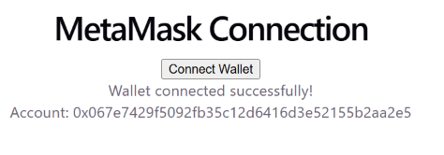

Student Task 1
Modify the application to display only the first six and last four characters of the address.
Example:
0x1234...5678
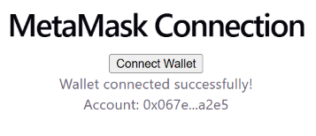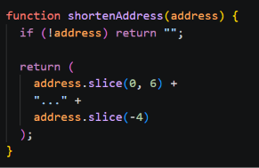
Part 4. Exercise 3. Web3.js Fundamentals

Step 11. Initialize Web3.js
Import Web3:
import { Web3 } from "web3";
Create a Web3 instance using the injected provider:
const web3 = new Web3(window.ethereum);
This allows the application to interact with the blockchain selected in MetaMask.

Step 12. Read the Wallet Balance
Use:
const balanceWei = await web3.eth.getBalance(account);
Convert the value from wei to ETH:
const balanceEth = web3.utils.fromWei(
balanceWei,
"ether"
);

Step 13. Read the Network ID
Use:
const chainId = await web3.eth.getChainId();
For Ethereum Sepolia, the chain ID is:
11155111
The chain ID identifies the network and helps prevent transactions from being sent to an unintended blockchain.

Step 14. Create a Wallet Information Component
Replace src/App.jsx with:
import { useState } from "react";
import { Web3 } from "web3";

export default function App() {

const [account, setAccount] = useState("");
const [balance, setBalance] = useState("");
const [chainId, setChainId] = useState("");
const [message, setMessage] = useState(
"Wallet disconnected."
);

async function connectWallet() {

try {

if (!window.ethereum) {
throw new Error(
"Ethereum wallet provider not found."
);
}

const web3 = new Web3(window.ethereum);

const accounts = await window.ethereum.request({
method: "eth_requestAccounts"
});

if (!accounts.length) {
throw new Error("No account selected.");
}

const selectedAccount = accounts[0];

const balanceWei =
await web3.eth.getBalance(selectedAccount);

const networkId =
await web3.eth.getChainId();

setAccount(selectedAccount);

setBalance(
web3.utils.fromWei(balanceWei, "ether")
);

setChainId(networkId.toString());

setMessage("Wallet connected!");

} catch (error) {

setMessage(
"Error: " + error.message
);

}
}

return (
<div>
<h1>Web3 Wallet Information</h1>

<button onClick={connectWallet}>
Connect Wallet
</button>

<p>{message}</p>

{account && (
<div>
<p>Address: {account}</p>
<p>Balance: {balance} ETH</p>
<p>Chain ID: {chainId}</p>
</div>
)}
</div>
);
}

Expected Result
After connecting a wallet on Sepolia:
Wallet connected!

Address: 0x...
Balance: [current test ETH balance] ETH
Chain ID: 11155111
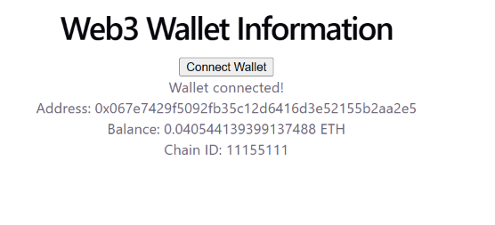
The balance depends on the account's available test ETH.

Student Task 2
Display a warning when the connected chain ID is not 11155111.
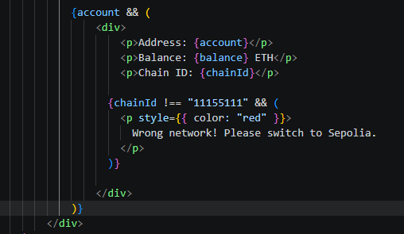
Part 5. Exercise 4. React Wallet State and Events

Step 15. Understand Wallet Events
A connected wallet can change while a DApp is open.
For example, a user may:
- Select another MetaMask account.
- Switch from Sepolia to another network.
- Revoke the website's account access.
A React DApp should respond to these changes.

Step 16. Listen for Account Changes
The Ethereum provider supports the accountsChanged event.
Example:
import { useEffect } from "react";

useEffect(() => {

if (!window.ethereum) return;

function handleAccountsChanged(accounts) {

if (accounts.length === 0) {
setAccount("");
setMessage("Wallet disconnected.");
} else {
setAccount(accounts[0]);
setMessage("Account changed.");
}
}

window.ethereum.on(
"accountsChanged",
handleAccountsChanged
);

return () => {
window.ethereum.removeListener(
"accountsChanged",
handleAccountsChanged
);
};

}, []);

The useEffect Hook registers the event listener and removes it when the component is unmounted.

Step 17. Listen for Network Changes
The provider also supports chainChanged.
Example:
useEffect(() => {

if (!window.ethereum) return;

function handleChainChanged() {
window.location.reload();
}

window.ethereum.on(
"chainChanged",
handleChainChanged
);

return () => {
window.ethereum.removeListener(
"chainChanged",
handleChainChanged
);
};

}, []);

Reloading is a simple approach for this introductory exercise. The integrated project below handles network changes through React state.
Checkpoint 2: Students can connect a wallet and understand how wallet changes affect a React application.

Part 6. Exercise 5. Connect React to a Smart Contract

Step 18. Understand the DApp Architecture
React Frontend
Wallet address, balance, deposit and withdrawal forms
Web3.js
Contract ABI, read calls, and transaction requests
MetaMask
Account access, network selection, and transaction approval
Sepolia Blockchain
Deployed SimpleTokenBank smart contract
The React interface does not directly modify blockchain balances. It uses Web3.js and MetaMask to interact with the deployed contract.

Step 19. Create the Contract Configuration
Open src/contract.js.
Paste the following code:
// Replace with the address from your Remix deployment.
export const CONTRACT_ADDRESS =
"PASTE_YOUR_SEPOLIA_CONTRACT_ADDRESS_HERE";

// Minimal ABI for the SimpleTokenBank contract from Lab 5.5.
export const CONTRACT_ABI = [
{
inputs: [],
name: "deposit",
outputs: [],
stateMutability: "payable",
type: "function"
},
{
inputs: [
{
internalType: "uint256",
name: "amount",
type: "uint256"
}
],
name: "withdraw",
outputs: [],
stateMutability: "nonpayable",
type: "function"
},
{
inputs: [],
name: "getMyBalance",
outputs: [
{
internalType: "uint256",
name: "",
type: "uint256"
}
],
stateMutability: "view",
type: "function"
},
{
inputs: [],
name: "getContractBalance",
outputs: [
{
internalType: "uint256",
name: "",
type: "uint256"
}
],
stateMutability: "view",
type: "function"
}
];

This minimal ABI includes the four functions needed for the lab. It is compatible with the SimpleTokenBank contract supplied in Lab 5.5.
Important: Replace the placeholder with the actual contract address deployed to Sepolia. The contract address is public information; a wallet private key is not.

Step 20. Create a Contract Instance
After connecting MetaMask, initialize the contract:
import { Web3 } from "web3";

import {
CONTRACT_ADDRESS,
CONTRACT_ABI
} from "./contract.js";

const web3 = new Web3(window.ethereum);

const contract = new web3.eth.Contract(
CONTRACT_ABI,
CONTRACT_ADDRESS
);
Web3.js uses the ABI and contract address to encode function calls and communicate with the deployed smart contract.

Step 21. Read a Smart Contract Balance
To read the caller's recorded balance:
const balanceWei =
await contract.methods.getMyBalance().call({
from: account
});

const balanceEth = web3.utils.fromWei(
balanceWei,
"ether"
);

console.log("Deposited Balance:", balanceEth, "ETH");
For a contract balance of 0.5 ETH, the expected console output is:
Deposited Balance: 0.5 ETH
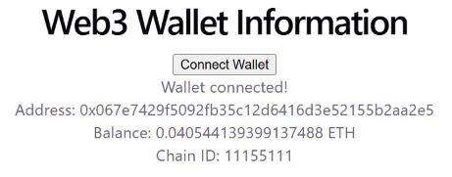
A read-only .call() does not create a blockchain transaction. Web3.js uses .send() when a state-changing transaction must be submitted.

Student Task 3
Use getContractBalance() to display the total amount of test ETH stored in the contract.
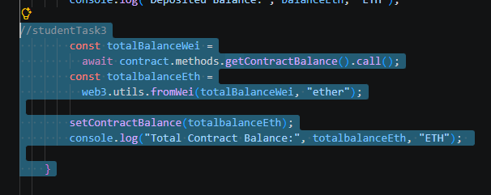
Part 7. Integrated Mini Project – Web3 Token Bank DApp

Step 22. Project Requirements
Build a React application that connects to the deployed SimpleTokenBank contract on Sepolia.
The application must support:
- MetaMask wallet connection.
- Wallet address and ETH balance display.
- Connected network detection.
- Contract balance display.
- Deposit and withdrawal transactions.
- Transaction approval through MetaMask.
- Transaction hash display.
- Loading, success, and error messages.
- Account and network change handling.

Step 23. Expected Application Interface

Web3 Token Bank

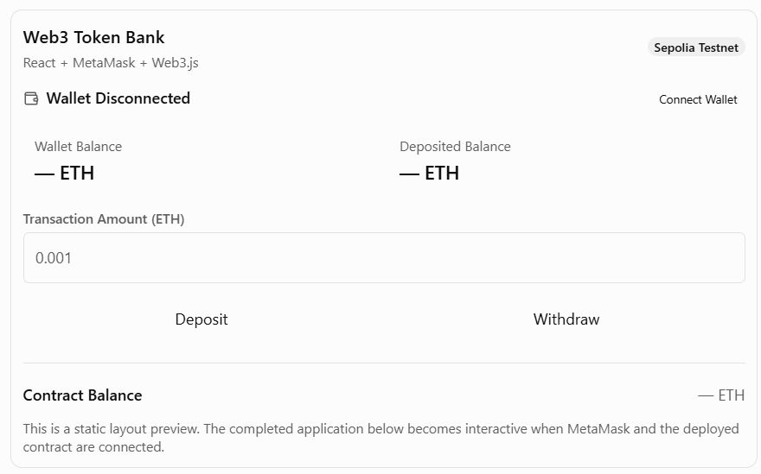

Step 24. Prepare index.html
Open index.html:
<!DOCTYPE html>
<html lang="en">
<head>
<meta charset="UTF-8">

<meta name="viewport"
content="width=device-width, initial-scale=1.0">

<title>Web3 Token Bank DApp</title>
</head>

<body>
<div id="root"></div>

<script type="module" src="/src/main.jsx"></script>
</body>
</html>

Step 25. Prepare src/main.jsx:
import React from "react";
import { createRoot } from "react-dom/client";

import App from "./App.jsx";
import "./styles.css";

createRoot(document.getElementById("root")).render(
<React.StrictMode>
<App />
</React.StrictMode>
);

Step 26. Implement the Complete React Application
Open src/App.jsx.
Replace the existing code with:
import { useEffect, useRef, useState } from "react";
import { Web3 } from "web3";

import {
CONTRACT_ADDRESS,
CONTRACT_ABI
} from "./contract.js";

const SEPOLIA_CHAIN_ID = "11155111";

function shortenAddress(address) {
if (!address) return "";
return address.slice(0, 6) + "..." + address.slice(-4);
}

function getErrorMessage(error) {
if (error?.code === 4001) {
return "Request rejected in MetaMask.";
}

return error?.message || "An unknown error occurred.";
}

export default function App() {

const [account, setAccount] = useState("");
const [chainId, setChainId] = useState("");
const [walletBalance, setWalletBalance] = useState("0");
const [depositedBalance, setDepositedBalance] = useState("0");
const [contractBalance, setContractBalance] = useState("0");

const [amount, setAmount] = useState("0.001");

const [isBusy, setIsBusy] = useState(false);
const [status, setStatus] = useState(
"Connect MetaMask to begin."
);
const [statusType, setStatusType] = useState("info");
const [transactionHash, setTransactionHash] = useState("");

const busyRef = useRef(false);
const sessionRef = useRef(0);

const isSepolia = chainId === SEPOLIA_CHAIN_ID;

const validContractAddress = Web3.utils.isAddress(
CONTRACT_ADDRESS
);

function showStatus(message, type = "info") {
setStatus(message);
setStatusType(type);
}

function clearBalances() {
setWalletBalance("0");
setDepositedBalance("0");
setContractBalance("0");
}

async function refreshBalances(
selectedAccount = account,
session = sessionRef.current
) {

if (
!window.ethereum ||
!selectedAccount ||
!validContractAddress
) {
return;
}

const web3 = new Web3(window.ethereum);
const currentChainId = (
await web3.eth.getChainId()
).toString();

if (currentChainId !== SEPOLIA_CHAIN_ID) {
return;
}

const contract = new web3.eth.Contract(
CONTRACT_ABI,
CONTRACT_ADDRESS
);

const [
walletWei,
depositedWei,
totalWei
] = await Promise.all([
web3.eth.getBalance(selectedAccount),

contract.methods.getMyBalance().call({
from: selectedAccount
}),

contract.methods.getContractBalance().call()
]);

// Ignore results from an outdated wallet session.
if (session !== sessionRef.current) {
return;
}

setWalletBalance(
web3.utils.fromWei(walletWei, "ether")
);

setDepositedBalance(
web3.utils.fromWei(depositedWei, "ether")
);

setContractBalance(
web3.utils.fromWei(totalWei, "ether")
);
}

async function connectWallet() {

if (busyRef.current) return;

busyRef.current = true;
setIsBusy(true);

try {

if (!window.ethereum) {
throw new Error(
"MetaMask provider not detected. Open the DApp " +
"in a browser page with MetaMask enabled."
);
}

showStatus("Waiting for wallet approval...");

const accounts = await window.ethereum.request({
method: "eth_requestAccounts"
});

if (!accounts.length) {
throw new Error("No wallet account available.");
}

const web3 = new Web3(window.ethereum);
const network = (
await web3.eth.getChainId()
).toString();

const session = ++sessionRef.current;

setAccount(accounts[0]);
setChainId(network);
setTransactionHash("");
clearBalances();

if (network !== SEPOLIA_CHAIN_ID) {
showStatus(
"Wrong network. Please switch MetaMask to Sepolia.",
"error"
);
return;
}

if (!validContractAddress) {
showStatus(
"Enter your deployed Sepolia contract address " +
"in src/contract.js.",
"error"
);
return;
}

await refreshBalances(accounts[0], session);

showStatus("Wallet connected successfully!", "success");

} catch (error) {

showStatus(
"Connection failed: " + getErrorMessage(error),
"error"
);

} finally {

busyRef.current = false;
setIsBusy(false);
}
}

async function switchToSepolia() {

if (!window.ethereum || busyRef.current) return;

busyRef.current = true;
setIsBusy(true);

try {

await window.ethereum.request({
method: "wallet_switchEthereumChain",
params: [
{ chainId: "0xaa36a7" }
]
});

showStatus("Network switch requested.", "info");

} catch (error) {

showStatus(
"Network switch failed: " + getErrorMessage(error),
"error"
);

} finally {

busyRef.current = false;
setIsBusy(false);
}
}

function getValidAmountWei(web3) {

if (!/^\d+(\.\d{1,18})?$/.test(amount)) {
throw new Error(
"Enter a valid ETH amount with up to 18 decimals."
);
}

const valueWei = web3.utils.toWei(amount, "ether");

if (BigInt(valueWei) <= 0n) {
throw new Error(
"Amount must be greater than zero."
);
}

return valueWei;
}

async function executeTransaction(type) {

if (
busyRef.current ||
!account ||
!isSepolia ||
!validContractAddress
) {
return;
}

busyRef.current = true;
setIsBusy(true);
setTransactionHash("");

const session = sessionRef.current;

try {

const web3 = new Web3(window.ethereum);

const accounts = await window.ethereum.request({
method: "eth_accounts"
});

const network = (
await web3.eth.getChainId()
).toString();

if (
!accounts.length ||
accounts[0].toLowerCase() !== account.toLowerCase() ||
network !== SEPOLIA_CHAIN_ID
) {
throw new Error(
"Wallet account or network changed. Reconnect first."
);
}

const valueWei = getValidAmountWei(web3);

const contract = new web3.eth.Contract(
CONTRACT_ABI,
CONTRACT_ADDRESS
);

if (type === "Withdraw") {

const currentWei =
await contract.methods.getMyBalance().call({
from: account
});

if (BigInt(valueWei) > BigInt(currentWei)) {
throw new Error(
"Insufficient deposited balance."
);
}
}

showStatus(
`Waiting for MetaMask approval: ${type}...`
);

let transaction;

if (type === "Deposit") {

transaction = contract.methods.deposit().send({
from: account,
value: valueWei
});

} else {

transaction = contract.methods.withdraw(
valueWei
).send({
from: account
});

}

transaction.on("transactionHash", hash => {
if (session === sessionRef.current) {
setTransactionHash(hash);
showStatus(
"Transaction submitted. Waiting for confirmation..."
);
}
});

const receipt = await transaction;

if (session !== sessionRef.current) {
return;
}

if (receipt.status === 0n || receipt.status === 0) {
throw new Error("Transaction reverted.");
}

setTransactionHash(receipt.transactionHash);

showStatus(
`${type} successful! Transaction confirmed.`,
"success"
);

await refreshBalances(account, session);

} catch (error) {

if (session === sessionRef.current) {
showStatus(
"Transaction failed: " + getErrorMessage(error),
"error"
);
}

} finally {

busyRef.current = false;
setIsBusy(false);
}
}

async function handleRefresh() {

if (busyRef.current || !account || !isSepolia) {
return;
}

busyRef.current = true;
setIsBusy(true);

try {
await refreshBalances();
showStatus("Balances refreshed.", "success");
} catch (error) {
showStatus(
"Refresh failed: " + getErrorMessage(error),
"error"
);
} finally {
busyRef.current = false;
setIsBusy(false);
}
}

// Restore previously authorized account access
// without opening a MetaMask approval popup.

useEffect(() => {

const provider = window.ethereum;

if (!provider) return;

let active = true;

async function restoreConnection() {

try {

const accounts = await provider.request({
method: "eth_accounts"
});

const web3 = new Web3(provider);

const network = (
await web3.eth.getChainId()
).toString();

if (!active) return;

setChainId(network);

if (!accounts.length) return;

const session = ++sessionRef.current;

setAccount(accounts[0]);

if (
network === SEPOLIA_CHAIN_ID &&
validContractAddress
) {
await refreshBalances(accounts[0], session);

if (active) {
showStatus(
"Wallet connection restored.",
"success"
);
}
}

} catch (error) {

if (active) {
showStatus(
"Could not restore wallet connection.",
"error"
);
}
}
}

function handleAccountsChanged(accounts) {

++sessionRef.current;
setTransactionHash("");
clearBalances();

if (!accounts.length) {
setAccount("");
showStatus("Wallet access removed.");
return;
}

setAccount(accounts[0]);

showStatus(
"Account changed. Click Refresh Balances.",
"info"
);
}

function handleChainChanged(hexChainId) {

++sessionRef.current;

const decimalChainId =
BigInt(hexChainId).toString();

setChainId(decimalChainId);
setTransactionHash("");
clearBalances();

showStatus(
decimalChainId === SEPOLIA_CHAIN_ID
? "Sepolia selected. Click Refresh Balances."
: "Wrong network. Switch to Sepolia.",
decimalChainId === SEPOLIA_CHAIN_ID
? "info"
: "error"
);
}

provider.on(
"accountsChanged",
handleAccountsChanged
);

provider.on(
"chainChanged",
handleChainChanged
);

restoreConnection();

return () => {

active = false;

provider.removeListener(
"accountsChanged",
handleAccountsChanged
);

provider.removeListener(
"chainChanged",
handleChainChanged
);
};

}, []);

const canTransact =
Boolean(account) &&
isSepolia &&
validContractAddress &&
!isBusy;

return (

<div className="container">

<header>
<div>
<h1>Web3 Token Bank</h1>
<p className="subtitle">
React + MetaMask + Web3.js
</p>
</div>

<span className="badge">
Sepolia Testnet
</span>
</header>

<section className="wallet-panel">

<div>
<strong>
Wallet Status:{" "}
{account ? "Connected" : "Disconnected"}
</strong>

{account && (
<p className="address">
{shortenAddress(account)}
</p>
)}
</div>

<button
id="connectBtn"
onClick={connectWallet}
disabled={isBusy}
>
{account
? "Reconnect Wallet"
: "Connect Wallet"}
</button>

</section>

<p>
Network:{" "}
<strong>
{chainId || "Not detected"}
{isSepolia ? " (Sepolia)" : ""}
</strong>
</p>

{account && !isSepolia && (
<button
className="switch-button"
onClick={switchToSepolia}
disabled={isBusy}
>
Switch to Sepolia
</button>
)}

<div className="balance-grid">

<div className="balance-card">
<p>Wallet Balance</p>
<h2>{walletBalance} ETH</h2>
</div>

<div className="balance-card deposited">
<p>Deposited Balance</p>
<h2>{depositedBalance} ETH</h2>
</div>

</div>

<label htmlFor="amount">
Transaction Amount (ETH)
</label>

<input
id="amount"
type="text"
inputMode="decimal"
value={amount}
onChange={event =>
setAmount(event.target.value)
}
disabled={isBusy}
/>

<div className="buttons">

<button
id="depositBtn"
onClick={() =>
executeTransaction("Deposit")
}
disabled={!canTransact}
>
Deposit
</button>

<button
id="withdrawBtn"
onClick={() =>
executeTransaction("Withdraw")
}
disabled={!canTransact}
>
Withdraw
</button>

</div>

<p
id="status"
className={`status ${statusType}`}
>
{status}
</p>

{transactionHash && (
<div className="transaction-result">

<strong>Transaction Hash</strong>

<p className="hash">
{transactionHash}
</p>

<a
href={
"https://sepolia.etherscan.io/tx/" +
transactionHash
}
target="_blank"
rel="noopener noreferrer"
>
View on Sepolia Etherscan
</a>

</div>
)}

<hr />

<div className="summary">

<strong>Contract Balance</strong>

<strong>{contractBalance} ETH</strong>

</div>

<button
id="refreshBtn"
onClick={handleRefresh}
disabled={!canTransact}
>
Refresh Balances
</button>

<p className="note">
Educational DApp using Sepolia test ETH only.
Do not use real funds.
</p>

</div>
);
}

Important Implementation Notes
The application uses:
React / Web3.js Feature | Purpose
useState | Stores wallet, network, balance, and transaction status
useEffect | Registers wallet event listeners
useRef | Tracks active wallet sessions and prevents duplicate requests
eth_requestAccounts | Requests wallet account access
eth_accounts | Checks previously authorized accounts
getBalance() | Reads the wallet's ETH balance
getChainId() | Detects the selected network
contract.methods...call() | Reads smart contract data
contract.methods...send() | Submits blockchain transactions
MetaMask emits accountsChanged and chainChanged events, which the DApp uses to invalidate stale balance displays when the user changes accounts or networks.
Note: This project does not implement a Disconnect Wallet button because clearing React state alone does not revoke MetaMask's website permissions. Users can manage connected sites and permissions directly in MetaMask.

Step 27. Add the Complete CSS
Open src/styles.css and paste:
* {
box-sizing: border-box;
}

body {
margin: 0;
padding: 25px;
font-family: Arial, sans-serif;
background: #f5f6fa;
color: #1f2937;
}

.container {
max-width: 850px;
margin: auto;
background: white;
border: 1px solid #e5e7eb;
border-radius: 18px;
padding: 28px;
}

header {
display: flex;
justify-content: space-between;
align-items: center;
gap: 15px;
}

h1 {
margin: 0;
font-size: 28px;
}

.subtitle {
color: #6b7280;
}

.badge {
background: #ede9fe;
color: #5b21b6;
padding: 9px 14px;
border-radius: 20px;
font-size: 13px;
white-space: nowrap;
}

.wallet-panel {
display: flex;
justify-content: space-between;
align-items: center;
gap: 15px;
padding: 20px;
margin: 25px 0;
background: #eaf3ff;
border-radius: 12px;
}

.address {
color: #4b5563;
margin-bottom: 0;
}

button {
padding: 14px 20px;
border-radius: 10px;
border: none;
cursor: pointer;
font-size: 15px;
font-weight: bold;
}

#connectBtn,
.switch-button {
background: #2563eb;
color: white;
}

.balance-grid {
display: grid;
grid-template-columns: 1fr 1fr;
gap: 15px;
margin: 25px 0;
}

.balance-card {
background: #ede9fe;
border-radius: 14px;
padding: 22px;
text-align: center;
overflow-wrap: anywhere;
}

.balance-card.deposited {
background: #e4f8e9;
}

.balance-card p {
color: #4b5563;
}

.balance-card h2 {
font-size: 27px;
margin: 10px 0;
}

label {
display: block;
margin: 15px 0 8px;
font-weight: bold;
}

input {
width: 100%;
padding: 14px;
border: 1px solid #d1d5db;
border-radius: 10px;
font-size: 16px;
}

.buttons {
display: grid;
grid-template-columns: 1fr 1fr;
gap: 12px;
margin-top: 20px;
}

#depositBtn {
background: #16a34a;
color: white;
}

#withdrawBtn {
background: #111827;
color: white;
}

button:disabled {
opacity: 0.5;
cursor: not-allowed;
}

.status {
margin-top: 20px;
padding: 14px;
border-radius: 10px;
background: #f3f4f6;
overflow-wrap: anywhere;
}

.status.success {
color: #166534;
background: #dcfce7;
}

.status.error {
color: #991b1b;
background: #fee2e2;
}

.status.info {
color: #1d4ed8;
background: #eff6ff;
}

.transaction-result {
background: #f8fafc;
padding: 15px;
border-radius: 10px;
}

.hash {
overflow-wrap: anywhere;
font-size: 13px;
}

.transaction-result a {
color: #2563eb;
}

hr {
border: none;
border-top: 1px solid #e5e7eb;
margin: 25px 0;
}

.summary {
display: flex;
justify-content: space-between;
gap: 15px;
align-items: center;
margin: 20px 0;
}

#refreshBtn {
width: 100%;
background: #f3f4f6;
border: 1px solid #d1d5db;
}

.note {
margin-top: 20px;
color: #6b7280;
font-size: 13px;
}

@media (max-width: 600px) {
header,
.wallet-panel {
flex-direction: column;
align-items: flex-start;
}

.balance-grid,
.buttons {
grid-template-columns: 1fr;
}
}

Step 28. Run the Web3 Token Bank DApp
- Verify that the web3 dependency is installed.
- Verify that CONTRACT_ADDRESS contains the correct Sepolia deployment address.
- Open the React application in a browser page where MetaMask is available.
- Select Sepolia in MetaMask.
- Click Connect Wallet.
- Approve the connection request.
- Confirm that the wallet address and ETH balance appear.
- Enter 0.001 in the transaction amount field.
- Click Deposit.
- Approve the transaction in MetaMask.
- Wait for blockchain confirmation.
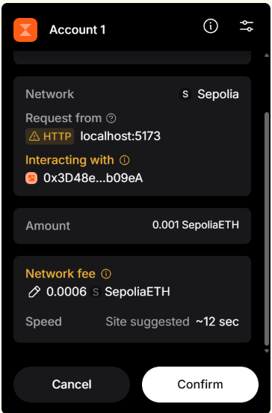
- Verify that the deposited balance increases.
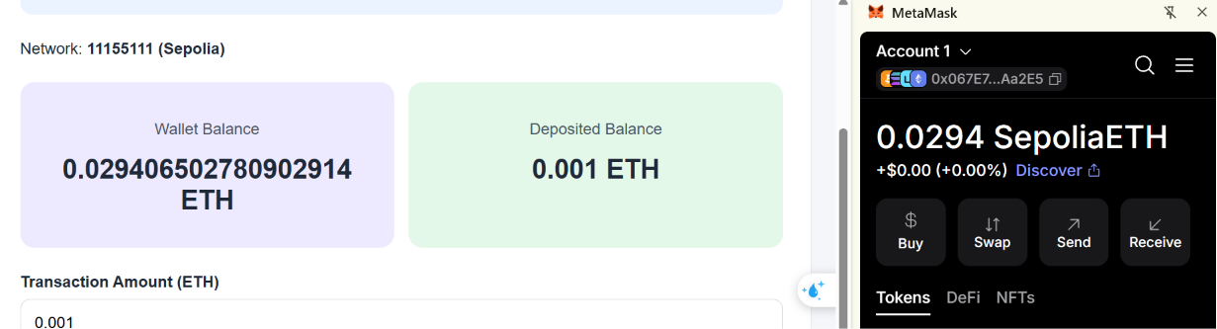
Checkpoint 3: The application displays actual Sepolia blockchain data rather than balances stored only in React state.
Part 8. Testing the Web3 DApp

Step 29. Test Wallet Connection
Test Case | Action | Expected Result
TC01 | Open application without an available wallet provider | Provider not detected  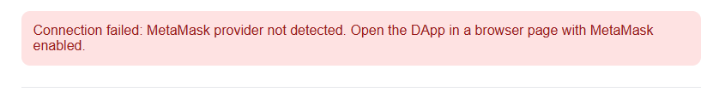
TC02 | Click Connect Wallet | MetaMask account approval request
TC03 | Approve wallet access | Connected address displayed  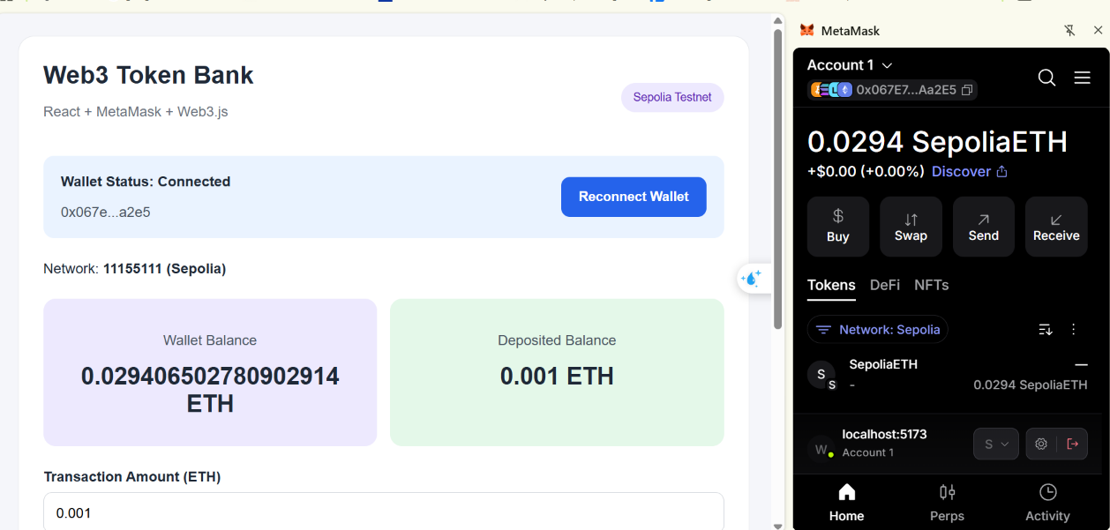
TC04 | Reject wallet access | Connection error displayed
TC05 | Switch to a network other than Sepolia | Wrong-network warning  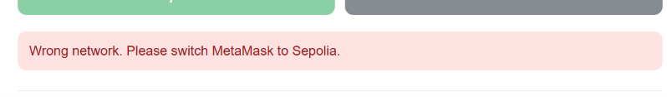
TC06 | Switch back to Sepolia | Sepolia detected  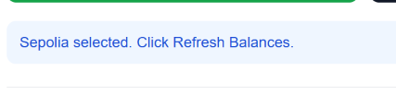
TC07 | Change MetaMask account | Account display updates; balances require refresh  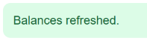

Step 30. Test Smart Contract Transactions
Start with a newly deployed contract, or use an account that has no prior deposits.
Test Case | Action | Expected Result
TC08 | Read initial deposited balance | 0 ETH  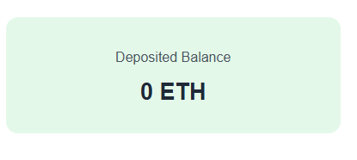
TC09 | Deposit 0.001 ETH | Deposited balance increases by 0.001 ETH  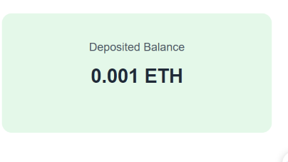
TC10 | Deposit another 0.002 ETH | Deposited balance becomes 0.003 ETH  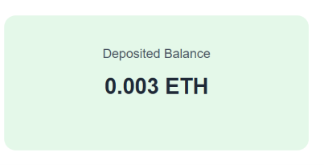
TC11 | Withdraw 0.001 ETH | Deposited balance becomes 0.002 ETH  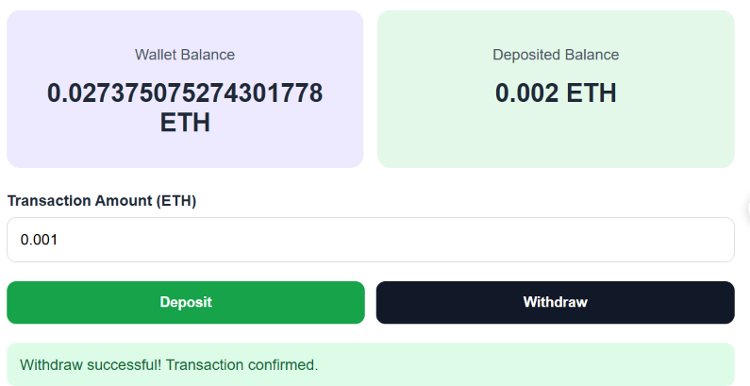
TC12 | Withdraw 1 ETH | Insufficient deposited balance  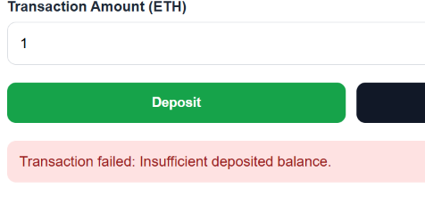
TC13 | Deposit 0 ETH | Invalid amount  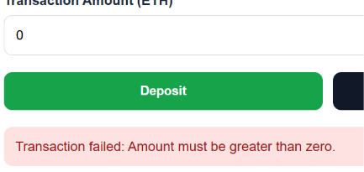
TC14 | Enter a negative amount | Invalid amount  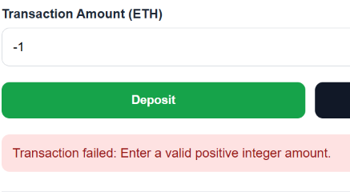
TC15 | Enter more than 18 decimal places | Invalid amount  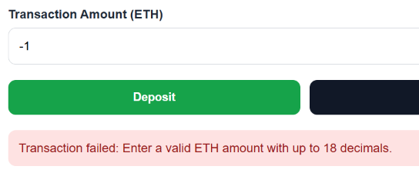  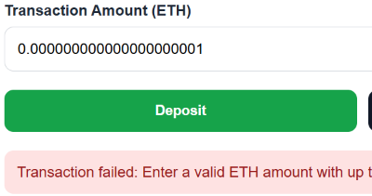
TC16 | Click Refresh Balances | Latest blockchain balances displayed  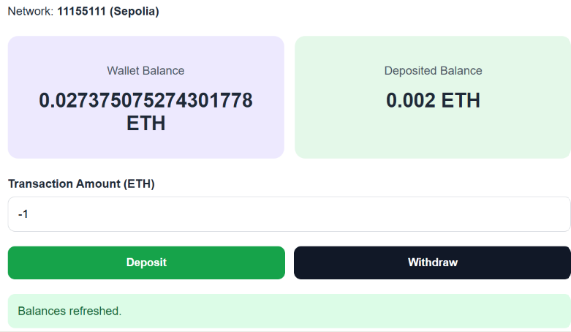
For successful transactions, students should verify that a transaction hash is displayed and can be inspected on Sepolia Etherscan.
Important: Wallet balances will also reflect gas fees. Therefore, a 0.001 ETH deposit generally reduces the wallet's balance by slightly more than 0.001 ETH.

Step 31. Verify Transaction Status -> GOOD
For a successful deposit or withdrawal, observe the following sequence:
Waiting for MetaMask approval: Deposit...
After the transaction is submitted:
Transaction submitted. Waiting for confirmation...
After confirmation:
Deposit successful! Transaction confirmed.
The exact time required depends on the Sepolia network and wallet transaction processing.
Part 9. Student Practice
Exercise 1. Display the Full Wallet Address
Add a Copy Address button that copies the connected wallet address to the clipboard.
The button must be disabled when no wallet is connected.


Exercise 2. Add a Network Indicator
Display a visual indicator showing:
- Sepolia connected.
- Wrong network.
- Wallet disconnected.
Use React conditional rendering.
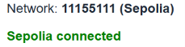

Exercise 3. Add a Transaction History
Create a TransactionHistory component that displays successful transactions initiated through the DApp during the current session.
Each record should include:
- Transaction type.
- Amount in ETH.
- Transaction hash.
- Confirmation status.
Note: React session history is not the same as retrieving historical blockchain transactions.
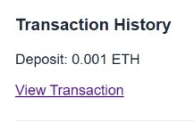

Exercise 4. Add a Maximum Deposit Limit
Prevent users from depositing more than 0.01 ETH in a single transaction.
Display a validation error before opening MetaMask.
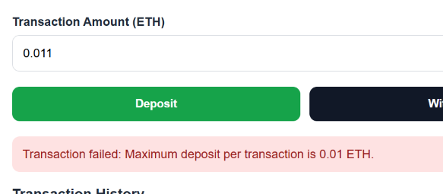

Exercise 5. Add a Contract Information Component
Create a reusable ContractInfo component displaying:
- Contract address.
- Network name.
- Chain ID.
- Total contract balance.
Pass the information through React props.
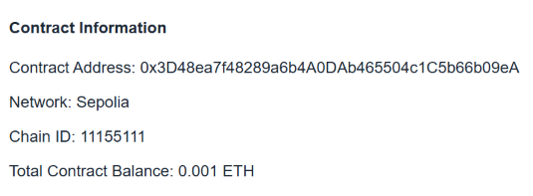

LAB 5.7 – Reading and Updating Blockchain State
- Lab Topic: Reading Smart Contract Data, Sending Transactions, and Synchronizing React State
- Development Environment: Remix IDE, MetaMask, PlayCode React, and Web3.js
- Integrated Mini Project: Blockchain Banking Dashboard – Real-Time State Management

1. Lab Overview
In Lab 5.5, students developed and deployed a Solidity smart contract. In Lab 5.6, they connected a React application to MetaMask and interacted with the deployed contract using Web3.js.
In Lab 5.7, students will focus on the difference between reading blockchain state and updating blockchain state.
Students will learn how to retrieve data stored in a smart contract, submit transactions that modify that data, wait for transaction confirmation, and update the React interface to reflect the latest blockchain state.
The integrated mini project, Blockchain Banking Dashboard, extends the SimpleTokenBank application from previous labs.
The application will display account balances, total contract deposits, transaction counts, and recent transaction activity.
All transactions must use Sepolia test ETH. No real funds are required.

2. Learning Objectives
By the end of this lab, students should be able to:
- Distinguish between read-only blockchain calls and state-changing transactions.
- Use Web3.js .call() to read smart contract state.
- Use Web3.js .send() to submit blockchain transactions.
- Read public Solidity variables and mappings.
- Retrieve transaction receipts and transaction hashes.
- Understand the relationship between transaction confirmation and React state updates.
- Use smart contract events to retrieve transaction activity.
- Handle loading states, transaction failures, and wallet changes.
- Build a React dashboard that displays blockchain-backed financial data.
- Verify blockchain state using Remix and Sepolia Etherscan.

3. Lab Activities
Part | Activity | Expected Outcome
1 | Prepare the environment | Reuse the Lab 5.6 wallet and contract
2 | Read blockchain state | Retrieve balances and contract variables
3 | Update blockchain state | Send deposit and withdrawal transactions
4 | Transaction confirmations | Retrieve transaction receipts
5 | Read blockchain events | Display confirmed transaction activity
6 | Synchronize React state | Refresh the interface after transactions
7 | Integrated Mini Project | Build Blockchain Banking Dashboard
8 | Testing and debugging | Verify read and write operations
9 | Student Practice | Extend the dashboard
10 | Lab Submission | Submit code and test evidence
Part 1. Prepare the Development Environment

Step 1. Prepare the Required Tools
Students will use the following tools:
Tool | Purpose
Remix IDE | Compile and deploy Solidity contracts
MetaMask | Connect an Ethereum account and approve transactions
PlayCode React | Develop the React frontend
Web3.js 4.x | Read blockchain data and submit transactions
Sepolia Etherscan | Inspect confirmed blockchain transactions
Students should have a MetaMask wallet connected to Sepolia with sufficient test ETH to pay transaction gas fees.
Important: Do not use Ethereum Mainnet, real ETH, private keys, or recovery phrases in this lab.

Step 2. Prepare the Smart Contract
The SimpleTokenBank contract from Lab 5.5 supports deposits, withdrawals, and balance queries.
For Lab 5.7, students will add a transaction counter and a function to retrieve account information.
Create a new Solidity file:
contracts/BlockchainBank.sol
Paste the following code:
// SPDX-License-Identifier: MIT
pragma solidity ^0.8.20;

contract BlockchainBank {

mapping(address => uint256) public balances;

uint256 public transactionCount;

event Deposited(
address indexed account,
uint256 amount,
uint256 newBalance
);

event Withdrawn(
address indexed account,
uint256 amount,
uint256 newBalance
);

function deposit() external payable {

require(
msg.value > 0,
"Deposit amount must be positive"
);

balances[msg.sender] += msg.value;

transactionCount++;

emit Deposited(
msg.sender,
msg.value,
balances[msg.sender]
);
}

function withdraw(uint256 amount) external {

require(
amount > 0,
"Withdrawal amount must be positive"
);

require(
balances[msg.sender] >= amount,
"Insufficient balance"
);

balances[msg.sender] -= amount;

transactionCount++;

(bool success, ) = payable(msg.sender).call{
value: amount
}("");

require(success, "Ether transfer failed");

emit Withdrawn(
msg.sender,
amount,
balances[msg.sender]
);
}

function getMyBalance()
external
view
returns (uint256)
{
return balances[msg.sender];
}

function getContractBalance()
external
view
returns (uint256)
{
return address(this).balance;
}

function getAccountSummary()
external
view
returns (
uint256 accountBalance,
uint256 totalContractBalance,
uint256 totalTransactions
)
{
return (
balances[msg.sender],
address(this).balance,
transactionCount
);
}
}

Contract Features
Feature | Solidity Implementation
Individual balances | mapping(address => uint256)
Transaction counter | uint256 public transactionCount
Deposit | deposit() payable
Withdrawal | withdraw(uint256 amount)
Account summary | getAccountSummary()
Transaction activity | Deposited and Withdrawn events
The contract updates the recorded balance before sending Ether during withdrawals, following the Checks-Effects-Interactions pattern.
This is a teaching example, not an audited financial contract.

Step 3. Compile and Deploy the Contract
- Open Remix IDE.
- Create BlockchainBank.sol.
- Compile with a compatible Solidity compiler.
- Open Deploy & Run Transactions.
- Select the injected MetaMask provider.
- Confirm MetaMask is connected to Sepolia.
- Select BlockchainBank.
- Deploy the contract.
- Confirm the deployment transaction in MetaMask.
- Copy the deployed contract address.
The newly deployed contract starts with:
Account Balance: 0 ETH
Contract Balance: 0 ETH
Transaction Count: 0
Checkpoint 1: Students have a deployed BlockchainBank contract on Sepolia and its address.
Part 2. Exercise 1. Reading Blockchain State

Step 4. Understand Read-Only Calls
A read-only blockchain operation retrieves data without modifying the smart contract.
Examples include reading a wallet balance, retrieving a contract balance, and checking a transaction counter.
In Web3.js, read-only contract functions are called using:
contract.methods.functionName().call()
These calls do not require MetaMask transaction approval and do not create blockchain transactions.

Step 5. Read a Public State Variable
The Solidity contract contains:
uint256 public transactionCount;
Solidity automatically creates a getter for this public variable.
In JavaScript:
const count =
await contract.methods.transactionCount().call();

console.log("Transaction Count:", count.toString());
For a newly deployed contract:
Transaction Count: 0

Step 6. Read a Mapping
The Solidity contract contains:
mapping(address => uint256) public balances;
To read the recorded balance for a specific account:
const balanceWei =
await contract.methods.balances(account).call();

const balanceEth = web3.utils.fromWei(
balanceWei,
"ether"
);

console.log("Account Balance:", balanceEth, "ETH");
The mapping getter requires an Ethereum address as its argument.

Step 7. Read Multiple Values
The getAccountSummary() function returns three values:
function getAccountSummary()
external
view
returns (
uint256 accountBalance,
uint256 totalContractBalance,
uint256 totalTransactions
);
Call it using:
const summary =
await contract.methods.getAccountSummary().call({
from: account
});

console.log(
"Account Balance:",
web3.utils.fromWei(summary[0], "ether")
);

console.log(
"Contract Balance:",
web3.utils.fromWei(summary[1], "ether")
);

console.log(
"Transaction Count:",
summary[2].toString()
);
Important: Because getAccountSummary() uses msg.sender, students must pass the connected account using { from: account }.

Student Task 1
Create a React component named AccountSummary that displays the three values returned by getAccountSummary().
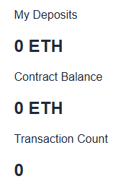
Part 3. Exercise 2. Updating Blockchain State

Step 8. Understand State-Changing Transactions
A state-changing transaction modifies data stored on the blockchain.
Examples include depositing Ether, withdrawing Ether, and incrementing a transaction counter.
In Web3.js, these operations use:
contract.methods.functionName().send({
from: account
});
The transaction must be authorized by the connected wallet.
Feature | .call() | .send()
Reads contract data | Yes | Can execute a function, but creates a transaction
Changes blockchain state | No | Yes, if execution succeeds
Requires wallet transaction approval | No | Yes, for normal wallet-initiated transactions
Consumes transaction gas | No transaction gas charged | Yes
Produces a transaction hash | No | Yes

Step 9. Deposit Test ETH
To deposit 0.001 ETH:
const amountWei = web3.utils.toWei(
"0.001",
"ether"
);

const receipt =
await contract.methods.deposit().send({
from: account,
value: amountWei
});

console.log(
"Transaction Hash:",
receipt.transactionHash
);
The deposit changes the account's recorded balance and the contract's ETH balance.
It also increases transactionCount by 1.
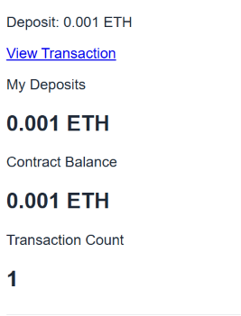

Step 10. Withdraw Test ETH
To withdraw 0.0005 ETH:
const amountWei = web3.utils.toWei(
"0.0005",
"ether"
);

const receipt =
await contract.methods.withdraw(
amountWei
).send({
from: account
});

console.log(
"Transaction Hash:",
receipt.transactionHash
);

The withdrawal reduces the account's deposited balance and the contract's ETH balance.
It also increases transactionCount by 1.
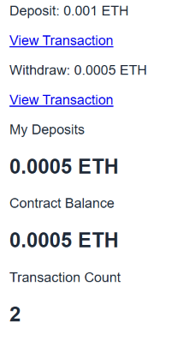

Student Task 2
Create two React buttons named Deposit and Withdraw.
Both buttons must use controlled input values and must display an error if the amount is zero, negative, or invalid.
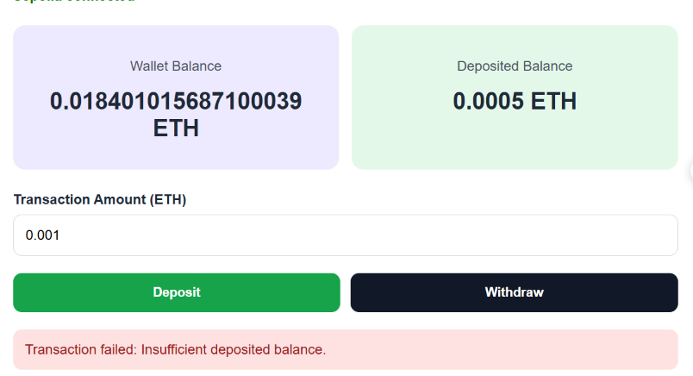
Part 4. Exercise 3. Transaction Confirmations

Step 11. Understand Transaction Status
When a user submits a blockchain transaction, several stages occur.
1. Transaction Requested
The user clicks Deposit or Withdraw
2. Wallet Approval
MetaMask asks the user to review and authorize the transaction
3. Transaction Submitted
A transaction hash becomes available
4. Transaction Included
The transaction is included in a block and a receipt becomes available
5. React State Refreshed
The DApp reads the updated contract values
A transaction hash indicates submission, not necessarily successful execution.
A transaction receipt provides execution information. A successful receipt indicates the transaction executed in its included block; additional block confirmations provide greater finality.

Step 12. Read a Transaction Receipt
const receipt =
await contract.methods.deposit().send({
from: account,
value: web3.utils.toWei("0.001", "ether")
});

console.log("Hash:", receipt.transactionHash);
console.log("Block:", receipt.blockNumber.toString());
console.log("Gas Used:", receipt.gasUsed.toString());
console.log("Status:", receipt.status);
Expected Result: The console displays a transaction hash, block number, gas used, and a successful status.

Step 13. Display a Transaction Hash
In React:
const [transactionHash, setTransactionHash] =
useState("");
After receiving the receipt:
setTransactionHash(receipt.transactionHash);
Display it:
{transactionHash && (
<a
href={
"https://sepolia.etherscan.io/tx/" +
transactionHash
}
target="_blank"
rel="noopener noreferrer"
>
View Transaction
</a>
)}

Student Task 3
Display the transaction's block number and gas used after a successful deposit or withdrawal.

Part 5. Exercise 4. Reading Smart Contract Events

Step 14. Understand Events
The BlockchainBank contract emits events when deposits and withdrawals succeed.
event Deposited(
address indexed account,
uint256 amount,
uint256 newBalance
);

event Withdrawn(
address indexed account,
uint256 amount,
uint256 newBalance
);
Events provide a convenient way for DApps to retrieve transaction activity.

Step 15. Read Deposit Events
Use Web3.js:
const events = await contract.getPastEvents(
"Deposited",
{
fromBlock: 0,
toBlock: "latest"
}
);

console.log(events);
Each event includes information such as the transaction hash, block number, and event parameters.

Step 16. Read Withdrawal Events
const events = await contract.getPastEvents(
"Withdrawn",
{
fromBlock: 0,
toBlock: "latest"
}
);

console.log(events);
Note: Public RPC providers may limit historical log queries. For classroom testing, querying from the deployment block is more efficient than querying the entire chain.

Student Task 4
Create a TransactionHistory component that displays deposit and withdrawal events for the connected account.
The component should display the transaction type, amount, and transaction hash.
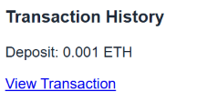
Part 6. Exercise 5. Synchronizing React State with Blockchain State

Step 17. Understand the Synchronization Problem
React stores application state locally in browser memory.
The blockchain stores smart contract state independently.
If a deposit succeeds on the blockchain, React does not automatically know the new deposited balance.
The application must read the latest contract state after the transaction is confirmed.

Step 18. Refresh Blockchain Data
Create a function:
async function refreshBlockchainState() {

const summary =
await contract.methods.getAccountSummary().call({
from: account
});

setDepositedBalance(
web3.utils.fromWei(summary[0], "ether")
);

setContractBalance(
web3.utils.fromWei(summary[1], "ether")
);

setTransactionCount(
summary[2].toString()
);
}

Call it after a successful transaction:
await contract.methods.deposit().send({
from: account,
value: amountWei
});

await refreshBlockchainState();

Step 19. Add Loading State
const [isProcessing, setIsProcessing] =
useState(false);
Before sending a transaction:
setIsProcessing(true);
After completion or failure:
setIsProcessing(false);
Disable the transaction buttons while processing:
<button disabled={isProcessing}>
Deposit
</button>
This reduces accidental duplicate submissions.

Student Task 5
Display:
Processing transaction...
while waiting for wallet approval or blockchain confirmation.
After confirmation, display:
Transaction confirmed. Blockchain state updated.
Part 7. Integrated Mini Project – Blockchain Banking Dashboard

Step 20. Project Requirements
Build a React dashboard that reads and updates blockchain state through Web3.js.
The dashboard must include:
- MetaMask wallet connection.
- Sepolia network validation.
- Wallet ETH balance.
- Deposited ETH balance.
- Total contract balance.
- Total transaction count.
- Deposit and withdrawal controls.
- Transaction hash and receipt details.
- Recent confirmed deposit and withdrawal events.
- Manual blockchain state refresh.

Step 21. Expected Application Interface

Blockchain Banking Dashboard

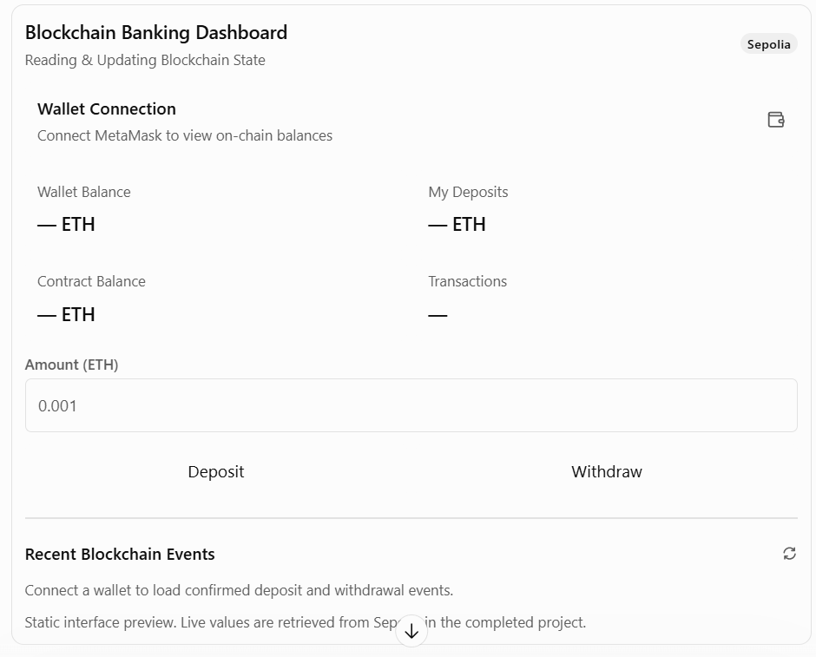

Step 22. Create the React Project
Open PlayCode React.
Create the following files:
Blockchain Banking Dashboard
│
├── index.html
│
└── src
├── main.jsx
├── App.jsx
├── contract.js
└── styles.css
Install the web3 package, using Web3.js 4.x.
The wallet must be available to the browser page running the DApp. If MetaMask is not detected in the embedded PlayCode preview, use a standalone preview or run the React project locally.

Step 23. Prepare index.html:
<!DOCTYPE html>
<html lang="en">
<head>
<meta charset="UTF-8" />

<meta name="viewport"
content="width=device-width, initial-scale=1.0" />

<title>Blockchain Banking Dashboard</title>
</head>
<body>
<div id="root"></div>

<script type="module" src="/src/main.jsx"></script>
</body>
</html>

Step 24. Prepare src/main.jsx:
import React from "react";
import { createRoot } from "react-dom/client";

import App from "./App.jsx";
import "./styles.css";

createRoot(document.getElementById("root")).render(
<React.StrictMode>
<App />
</React.StrictMode>
);

Step 25. Configure the Smart Contract
Create src/contract.js.
Replace the placeholder address with the actual Sepolia address of the BlockchainBank contract deployed in Part 1.
export const CONTRACT_ADDRESS =
"PASTE_YOUR_DEPLOYED_CONTRACT_ADDRESS_HERE";

// Enter the deployment block shown in Remix or Etherscan.
// This limits historical event queries.
export const DEPLOYMENT_BLOCK = 0;

export const CONTRACT_ABI = [
{
inputs: [],
name: "deposit",
outputs: [],
stateMutability: "payable",
type: "function"
},
{
inputs: [
{
name: "amount",
type: "uint256"
}
],
name: "withdraw",
outputs: [],
stateMutability: "nonpayable",
type: "function"
},
{
inputs: [],
name: "getAccountSummary",
outputs: [
{ name: "accountBalance", type: "uint256" },
{ name: "totalContractBalance", type: "uint256" },
{ name: "totalTransactions", type: "uint256" }
],
stateMutability: "view",
type: "function"
},
{
inputs: [],
name: "transactionCount",
outputs: [
{ name: "", type: "uint256" }
],
stateMutability: "view",
type: "function"
},
{
anonymous: false,
inputs: [
{
indexed: true,
name: "account",
type: "address"
},
{
indexed: false,
name: "amount",
type: "uint256"
},
{
indexed: false,
name: "newBalance",
type: "uint256"
}
],
name: "Deposited",
type: "event"
},
{
anonymous: false,
inputs: [
{
indexed: true,
name: "account",
type: "address"
},
{
indexed: false,
name: "amount",
type: "uint256"
},
{
indexed: false,
name: "newBalance",
type: "uint256"
}
],
name: "Withdrawn",
type: "event"
}
];

Important: The ABI and deployed address must belong to the same contract. Do not use the Lab 5.6 SimpleTokenBank address with this new BlockchainBank ABI.

Step 26. Implement the React Application
Open src/App.jsx and paste:
import { useEffect, useRef, useState } from "react";
import { Web3 } from "web3";

import {
CONTRACT_ADDRESS,
CONTRACT_ABI,
DEPLOYMENT_BLOCK
} from "./contract.js";

const SEPOLIA_CHAIN_ID = "11155111";

function shortenAddress(value) {
if (!value) return "";
return value.slice(0, 6) + "..." + value.slice(-4);
}

function errorMessage(error) {
if (error?.code === 4001) {
return "Request rejected in MetaMask.";
}

return error?.message || "Unknown error.";
}

function SummaryCard({ title, value }) {
return (
<div className="summary-card">
<p>{title}</p>
<h2>{value}</h2>
</div>
);
}

function TransactionHistory({ events }) {
return (
<section className="history-section">
<h3>Recent Blockchain Events</h3>

{events.length === 0 ? (
<p>No events found for this account.</p>
) : (
events.map(event => (
<div
className="event-item"
key={event.id}
>
<strong>{event.type}</strong>

<span>{event.amount} ETH</span>

<a
href={
"https://sepolia.etherscan.io/tx/" +
event.hash
}
target="_blank"
rel="noopener noreferrer"
>
{shortenAddress(event.hash)}
</a>
</div>
))
)}
</section>
);
}

export default function App() {

const [account, setAccount] = useState("");
const [chainId, setChainId] = useState("");

const [walletBalance, setWalletBalance] =
useState("0");

const [depositedBalance, setDepositedBalance] =
useState("0");

const [contractBalance, setContractBalance] =
useState("0");

const [transactionCount, setTransactionCount] =
useState("0");

const [amount, setAmount] = useState("0.001");

const [events, setEvents] = useState([]);

const [isProcessing, setIsProcessing] =
useState(false);

const [status, setStatus] = useState(
"Connect MetaMask to begin."
);

const [statusType, setStatusType] = useState("info");

const [transactionHash, setTransactionHash] =
useState("");

const [receiptInfo, setReceiptInfo] = useState(null);

const sessionRef = useRef(0);
const busyRef = useRef(false);

const isSepolia = chainId === SEPOLIA_CHAIN_ID;

const validContract = Web3.utils.isAddress(
CONTRACT_ADDRESS
);

function updateStatus(message, type = "info") {
setStatus(message);
setStatusType(type);
}

function clearBlockchainData() {
setWalletBalance("0");
setDepositedBalance("0");
setContractBalance("0");
setTransactionCount("0");
setEvents([]);
setTransactionHash("");
setReceiptInfo(null);
}

function getContract(web3) {
return new web3.eth.Contract(
CONTRACT_ABI,
CONTRACT_ADDRESS
);
}

async function loadEvents(
web3,
contract,
selectedAccount
) {

const filter = {
account: selectedAccount
};

const options = {
filter,
fromBlock: DEPLOYMENT_BLOCK,
toBlock: "latest"
};

const [deposits, withdrawals] = await Promise.all([
contract.getPastEvents("Deposited", options),
contract.getPastEvents("Withdrawn", options)
]);

const normalize = (items, type) =>
items.map(item => ({
id: `${item.transactionHash}-${item.logIndex}`,
type,
amount: web3.utils.fromWei(
item.returnValues.amount,
"ether"
),
hash: item.transactionHash,
blockNumber: Number(item.blockNumber),
logIndex: Number(item.logIndex)
}));

return [
...normalize(deposits, "Deposit"),
...normalize(withdrawals, "Withdraw")
]
.sort((a, b) =>
b.blockNumber - a.blockNumber ||
b.logIndex - a.logIndex
)
.slice(0, 10);
}

async function refreshBlockchainState(
selectedAccount = account,
session = sessionRef.current
) {

if (
!window.ethereum ||
!selectedAccount ||
!validContract
) {
return;
}

const web3 = new Web3(window.ethereum);

const currentChain = (
await web3.eth.getChainId()
).toString();

if (currentChain !== SEPOLIA_CHAIN_ID) {
throw new Error("Please select Sepolia.");
}

const contract = getContract(web3);

const [walletWei, summary] = await Promise.all([
web3.eth.getBalance(selectedAccount),

contract.methods.getAccountSummary().call({
from: selectedAccount
})
]);

const accountEth = web3.utils.fromWei(
summary[0],
"ether"
);

const totalEth = web3.utils.fromWei(
summary[1],
"ether"
);

const count = summary[2].toString();

if (session !== sessionRef.current) return;

setWalletBalance(
web3.utils.fromWei(walletWei, "ether")
);

setDepositedBalance(accountEth);
setContractBalance(totalEth);
setTransactionCount(count);

// Event queries may be restricted by the RPC provider.
// Balance reads should still succeed independently.

try {

const recentEvents = await loadEvents(
web3,
contract,
selectedAccount
);

if (session === sessionRef.current) {
setEvents(recentEvents);
}

} catch (error) {

if (session === sessionRef.current) {
setEvents([]);

updateStatus(
"Balances loaded, but historical events " +
"could not be retrieved. Try a smaller " +
"deployment-block range.",
"info"
);
}
}
}

async function connectWallet() {

if (busyRef.current) return;

busyRef.current = true;
setIsProcessing(true);

try {

if (!window.ethereum) {
throw new Error(
"MetaMask provider not detected."
);
}

const accounts = await window.ethereum.request({
method: "eth_requestAccounts"
});

if (!accounts.length) {
throw new Error("No wallet account available.");
}

const web3 = new Web3(window.ethereum);

const network = (
await web3.eth.getChainId()
).toString();

const session = ++sessionRef.current;

setAccount(accounts[0]);
setChainId(network);
clearBlockchainData();

if (network !== SEPOLIA_CHAIN_ID) {
updateStatus(
"Wrong network. Switch to Sepolia.",
"error"
);
return;
}

if (!validContract) {
updateStatus(
"Set your deployed contract address " +
"in src/contract.js.",
"error"
);
return;
}

await refreshBlockchainState(
accounts[0],
session
);

updateStatus(
"Wallet connected. Blockchain data loaded.",
"success"
);

} catch (error) {

updateStatus(
"Connection failed: " + errorMessage(error),
"error"
);

} finally {

busyRef.current = false;
setIsProcessing(false);
}
}

function getAmountWei(web3) {

if (!/^\d+(\.\d{1,18})?$/.test(amount)) {
throw new Error(
"Enter a valid ETH amount with up to 18 decimals."
);
}

const amountWei = web3.utils.toWei(
amount,
"ether"
);

if (BigInt(amountWei) <= 0n) {
throw new Error(
"Amount must be greater than zero."
);
}

return amountWei;
}

async function executeTransaction(type) {

if (
busyRef.current ||
!account ||
!isSepolia ||
!validContract
) {
return;
}

busyRef.current = true;
setIsProcessing(true);
setTransactionHash("");
setReceiptInfo(null);

const session = sessionRef.current;

try {

const web3 = new Web3(window.ethereum);

const activeAccounts =
await window.ethereum.request({
method: "eth_accounts"
});

const activeChain = (
await web3.eth.getChainId()
).toString();

if (
!activeAccounts.length ||
activeAccounts[0].toLowerCase() !==
account.toLowerCase() ||
activeChain !== SEPOLIA_CHAIN_ID
) {
throw new Error(
"Wallet account or network changed. " +
"Reconnect first."
);
}

const amountWei = getAmountWei(web3);

const contract = getContract(web3);

if (type === "Withdraw") {

const summary =
await contract.methods.getAccountSummary().call({
from: account
});

if (
BigInt(amountWei) >
BigInt(summary[0])
) {
throw new Error(
"Insufficient deposited balance."
);
}
}

updateStatus(
`Waiting for MetaMask approval: ${type}...`
);

const transaction =
type === "Deposit"
? contract.methods.deposit().send({
from: account,
value: amountWei
})
: contract.methods.withdraw(
amountWei
).send({
from: account
});

transaction.on("transactionHash", hash => {

if (session === sessionRef.current) {
setTransactionHash(hash);

updateStatus(
"Transaction submitted. " +
"Waiting for confirmation..."
);
}
});

const receipt = await transaction;

if (session !== sessionRef.current) return;

if (
receipt.status === 0n ||
receipt.status === 0
) {
throw new Error("Transaction reverted.");
}

setTransactionHash(receipt.transactionHash);

setReceiptInfo({
blockNumber: receipt.blockNumber.toString(),
gasUsed: receipt.gasUsed.toString()
});

await refreshBlockchainState(
account,
session
);

updateStatus(
`${type} confirmed. Blockchain state updated.`,
"success"
);

} catch (error) {

if (session === sessionRef.current) {
updateStatus(
"Transaction failed: " + errorMessage(error),
"error"
);
}

} finally {

busyRef.current = false;
setIsProcessing(false);
}
}

async function handleRefresh() {

if (
busyRef.current ||
!account ||
!isSepolia
) {
return;
}

busyRef.current = true;
setIsProcessing(true);

try {

await refreshBlockchainState();

updateStatus(
"Blockchain state refreshed.",
"success"
);

} catch (error) {

updateStatus(
"Refresh failed: " + errorMessage(error),
"error"
);

} finally {

busyRef.current = false;
setIsProcessing(false);
}
}

useEffect(() => {

const provider = window.ethereum;

if (!provider) return;

let active = true;

async function restoreConnection() {

try {

const accounts = await provider.request({
method: "eth_accounts"
});

const web3 = new Web3(provider);

const network = (
await web3.eth.getChainId()
).toString();

if (!active) return;

setChainId(network);

if (!accounts.length) return;

const session = ++sessionRef.current;

setAccount(accounts[0]);

if (
network === SEPOLIA_CHAIN_ID &&
validContract
) {
await refreshBlockchainState(
accounts[0],
session
);
}

} catch (error) {

if (active) {
updateStatus(
"Could not restore wallet data.",
"error"
);
}
}
}

function handleAccountsChanged(accounts) {

++sessionRef.current;
clearBlockchainData();

if (!accounts.length) {
setAccount("");
updateStatus("Wallet access removed.");
return;
}

setAccount(accounts[0]);

updateStatus(
"Account changed. Click Refresh State."
);
}

function handleChainChanged(hexChainId) {

++sessionRef.current;
clearBlockchainData();

const nextChain =
BigInt(hexChainId).toString();

setChainId(nextChain);

updateStatus(
nextChain === SEPOLIA_CHAIN_ID
? "Sepolia selected. Click Refresh State."
: "Wrong network. Switch to Sepolia.",
nextChain === SEPOLIA_CHAIN_ID
? "info"
: "error"
);
}

provider.on(
"accountsChanged",
handleAccountsChanged
);

provider.on(
"chainChanged",
handleChainChanged
);

restoreConnection();

return () => {

active = false;

provider.removeListener(
"accountsChanged",
handleAccountsChanged
);

provider.removeListener(
"chainChanged",
handleChainChanged
);
};

}, []);

const canTransact =
Boolean(account) &&
isSepolia &&
validContract &&
!isProcessing;

return (

<div className="container">

<header>
<div>
<h1>Blockchain Banking Dashboard</h1>

<p className="subtitle">
Reading & Updating Blockchain State
</p>
</div>

<span className="badge">
Sepolia Testnet
</span>
</header>

<section className="wallet-panel">

<div>
<strong>
Wallet:{" "}
{account ? "Connected" : "Disconnected"}
</strong>

{account && (
<p>{shortenAddress(account)}</p>
)}
</div>

<button
onClick={connectWallet}
disabled={isProcessing}
>
{account
? "Reconnect Wallet"
: "Connect Wallet"}
</button>

</section>

<p>
Network:{" "}
<strong>
{chainId || "Not detected"}
{isSepolia ? " (Sepolia)" : ""}
</strong>
</p>

<div className="summary-grid">

<SummaryCard
title="Wallet Balance"
value={`${walletBalance} ETH`}
/>

<SummaryCard
title="My Deposits"
value={`${depositedBalance} ETH`}
/>

<SummaryCard
title="Contract Balance"
value={`${contractBalance} ETH`}
/>

<SummaryCard
title="Transactions"
value={transactionCount}
/>

</div>

<label htmlFor="amount">
Transaction Amount (ETH)
</label>

<input
id="amount"
type="text"
inputMode="decimal"
value={amount}
onChange={event =>
setAmount(event.target.value)
}
disabled={isProcessing}
/>

<div className="buttons">

<button
className="deposit"
onClick={() =>
executeTransaction("Deposit")
}
disabled={!canTransact}
>
Deposit
</button>

<button
className="withdraw"
onClick={() =>
executeTransaction("Withdraw")
}
disabled={!canTransact}
>
Withdraw
</button>

</div>

<p className={`status ${statusType}`}>
{status}
</p>

{transactionHash && (
<section className="receipt">

<h3>Latest Transaction</h3>

<p className="hash">
{transactionHash}
</p>

{receiptInfo && (
<>
<p>
Block: {receiptInfo.blockNumber}
</p>

<p>
Gas Used: {receiptInfo.gasUsed}
</p>
</>
)}

<a
href={
"https://sepolia.etherscan.io/tx/" +
transactionHash
}
target="_blank"
rel="noopener noreferrer"
>
View on Sepolia Etherscan
</a>

</section>
)}

<TransactionHistory events={events} />

<button
className="refresh"
onClick={handleRefresh}
disabled={!canTransact}
>
Refresh Blockchain State
</button>

<p className="note">
Educational application using Sepolia test ETH.
Do not use real funds.
</p>

</div>
);
}

Explanation of the Integrated Project
The application combines four important concepts:
1. Blockchain reads: The dashboard retrieves wallet balances and smart contract state through Web3.js.
2. Blockchain writes: Deposits and withdrawals are submitted as transactions through MetaMask.
3. Transaction confirmation: The application waits for a transaction receipt before reporting success.
4. React synchronization: After confirmation, the application reads the updated blockchain state and updates the displayed values.
Historical events are loaded separately because some RPC providers restrict event-log queries.

Step 27. Add the CSS
Open src/styles.css and paste:
* {
box-sizing: border-box;
}

body {
margin: 0;
padding: 25px;
font-family: Arial, sans-serif;
background: #f5f6fa;
color: #1f2937;
}

.container {
max-width: 950px;
margin: auto;
padding: 30px;
background: white;
border: 1px solid #e5e7eb;
border-radius: 18px;
}

header {
display: flex;
align-items: center;
justify-content: space-between;
gap: 15px;
}

h1 {
margin: 0;
font-size: 27px;
}

.subtitle {
color: #6b7280;
}

.badge {
background: #ede9fe;
color: #5b21b6;
padding: 9px 14px;
border-radius: 20px;
font-size: 13px;
white-space: nowrap;
}

.wallet-panel {
display: flex;
justify-content: space-between;
align-items: center;
gap: 15px;
padding: 18px;
margin: 25px 0;
border-radius: 12px;
background: #eaf3ff;
}

.wallet-panel p {
margin-bottom: 0;
color: #4b5563;
}

.summary-grid {
display: grid;
grid-template-columns: repeat(2, 1fr);
gap: 14px;
margin: 25px 0;
}

.summary-card {
padding: 20px;
border-radius: 14px;
background: #ede9fe;
overflow-wrap: anywhere;
}

.summary-card:nth-child(2) {
background: #e4f8e9;
}

.summary-card:nth-child(3) {
background: #ffe8ec;
}

.summary-card:nth-child(4) {
background: #fff3d6;
}

.summary-card p {
margin-top: 0;
color: #4b5563;
}

.summary-card h2 {
margin-bottom: 0;
font-size: 25px;
}

label {
display: block;
font-weight: bold;
margin-bottom: 8px;
}

input {
width: 100%;
padding: 14px;
border: 1px solid #d1d5db;
border-radius: 10px;
font-size: 16px;
}

.buttons {
display: grid;
grid-template-columns: 1fr 1fr;
gap: 12px;
margin-top: 18px;
}

button {
padding: 14px 20px;
border: none;
border-radius: 10px;
font-size: 15px;
font-weight: bold;
cursor: pointer;
}

.wallet-panel button {
background: #2563eb;
color: white;
}

.deposit {
background: #16a34a;
color: white;
}

.withdraw {
background: #111827;
color: white;
}

button:disabled {
opacity: 0.5;
cursor: not-allowed;
}

.status {
padding: 14px;
margin: 20px 0;
border-radius: 10px;
background: #eff6ff;
overflow-wrap: anywhere;
}

.status.success {
background: #dcfce7;
color: #166534;
}

.status.error {
background: #fee2e2;
color: #991b1b;
}

.receipt {
padding: 18px;
background: #f8fafc;
border-radius: 12px;
margin-bottom: 20px;
}

.hash {
overflow-wrap: anywhere;
font-size: 13px;
}

.receipt a,
.event-item a {
color: #2563eb;
}

.history-section {
border-top: 1px solid #e5e7eb;
padding-top: 15px;
}

.event-item {
display: grid;
grid-template-columns: 1fr 1fr 1fr;
gap: 10px;
align-items: center;
padding: 14px;
margin: 8px 0;
background: #f1f4f8;
border-radius: 10px;
}

.refresh {
width: 100%;
margin-top: 20px;
background: #f3f4f6;
border: 1px solid #d1d5db;
}

.note {
color: #6b7280;
font-size: 13px;
margin-top: 20px;
}

@media (max-width: 600px) {

header,
.wallet-panel {
flex-direction: column;
align-items: flex-start;
}

.summary-grid,
.buttons {
grid-template-columns: 1fr;
}

.event-item {
grid-template-columns: 1fr;
}
}

Step 28. Run the Application
- Verify that the web3 dependency is installed.
- Enter the correct BlockchainBank address in contract.js.
- Set DEPLOYMENT_BLOCK to the block number of the contract deployment.
- Open the React application in a browser with MetaMask available.
- Select Sepolia in MetaMask.
- Click Connect Wallet.
- Confirm that the dashboard displays blockchain data.
- Deposit 0.001 ETH.
- Approve the transaction in MetaMask.
- Wait for confirmation.
- Verify that the deposited balance, contract balance, transaction count, and event history update.
Checkpoint 2: Students can read and update blockchain state from a React interface.
Part 8. Testing and Debugging

Step 29. Test Read Operations
Use a newly deployed contract and a connected Sepolia wallet.
Test Case | Action | Expected Result
TC01 | Connect MetaMask | Wallet address displayed  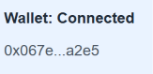
TC02 | Read wallet balance | Current Sepolia ETH balance displayed  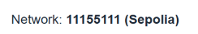
TC03 | Read deposited balance | 0 ETH initially  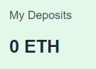
TC04 | Read contract balance | 0 ETH initially  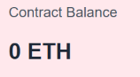
TC05 | Read transaction count | 0 initially  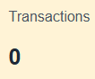
TC06 | Click Refresh Blockchain State | Values refreshed without a transaction approval request

Step 30. Test Write Operations
Run these tests sequentially on the same newly deployed contract.
Test Case | Action | Expected Deposited Balance | Expected Transaction Count
TC07 | Deposit 0.001 ETH | 0.001 ETH  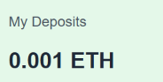 | 1
TC08 | Deposit 0.002 ETH | 0.003 ETH  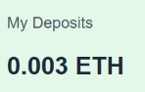 | 2
TC09 | Withdraw 0.001 ETH | 0.002 ETH  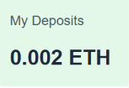 | 3
TC10 | Withdraw 1 ETH | Unchanged: 0.002 ETH | 3
TC11 | Deposit 0 ETH | Unchanged: 0.002 ETH | 3
TC12 | Withdraw a negative amount | Unchanged: 0.002 ETH | 3
For TC10, the DApp should reject the withdrawal because the deposited balance is insufficient.
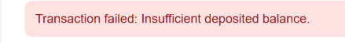
For TC11 and TC12, the DApp should reject the amount before sending a transaction.
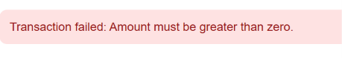

Step 31. Test Event History
After TC07–TC09, the recent event list should show three confirmed events:
Deposit 0.001 ETH
Deposit 0.002 ETH
Withdraw 0.001 ETH
The dashboard displays the newest event first.
If the RPC provider restricts event queries, students should inspect the corresponding transactions in Remix or Sepolia Etherscan and record the limitation.

Step 32. Test Wallet and Network Changes
Test Case | Action | Expected Result
TC13 | Change MetaMask account | Account display updates; stale balances cleared  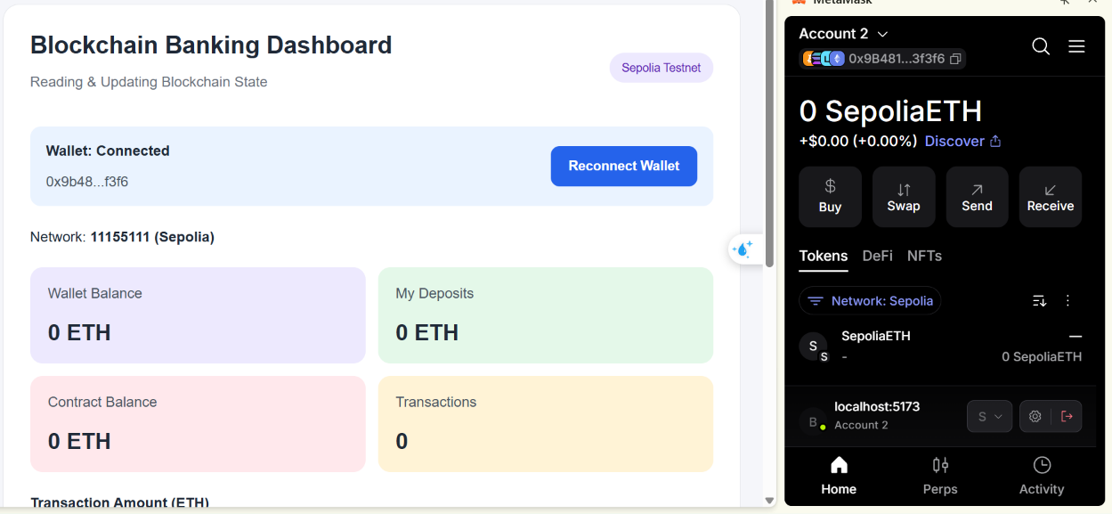
TC14 | Click Refresh Blockchain State | New account's balances loaded  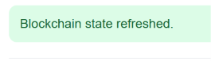
TC15 | Switch away from Sepolia | Wrong-network warning  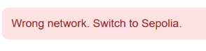
TC16 | Return to Sepolia | Network recognized  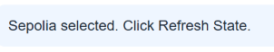
TC17 | Refresh blockchain state | Sepolia contract data loaded  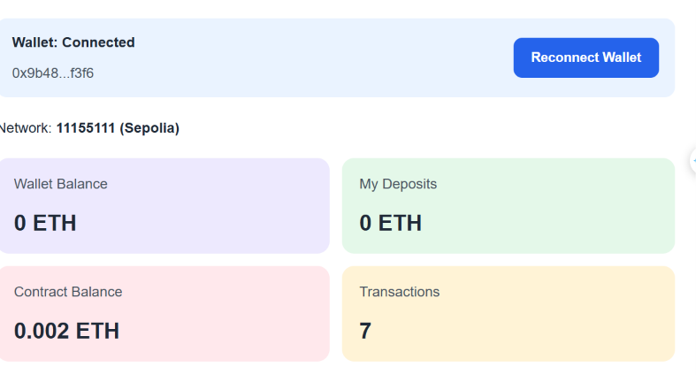
Part 9. Student Practice

Exercise 1. Add a Last Updated Timestamp
Display the time when blockchain state was last successfully refreshed.
Example:
Last Updated: 14:35:20
Use React state to store the timestamp.
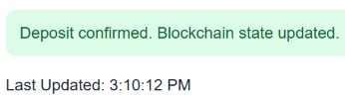

Exercise 2. Add a Read-Only Mode
Allow users to enter a public Ethereum address and read its deposited balance using the public balances(address) mapping getter.
This feature must work without requesting a transaction signature.
Update the ABI to include the balances getter.
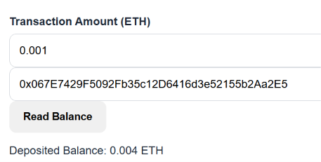

Exercise 3. Add Event Filtering
Add a dropdown with the following options:
- All Transactions.
- Deposits Only.
- Withdrawals Only.
Filter the events already loaded into React state.
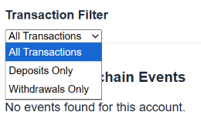

Exercise 4. Display Gas Usage
Create a TransactionReceipt component that displays the transaction hash, block number, gas used, and execution status.
Use the transaction receipt returned by Web3.js.
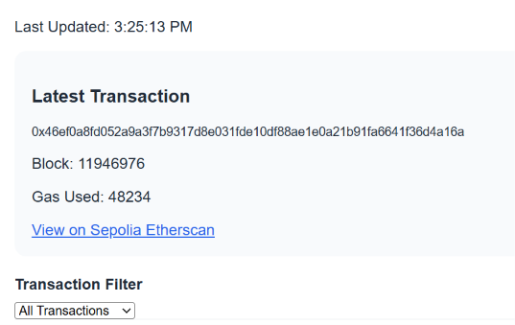

Exercise 5. Add a State Comparison
Display the deposited balance before and after a confirmed transaction.
Example:
Previous Balance: 0.001 ETH
New Balance: 0.003 ETH
Change: +0.002 ETH
Use blockchain reads rather than calculating the final balance only from the entered amount.
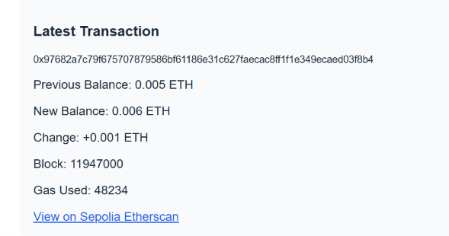

LAB 5.8 – Integrated Lab: Building a Complete SimpleStorage DApp
- Lab Topic: End-to-End DApp Development with Solidity, React, MetaMask, and Web3.js
- Development Environment: Remix IDE, PlayCode React, MetaMask, and Sepolia Testnet
- Integrated Project: SimpleStorage DApp - Blockchain Data Management

1. Lab Overview
In previous labs, students learned to develop React interfaces, create Solidity smart contracts, connect Ethereum wallets, and read and update blockchain state.
In Lab 5.8, students will integrate these skills into a complete decentralized application (DApp).
The project is a SimpleStorage DApp that allows users to store and retrieve a numeric value on the Ethereum Sepolia test network.
The DApp will allow users to:
- Connect their MetaMask wallet.
- Display the connected Ethereum account.
- Verify the Sepolia blockchain network.
- Read the current value stored in a Solidity smart contract.
- Update the stored value through a blockchain transaction.
- View the account that last updated the value.
- Display the number of successful updates.
- View the latest transaction hash and receipt.
- Retrieve recent value-update events.
- Refresh blockchain data without submitting a transaction.
Unlike a conventional React application, the stored value will remain on the blockchain even after the browser is refreshed or the DApp is reopened.
Important: This lab uses Sepolia test ETH only. Students must not use real funds or submit wallet private keys or recovery phrases.

2. Learning Objectives
By the end of this lab, students should be able to:
- Develop a Solidity smart contract for persistent data storage.
- Compile and deploy the contract using Remix IDE.
- Connect a React frontend to MetaMask.
- Initialize Web3.js using an injected Ethereum provider.
- Configure a smart contract ABI and deployed address.
- Read blockchain state using .call().
- Update blockchain state using .send().
- Validate user input before submitting transactions.
- Handle wallet approval, transaction confirmation, and errors.
- Synchronize React state with confirmed blockchain data.
- Retrieve smart contract events.
- Test and demonstrate a complete end-to-end DApp.

3. Lab Activities
Part | Activity | Expected Outcome
1 | Prepare development tools | Set up Remix, MetaMask, and React
2 | Develop SimpleStorage contract | Create Solidity storage functions
3 | Compile and deploy | Deploy the contract to Sepolia
4 | Connect React and MetaMask | Display wallet and network
5 | Read blockchain state | Retrieve the stored value
6 | Update blockchain state | Submit and confirm transactions
7 | Integrated Mini Project | Build the complete SimpleStorage DApp
8 | Testing and debugging | Verify DApp functionality
9 | Student Practice | Extend the application
10 | Lab Submission | Submit code and test evidence
Part 1. Prepare the Development Environment

Step 1. Prepare the Required Tools
Students need:
Tool | Website | Purpose
Remix IDE | Open Remix | Smart contract development and deployment
MetaMask | Open MetaMask | Wallet connection and transaction approval
PlayCode React | Open PlayCode React | React frontend development
Sepolia Etherscan | Open Etherscan | Blockchain transaction verification
Use Web3.js version 4.x for the React application.

Step 2. Prepare MetaMask
- Open MetaMask in a desktop browser.
- Select the Sepolia test network.
- Verify that the wallet contains enough Sepolia test ETH for deployment and transaction gas fees.
- Keep MetaMask available in the browser used to run the DApp.
If the wallet does not contain test ETH, obtain some through a reputable Sepolia faucet.
Security: Use a dedicated learning wallet. Never share a recovery phrase or private key.

Step 3. Understand the Complete DApp Architecture
React Frontend
Display stored value, collect input, show transaction status
Web3.js
Encode contract calls and transactions using the ABI
MetaMask
Provide account access and authorize state-changing transactions
SimpleStorage Contract – Sepolia
Persist numeric value, updater address, count, and events
A read-only call retrieves data without requiring a wallet transaction signature. Updating the stored value requires a transaction authorized through MetaMask.
Part 2. Exercise 1. Develop the SimpleStorage Smart Contract

Step 4. Create the Solidity Contract
Open Remix IDE and create:
contracts/SimpleStorage.sol
Paste the following complete code:
// SPDX-License-Identifier: MIT
pragma solidity ^0.8.20;

contract SimpleStorage {

uint256 private storedValue;

address public lastUpdatedBy;

uint256 public updateCount;

event ValueUpdated(
address indexed updatedBy,
uint256 oldValue,
uint256 newValue,
uint256 updateNumber
);

constructor() {
storedValue = 0;
}

function getValue()
external
view
returns (uint256)
{
return storedValue;
}

function setValue(uint256 newValue) external {

uint256 oldValue = storedValue;

storedValue = newValue;

lastUpdatedBy = msg.sender;

updateCount++;

emit ValueUpdated(
msg.sender,
oldValue,
newValue,
updateCount
);
}

function getStorageInfo()
external
view
returns (
uint256 value,
address updater,
uint256 updates
)
{
return (
storedValue,
lastUpdatedBy,
updateCount
);
}
}

Step 5. Understand the Smart Contract
Solidity Element | Purpose
storedValue | Stores the numeric value on the blockchain
lastUpdatedBy | Records the address of the most recent updater
updateCount | Counts successful calls to setValue()
getValue() | Returns the current stored value
setValue() | Updates the value and emits an event
getStorageInfo() | Returns the value, updater, and update count
ValueUpdated | Records successful updates in transaction logs
The stored value is a uint256, so it must be a nonnegative integer within the Solidity uint256 range.
The setValue() function is intentionally public to all accounts. Any user can update the stored value. This behavior is suitable for demonstrating a shared blockchain state, but it is not appropriate for sensitive or access-controlled data.

Step 6. Compile the Contract
- Open the Solidity Compiler panel.
- Select a compiler version compatible with ^0.8.20.
- Click Compile SimpleStorage.sol.
- Confirm that the contract compiles successfully.
Expected Result: No compilation errors.
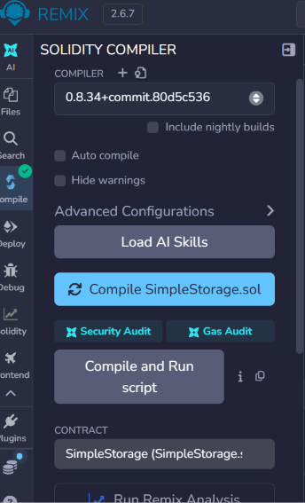

Step 7. Test the Contract in Remix VM
Before deploying to Sepolia, test the contract using Remix VM.
- Select a Remix VM environment.
- Deploy SimpleStorage.
- Call getValue().
Expected output:
0
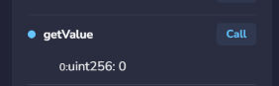
Call:
setValue(25)
Call getValue() again.
Expected output:
25
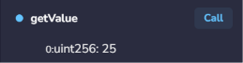
Call updateCount().
Expected output:
1
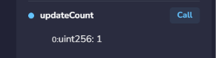
Call:
setValue(50)
Expected results:
Stored Value: 50
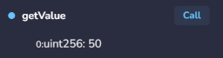
Update Count: 2
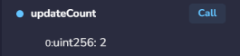
Call lastUpdatedBy() to retrieve the Ethereum address of the account that performed the latest update.
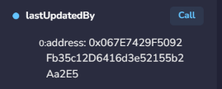

Student Task 1
Using Remix VM, update the stored value sequentially to:
10 → 25 → 100
Verify that the final value is 100 and the update count is 3 on a fresh contract deployment.
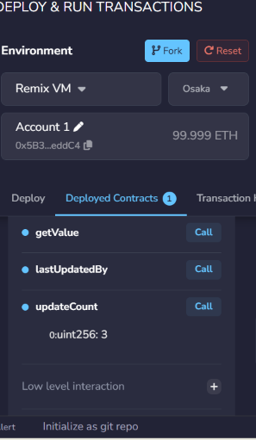
Part 3. Exercise 2. Deploy the Contract to Sepolia

Step 8. Connect Remix to MetaMask
- Open MetaMask.
- Select Sepolia.
- Return to Remix IDE.
- Open Deploy & Run Transactions.
- Select Injected Provider – MetaMask, or the equivalent injected-provider option.
- Approve the wallet connection.
- Confirm that Remix is using the correct Sepolia account.

Step 9. Deploy SimpleStorage
- Select the compiled SimpleStorage contract.
- Set the deployment VALUE to 0.
- Click Deploy.
- Review the deployment transaction in MetaMask.
- Confirm the transaction.
- Wait for confirmation.
Copy the contract address.
Example address format:
0x1234567890abcdef1234567890abcdef12345678
This is an example format only. Students must use their actual deployed address.

Step 10. Record Deployment Information
Students should record the following information for their submission:
Field | Value
Network | Sepolia
Chain ID | 11155111
Contract Name | SimpleStorage
Contract Address | Actual deployment address
Deployment Transaction Hash | Actual transaction hash
Deployment Block | Actual block number
The deployment block will be used to retrieve smart contract events efficiently.
Checkpoint 1: Students have successfully deployed SimpleStorage to Sepolia.
Part 4. Exercise 3. Connect React to MetaMask

Step 11. Create a React Project
Open PlayCode React.
Create the following project structure:
SimpleStorage DApp
│
├── index.html
│
└── src
├── main.jsx
├── App.jsx
├── contract.js
└── styles.css
Add the web3 package using PlayCode's dependency manager.
Use Web3.js 4.x.
Environment note: MetaMask must be available to the page running the DApp. If the embedded PlayCode preview does not expose window.ethereum, open a standalone preview or use a local React development environment. Do not try to work around browser wallet permissions by entering a private key into the application.

Step 12. Detect the Wallet Provider
A DApp can check whether an Ethereum provider is available:
if (!window.ethereum) {
console.log("Ethereum wallet provider not detected.");
}
A compatible wallet provider allows the application to request account access.

Step 13. Request Wallet Connection
const accounts = await window.ethereum.request({
method: "eth_requestAccounts"
});

const account = accounts[0];
The wallet connection request must be initiated by a user action.

Step 14. Read the Connected Network
import { Web3 } from "web3";

const web3 = new Web3(window.ethereum);

const chainId = await web3.eth.getChainId();

console.log(chainId.toString());
For Sepolia, the expected chain ID is:
11155111

Student Task 2
Create a Connect Wallet button that displays the connected account and shows a warning when the network is not Sepolia.
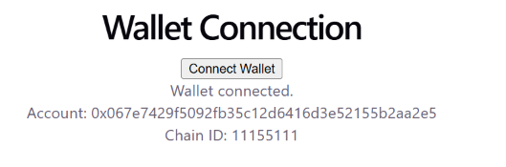
Part 5. Exercise 4 . Read Smart Contract State

Step 15. Understand the Contract ABI
The ABI describes the functions and events that a frontend can access.
A React application needs both the ABI and the deployed contract address to interact with SimpleStorage.

Step 16. Create src/contract.js
Paste the following code:
export const CONTRACT_ADDRESS =
"PASTE_YOUR_DEPLOYED_SEPOLIA_CONTRACT_ADDRESS_HERE";

// Replace 0 with the actual deployment block
// recorded in Remix or Sepolia Etherscan.
export const DEPLOYMENT_BLOCK = 0;

export const CONTRACT_ABI = [
{
inputs: [],
name: "getValue",
outputs: [
{ name: "", type: "uint256" }
],
stateMutability: "view",
type: "function"
},
{
inputs: [
{ name: "newValue", type: "uint256" }
],
name: "setValue",
outputs: [],
stateMutability: "nonpayable",
type: "function"
},
{
inputs: [],
name: "getStorageInfo",
outputs: [
{ name: "value", type: "uint256" },
{ name: "updater", type: "address" },
{ name: "updates", type: "uint256" }
],
stateMutability: "view",
type: "function"
},
{
inputs: [],
name: "lastUpdatedBy",
outputs: [
{ name: "", type: "address" }
],
stateMutability: "view",
type: "function"
},
{
inputs: [],
name: "updateCount",
outputs: [
{ name: "", type: "uint256" }
],
stateMutability: "view",
type: "function"
},
{
anonymous: false,
inputs: [
{
indexed: true,
name: "updatedBy",
type: "address"
},
{
indexed: false,
name: "oldValue",
type: "uint256"
},
{
indexed: false,
name: "newValue",
type: "uint256"
},
{
indexed: false,
name: "updateNumber",
type: "uint256"
}
],
name: "ValueUpdated",
type: "event"
}
];

Important: Replace the placeholder contract address and deployment block with the actual values from Part 3.

Step 17. Initialize the Contract
import { Web3 } from "web3";

import {
CONTRACT_ADDRESS,
CONTRACT_ABI
} from "./contract.js";

const web3 = new Web3(window.ethereum);

const contract = new web3.eth.Contract(
CONTRACT_ABI,
CONTRACT_ADDRESS
);

Step 18. Read the Stored Value
const value = await contract.methods.getValue().call();

console.log("Stored Value:", value.toString());
The .call() method retrieves blockchain data without creating a transaction.

Step 19. Read the Complete Storage Information
const info =
await contract.methods.getStorageInfo().call();

console.log("Value:", info[0].toString());
console.log("Last Updater:", info[1]);
console.log("Update Count:", info[2].toString());

Student Task 3
Display the stored value, last updater, and update count in three separate React cards.
Part 6. Exercise 5. Update Smart Contract State

Step 20. Send a State-Changing Transaction
To update the stored value:
const receipt =
await contract.methods.setValue(100).send({
from: account
});

console.log("Transaction Hash:", receipt.transactionHash);
MetaMask will ask the user to approve the transaction.
After the transaction is confirmed, the new value can be retrieved using getValue().

Step 21. Validate User Input
The DApp must reject invalid inputs before sending a transaction.
Valid examples:
0
10
25
100
999
Invalid examples:
-5
2.5
abc
The value must also fit within Solidity's uint256 range.
Use a regular expression and BigInt for validation:
function validateValue(input) {

if (!/^\d+$/.test(input)) {
throw new Error(
"Enter a nonnegative whole number."
);
}

const value = BigInt(input);

const maxUint256 = (1n << 256n) - 1n;

if (value > maxUint256) {
throw new Error(
"Value exceeds the uint256 limit."
);
}

return value.toString();
}

Step 22. Refresh the Value After Confirmation
const receipt =
await contract.methods.setValue(newValue).send({
from: account
});

const updatedValue =
await contract.methods.getValue().call();

setStoredValue(updatedValue.toString());
Checkpoint 2: Students can update the stored value through MetaMask and retrieve the confirmed value from the blockchain.
Part 7. Integrated Mini Project – Complete SimpleStorage DApp

Step 23. Project Requirements
Build a complete React application with the following features:
- Wallet connection.
- Sepolia network detection.
- Current stored value.
- Last updater address.
- Total successful updates.
- Input for a new value.
- Update Value button.
- Transaction loading and confirmation status.
- Transaction hash, block number, and gas used.
- Recent ValueUpdated events.
- Refresh Blockchain Data button.

Step 24. Expected Application Interface

SimpleStorage DApp
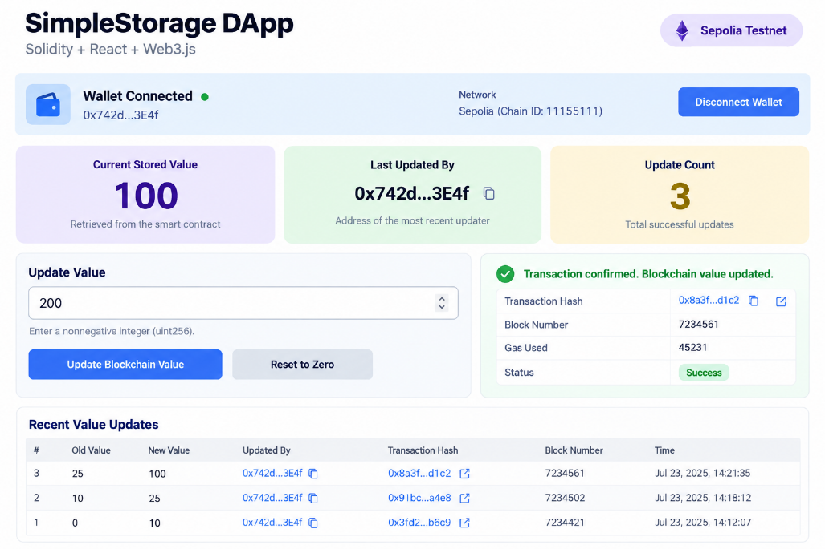

Step 25. Prepare index.html:
<!DOCTYPE html>
<html lang="en">
<head>
<meta charset="UTF-8" />

<meta name="viewport"
content="width=device-width, initial-scale=1.0" />

<title>SimpleStorage DApp</title>
</head>
<body>
<div id="root"></div>

<script type="module" src="/src/main.jsx"></script>
</body>
</html>

Step 26. Prepare src/main.jsx:
import React from "react";
import { createRoot } from "react-dom/client";

import App from "./App.jsx";
import "./styles.css";

createRoot(document.getElementById("root")).render(
<React.StrictMode>
<App />
</React.StrictMode>
);

Step 27. Implement src/App.jsx:
Paste the following complete code:
import { useEffect, useRef, useState } from "react";
import { Web3 } from "web3";

import {
CONTRACT_ADDRESS,
CONTRACT_ABI,
DEPLOYMENT_BLOCK
} from "./contract.js";

const SEPOLIA_CHAIN_ID = "11155111";

const ZERO_ADDRESS =
"0x0000000000000000000000000000000000000000";

function shortenAddress(value) {
if (!value) return "—";
return value.slice(0, 6) + "..." + value.slice(-4);
}

function getErrorMessage(error) {
if (error?.code === 4001) {
return "Request rejected in MetaMask.";
}
return error?.message || "Unknown error.";
}

function validateValue(input) {

if (!/^\d+$/.test(input)) {
throw new Error(
"Enter a nonnegative whole number."
);
}

const value = BigInt(input);
const maxUint256 = (1n << 256n) - 1n;

if (value > maxUint256) {
throw new Error(
"Value exceeds the uint256 limit."
);
}

return value.toString();
}

function InfoCard({ label, value }) {
return (
<div className="info-card">
<p>{label}</p>
<strong>{value}</strong>
</div>
);
}

function UpdateHistory({ events }) {
return (
<section className="history">
<h3>Recent Value Updates</h3>

{events.length === 0 ? (
<p>No update events found.</p>
) : (
events.map(event => (
<div
className="history-item"
key={event.id}
>
<div>
<strong>
{event.oldValue}
{" → "}
{event.newValue}
</strong>

<p>
By {shortenAddress(event.updater)}
</p>
</div>

<a
href={
"https://sepolia.etherscan.io/tx/" +
event.hash
}
target="_blank"
rel="noopener noreferrer"
>
View Transaction
</a>
</div>
))
)}
</section>
);
}

export default function App() {

const [account, setAccount] = useState("");
const [chainId, setChainId] = useState("");

const [storedValue, setStoredValue] =
useState("—");

const [lastUpdatedBy, setLastUpdatedBy] =
useState(ZERO_ADDRESS);

const [updateCount, setUpdateCount] =
useState("0");

const [newValue, setNewValue] = useState("");

const [events, setEvents] = useState([]);

const [status, setStatus] = useState(
"Connect MetaMask to begin."
);

const [statusType, setStatusType] =
useState("info");

const [isProcessing, setIsProcessing] =
useState(false);

const [transactionHash, setTransactionHash] =
useState("");

const [receiptInfo, setReceiptInfo] =
useState(null);

const sessionRef = useRef(0);
const busyRef = useRef(false);

const isSepolia =
chainId === SEPOLIA_CHAIN_ID;

const validContract =
Web3.utils.isAddress(CONTRACT_ADDRESS);

function updateStatus(message, type = "info") {
setStatus(message);
setStatusType(type);
}

function clearBlockchainData() {
setStoredValue("—");
setLastUpdatedBy(ZERO_ADDRESS);
setUpdateCount("0");
setEvents([]);
setTransactionHash("");
setReceiptInfo(null);
}

function getContract(web3) {
return new web3.eth.Contract(
CONTRACT_ABI,
CONTRACT_ADDRESS
);
}

async function loadUpdateEvents(contract) {

const items = await contract.getPastEvents(
"ValueUpdated",
{
fromBlock: DEPLOYMENT_BLOCK,
toBlock: "latest"
}
);

return items
.map(item => ({
id:
item.transactionHash +
"-" +
item.logIndex.toString(),

oldValue:
item.returnValues.oldValue.toString(),

newValue:
item.returnValues.newValue.toString(),

updater:
item.returnValues.updatedBy,

hash:
item.transactionHash,

blockNumber:
Number(item.blockNumber),

logIndex:
Number(item.logIndex)
}))
.sort((a, b) =>
b.blockNumber - a.blockNumber ||
b.logIndex - a.logIndex
)
.slice(0, 10);
}

async function refreshBlockchainData(
session = sessionRef.current
) {

if (!window.ethereum || !validContract) {
return;
}

const web3 = new Web3(window.ethereum);

const currentChain = (
await web3.eth.getChainId()
).toString();

if (currentChain !== SEPOLIA_CHAIN_ID) {
throw new Error(
"Please switch MetaMask to Sepolia."
);
}

const contract = getContract(web3);

const info =
await contract.methods.getStorageInfo().call();

if (session !== sessionRef.current) return;

setStoredValue(info[0].toString());
setLastUpdatedBy(info[1]);
setUpdateCount(info[2].toString());

try {

const recentEvents =
await loadUpdateEvents(contract);

if (session === sessionRef.current) {
setEvents(recentEvents);
}

} catch (error) {

if (session === sessionRef.current) {
setEvents([]);

updateStatus(
"Storage data loaded, but historical " +
"events could not be retrieved. Check " +
"the deployment block or RPC limits.",
"info"
);
}
}
}

async function connectWallet() {

if (busyRef.current) return;

busyRef.current = true;
setIsProcessing(true);

try {

if (!window.ethereum) {
throw new Error(
"MetaMask provider not detected."
);
}

const accounts =
await window.ethereum.request({
method: "eth_requestAccounts"
});

if (!accounts.length) {
throw new Error(
"No wallet account available."
);
}

const web3 = new Web3(window.ethereum);

const network = (
await web3.eth.getChainId()
).toString();

const session = ++sessionRef.current;

setAccount(accounts[0]);
setChainId(network);
clearBlockchainData();

if (network !== SEPOLIA_CHAIN_ID) {
updateStatus(
"Wrong network. Switch to Sepolia.",
"error"
);
return;
}

if (!validContract) {
updateStatus(
"Set the deployed contract address " +
"in src/contract.js.",
"error"
);
return;
}

await refreshBlockchainData(session);

updateStatus(
"Wallet connected. Blockchain data loaded.",
"success"
);

} catch (error) {

updateStatus(
"Connection failed: " +
getErrorMessage(error),
"error"
);

} finally {

busyRef.current = false;
setIsProcessing(false);
}
}

async function updateStoredValue() {

if (
busyRef.current ||
!account ||
!isSepolia ||
!validContract
) {
return;
}

busyRef.current = true;
setIsProcessing(true);
setTransactionHash("");
setReceiptInfo(null);

const session = sessionRef.current;

try {

const value = validateValue(newValue);

const web3 = new Web3(window.ethereum);

const accounts =
await window.ethereum.request({
method: "eth_accounts"
});

const network = (
await web3.eth.getChainId()
).toString();

if (
!accounts.length ||
accounts[0].toLowerCase() !==
account.toLowerCase() ||
network !== SEPOLIA_CHAIN_ID
) {
throw new Error(
"Wallet account or network changed. " +
"Reconnect first."
);
}

const contract = getContract(web3);

updateStatus(
"Waiting for MetaMask approval..."
);

const transaction =
contract.methods.setValue(value).send({
from: account
});

transaction.on(
"transactionHash",
hash => {

if (session === sessionRef.current) {
setTransactionHash(hash);

updateStatus(
"Transaction submitted. " +
"Waiting for confirmation..."
);
}
}
);

const receipt = await transaction;

if (session !== sessionRef.current) return;

if (
receipt.status === 0n ||
receipt.status === 0
) {
throw new Error(
"Transaction reverted."
);
}

setTransactionHash(
receipt.transactionHash
);

setReceiptInfo({
blockNumber:
receipt.blockNumber.toString(),

gasUsed:
receipt.gasUsed.toString()
});

await refreshBlockchainData(session);

updateStatus(
"Transaction confirmed. " +
"Blockchain value updated.",
"success"
);

} catch (error) {

if (session === sessionRef.current) {
updateStatus(
"Update failed: " +
getErrorMessage(error),
"error"
);
}

} finally {

busyRef.current = false;
setIsProcessing(false);
}
}

async function handleRefresh() {

if (
busyRef.current ||
!isSepolia ||
!validContract
) {
return;
}

busyRef.current = true;
setIsProcessing(true);

try {

await refreshBlockchainData();

updateStatus(
"Blockchain data refreshed.",
"success"
);

} catch (error) {

updateStatus(
"Refresh failed: " +
getErrorMessage(error),
"error"
);

} finally {

busyRef.current = false;
setIsProcessing(false);
}
}

useEffect(() => {

const provider = window.ethereum;

if (!provider) return;

let active = true;

async function restoreConnection() {

try {

const accounts =
await provider.request({
method: "eth_accounts"
});

const web3 = new Web3(provider);

const network = (
await web3.eth.getChainId()
).toString();

if (!active) return;

setChainId(network);

if (!accounts.length) return;

const session = ++sessionRef.current;

setAccount(accounts[0]);

if (
network === SEPOLIA_CHAIN_ID &&
validContract
) {
await refreshBlockchainData(session);
}

} catch (error) {

if (active) {
updateStatus(
"Could not restore wallet data.",
"error"
);
}
}
}

function handleAccountsChanged(accounts) {

++sessionRef.current;
clearBlockchainData();

if (!accounts.length) {
setAccount("");
updateStatus(
"Wallet access removed."
);
return;
}

setAccount(accounts[0]);

updateStatus(
"Account changed. Click Refresh Data."
);
}

function handleChainChanged(hexChainId) {

++sessionRef.current;
clearBlockchainData();

const nextChain =
BigInt(hexChainId).toString();

setChainId(nextChain);

updateStatus(
nextChain === SEPOLIA_CHAIN_ID
? "Sepolia selected. Click Refresh Data."
: "Wrong network. Switch to Sepolia.",
nextChain === SEPOLIA_CHAIN_ID
? "info"
: "error"
);
}

provider.on(
"accountsChanged",
handleAccountsChanged
);

provider.on(
"chainChanged",
handleChainChanged
);

restoreConnection();

return () => {

active = false;

provider.removeListener(
"accountsChanged",
handleAccountsChanged
);

provider.removeListener(
"chainChanged",
handleChainChanged
);
};

}, []);

const canUpdate =
Boolean(account) &&
isSepolia &&
validContract &&
!isProcessing;

return (

<div className="container">

<header>

<div>
<h1>SimpleStorage DApp</h1>

<p className="subtitle">
Solidity + React + Web3.js
</p>
</div>

<span className="badge">
Sepolia Testnet
</span>

</header>

<section className="wallet-panel">

<div>
<strong>
Wallet:{" "}
{account
? "Connected"
: "Disconnected"}
</strong>

{account && (
<p>{shortenAddress(account)}</p>
)}
</div>

<button
onClick={connectWallet}
disabled={isProcessing}
>
{account
? "Reconnect Wallet"
: "Connect Wallet"}
</button>

</section>

<p>
Network:{" "}
<strong>
{chainId || "Not detected"}
{isSepolia ? " (Sepolia)" : ""}
</strong>
</p>

<section className="value-card">

<p>Current Stored Value</p>

<h2>{storedValue}</h2>

<span>
Retrieved from the smart contract
</span>

</section>

<div className="info-grid">

<InfoCard
label="Last Updated By"
value={
lastUpdatedBy === ZERO_ADDRESS
? "No updates yet"
: shortenAddress(lastUpdatedBy)
}
/>

<InfoCard
label="Update Count"
value={updateCount}
/>

</div>

<label htmlFor="newValue">
New Value
</label>

<input
id="newValue"
type="text"
inputMode="numeric"
placeholder="Enter a nonnegative integer"
value={newValue}
onChange={event =>
setNewValue(event.target.value)
}
disabled={isProcessing}
/>

<button
className="update-button"
onClick={updateStoredValue}
disabled={!canUpdate}
>
{isProcessing
? "Processing..."
: "Update Blockchain Value"}
</button>

<p className={`status ${statusType}`}>
{status}
</p>

{transactionHash && (
<section className="receipt">

<h3>Latest Transaction</h3>

<p className="hash">
{transactionHash}
</p>

{receiptInfo && (
<>
<p>
Block:{" "}
{receiptInfo.blockNumber}
</p>

<p>
Gas Used:{" "}
{receiptInfo.gasUsed}
</p>
</>
)}

<a
href={
"https://sepolia.etherscan.io/tx/" +
transactionHash
}
target="_blank"
rel="noopener noreferrer"
>
View on Sepolia Etherscan
</a>

</section>
)}

<UpdateHistory events={events} />

<button
className="refresh-button"
onClick={handleRefresh}
disabled={!canUpdate}
>
Refresh Blockchain Data
</button>

<p className="note">
Educational DApp using Sepolia test ETH only.
Never share wallet private keys or recovery phrases.
</p>

</div>
);
}

Explanation of the Main React Components
Component / Function | Purpose
App | Manages wallet and blockchain state
InfoCard | Displays reusable information cards
UpdateHistory | Displays recent smart contract events
connectWallet() | Requests MetaMask account access
refreshBlockchainData() | Reads current contract state
updateStoredValue() | Sends the setValue() transaction
loadUpdateEvents() | Retrieves confirmed update events
validateValue() | Validates a Solidity-compatible integer

Step 28. Add the CSS
Open src/styles.css and paste:
* {
box-sizing: border-box;
}

body {
margin: 0;
padding: 25px;
font-family: Arial, sans-serif;
background: #f5f6fa;
color: #1f2937;
}

.container {
max-width: 900px;
margin: auto;
padding: 30px;
background: white;
border: 1px solid #e5e7eb;
border-radius: 18px;
}

header {
display: flex;
justify-content: space-between;
align-items: center;
gap: 15px;
}

h1 {
margin: 0;
font-size: 28px;
}

.subtitle {
color: #6b7280;
}

.badge {
background: #ede9fe;
color: #5b21b6;
padding: 9px 14px;
border-radius: 20px;
font-size: 13px;
white-space: nowrap;
}

.wallet-panel {
display: flex;
justify-content: space-between;
align-items: center;
gap: 15px;
padding: 20px;
margin: 25px 0;
background: #eaf3ff;
border-radius: 12px;
}

.wallet-panel p {
margin-bottom: 0;
color: #4b5563;
}

button {
padding: 14px 20px;
border: none;
border-radius: 10px;
font-size: 15px;
font-weight: bold;
cursor: pointer;
}

.wallet-panel button {
background: #2563eb;
color: white;
}

.value-card {
padding: 35px 20px;
margin: 25px 0;
border-radius: 16px;
text-align: center;
background: #ede9fe;
}

.value-card p {
color: #4b5563;
font-weight: bold;
}

.value-card h2 {
font-size: 54px;
margin: 15px 0;
overflow-wrap: anywhere;
}

.value-card span {
color: #6b7280;
font-size: 13px;
}

.info-grid {
display: grid;
grid-template-columns: 1fr 1fr;
gap: 15px;
margin: 25px 0;
}

.info-card {
padding: 20px;
background: #e4f8e9;
border-radius: 14px;
}

.info-card:nth-child(2) {
background: #fff3d6;
}

.info-card p {
color: #4b5563;
}

.info-card strong {
font-size: 20px;
overflow-wrap: anywhere;
}

label {
display: block;
margin: 20px 0 8px;
font-weight: bold;
}

input {
width: 100%;
padding: 14px;
border: 1px solid #d1d5db;
border-radius: 10px;
font-size: 16px;
}

.update-button {
width: 100%;
margin-top: 15px;
background: #16a34a;
color: white;
}

button:disabled {
opacity: 0.5;
cursor: not-allowed;
}

.status {
padding: 14px;
margin: 20px 0;
border-radius: 10px;
background: #eff6ff;
overflow-wrap: anywhere;
}

.status.success {
background: #dcfce7;
color: #166534;
}

.status.error {
background: #fee2e2;
color: #991b1b;
}

.receipt {
padding: 18px;
background: #f8fafc;
border-radius: 12px;
margin-bottom: 20px;
}

.hash {
font-size: 13px;
overflow-wrap: anywhere;
}

.receipt a,
.history-item a {
color: #2563eb;
}

.history {
border-top: 1px solid #e5e7eb;
margin-top: 25px;
padding-top: 15px;
}

.history-item {
display: flex;
justify-content: space-between;
align-items: center;
gap: 15px;
padding: 15px;
margin: 8px 0;
background: #f1f4f8;
border-radius: 10px;
}

.history-item p {
color: #6b7280;
font-size: 13px;
}

.refresh-button {
width: 100%;
margin-top: 20px;
background: #f3f4f6;
border: 1px solid #d1d5db;
}

.note {
margin-top: 20px;
color: #6b7280;
font-size: 13px;
}

@media (max-width: 600px) {

header,
.wallet-panel,
.history-item {
flex-direction: column;
align-items: flex-start;
}

.info-grid {
grid-template-columns: 1fr;
}

.value-card h2 {
font-size: 38px;
}
}

Step 29. Run the Complete DApp
- Verify that the web3 dependency is installed.
- Enter the correct contract address in contract.js.
- Enter the actual deployment block.
- Open the application in a browser with MetaMask available.
- Select Sepolia in MetaMask.
- Click Connect Wallet.
- Approve wallet access.
- Verify that the current stored value is displayed.
- Enter 25 in the New Value field.
- Click Update Blockchain Value.
- Approve the transaction in MetaMask.
- Wait for confirmation.
- Verify that the stored value becomes 25.
- Verify that the update count increases.
- Inspect the transaction hash and event history
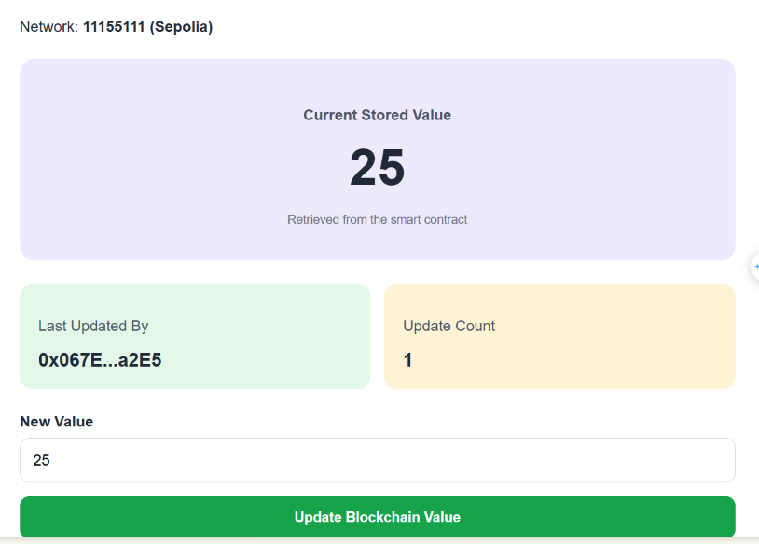.
Checkpoint 3: Students have a complete React DApp connected to a deployed Solidity smart contract.
Part 8. Testing and Debugging

Step 30. Test the Complete DApp
Use a newly deployed SimpleStorage contract and run the tests sequentially.
Test Case | Action | Expected Stored Value | Expected Update Count
TC01 | Read initial state | 0 | 0
TC02 | Set value to 10 | 10  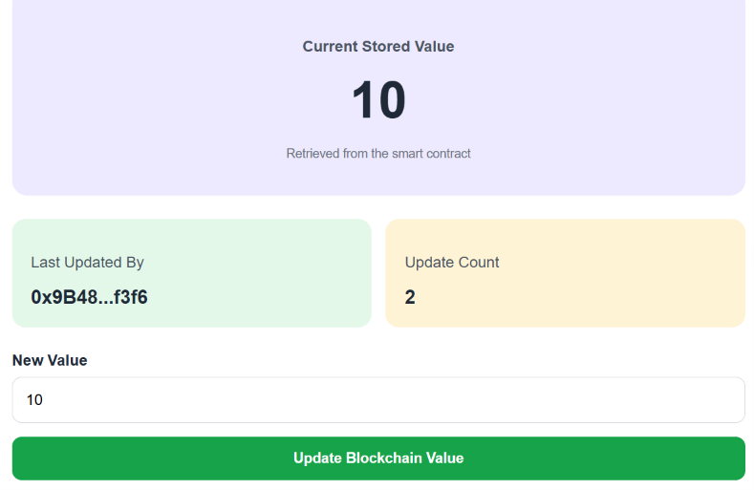 | 1
TC03 | Set value to 25 | 25 | 2
TC04 | Set value to 100 | 100  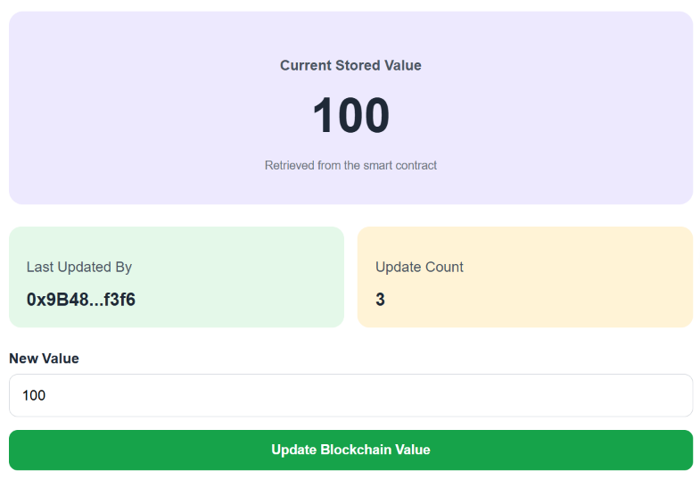 | 3
TC05 | Refresh browser and reconnect | 100  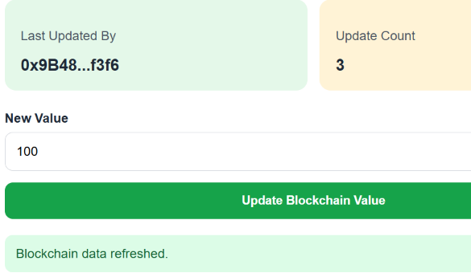 | 3
TC06 | Set value to 0 | 0  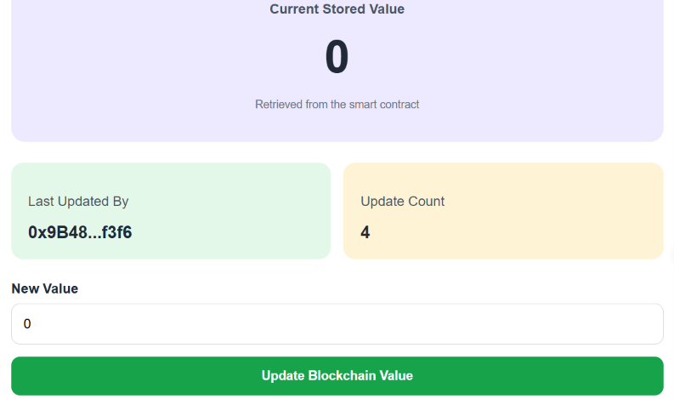 | 4
TC07 | Enter -5 | Unchanged  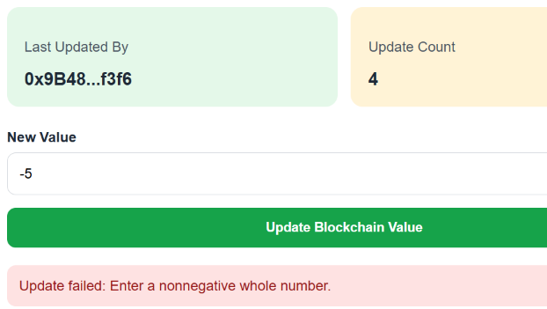 | 4
TC08 | Enter 2.5 | Unchanged  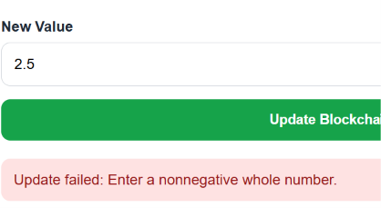 | 4
TC09 | Enter abc | Unchanged  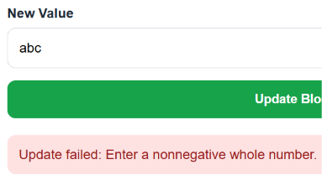 | 4
TC10 | Enter an integer larger than uint256 | Unchanged  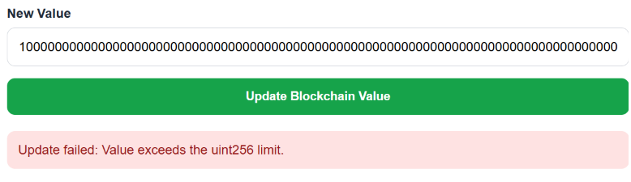 | 4
Important: Updating the contract to the same value again still creates a transaction and increments updateCount. The contract records successful update operations, not only changes to a different value.

Step 31. Test Wallet and Network Behavior
Test Case | Action | Expected Result
TC11 | Connect MetaMask | Wallet address displayed  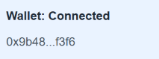
TC12 | Reject a transaction in MetaMask | Error message; stored value unchanged  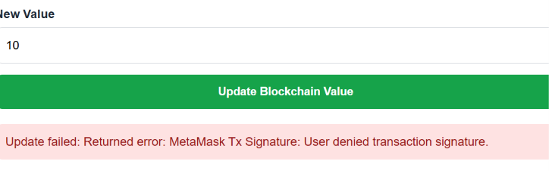
TC13 | Change MetaMask account | Account display updates  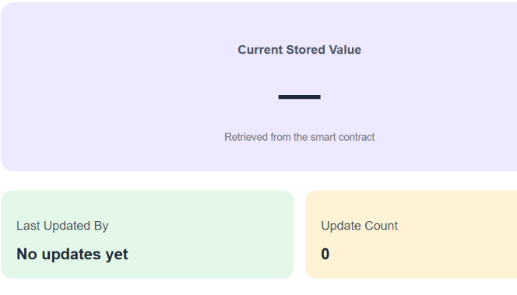
TC14 | Switch away from Sepolia | Wrong-network warning  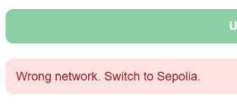
TC15 | Return to Sepolia | Sepolia recognized  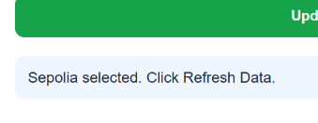
TC16 | Click Refresh Blockchain Data | Latest contract value displayed  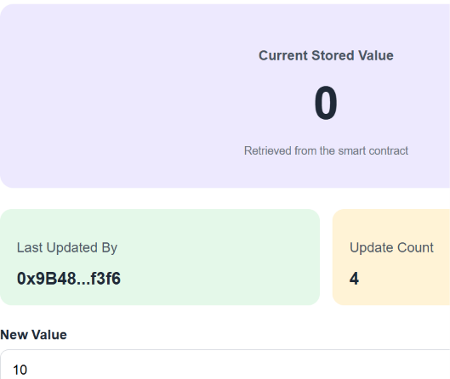

Step 32. Verify Blockchain Persistence
To confirm that the stored value exists on the blockchain:
- Update the value to 100.
- Wait for transaction confirmation.
- Close or refresh the React application.
- Reopen the DApp.
- Connect MetaMask.
- Read the value again.
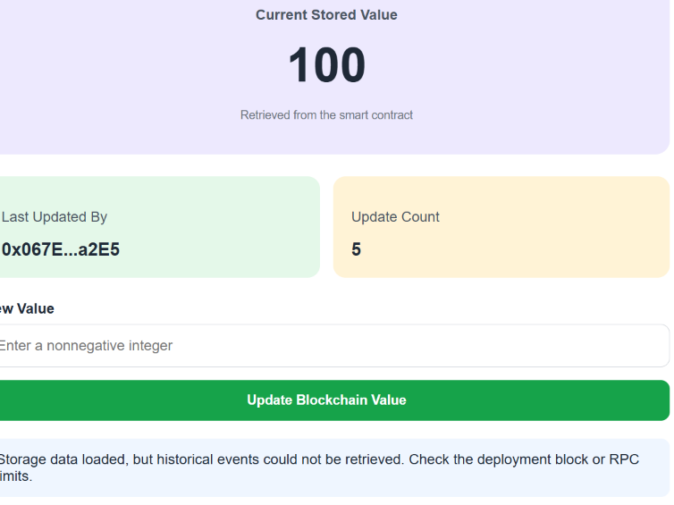
Expected Result: The stored value remains 100, assuming no other account has updated the shared contract in the meantime.
This demonstrates that blockchain state is independent of React component state.

Step 33. Inspect Smart Contract Events
After successful updates to 10, 25, and 100, the event history should contain:
0 → 10
10 → 25
25 → 100
The dashboard displays the most recent event first.
If event history cannot be retrieved, students should inspect the corresponding transaction logs in Remix or Sepolia Etherscan. Some RPC providers restrict historical log queries.
Part 9. Student Practice

Exercise 1. Add a Reset Button
Create a Reset to Zero button.
The button must call:
contract.methods.setValue(0).send({
from: account
});
The reset must require MetaMask transaction approval.
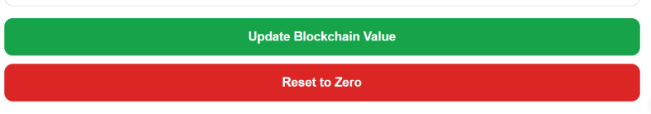

Exercise 2. Add a Value Comparison
Display the previous and new stored values after a successful update.
Example:
Previous Value: 25
New Value: 100
Change: +75
Use BigInt to calculate the difference so that large Solidity integers remain accurate.
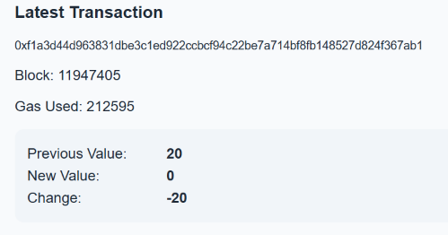

Exercise 3. Add an Update History Filter
Add a dropdown allowing users to display:
- All Updates.
- My Updates Only.
Filter the loaded ValueUpdated events using the connected wallet address.
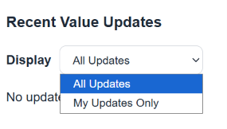

Exercise 4. Add a Contract Information Component
Create a reusable ContractInfo component displaying the contract address, network, chain ID, and deployment block.
Pass these values through React props.
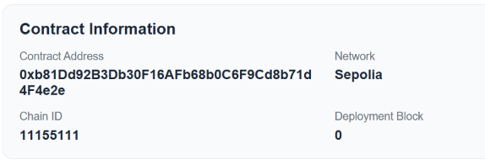

Exercise 5. Add a Maximum Allowed Value
Modify the Solidity contract so that setValue() accepts values only between 0 and 1000.
Example:
require(
newValue <= 1000,
"Value must not exceed 1000"
);
Recompile and deploy the modified contract to Sepolia.
Update the contract address in React, then test setValue(1000) and setValue(1001).
Important: Redeploying creates a new contract with new state and a new address. It does not modify the previously deployed contract.
